GETTING READY FOR A-LEVEL MATHEMATICS:

**Practice Questions:**

**10 Bridging Topics to prepare you for A level Maths:**

1. Expanding brackets and simplifying expressions
2. Rearranging equations
3. Rules of indices
4. Factorising expressions
5. Completing the square
6. Solving quadratic equations
7. Solving linear simultaneous equations
8. Linear inequalities
9. Straight line graphs
10. Trigonometry

**Expanding brackets & simplifying expressions**

**1** Expand −2(5*pq* + 4*q*2)

**Watch out!**

When multiplying (or dividing) positive and negative numbers, if the signs are the same the answer is ‘+’; if the signs are different the answer is ‘–’.

**2** Expand and simplify 2(4*x* – 3) – (3*x* + 5)

**3** Expand –3*s*(4*s*2 – 7*s* + 2)

**4** Expand and simplify 3*b*(4*b* – 3) – *b*(6*b* – 9)

**5** Expand (2*y* – 8)

**6** Expand and simplify.

**a** 13 – 2(*m* + 7) **b** 5*p*(*p*2 + 6*p*) – 9*p*(2*p* – 3)

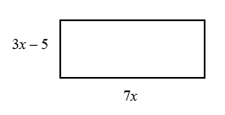**7** The diagram shows a rectangle.

Write down an expression, in terms of *x*, for the area of the rectangle.

Show that the area of the rectangle can be written as 21*x*2– 35*x*

**8** Expand and simplify.

**a** (3*x* – 2)(7 + 4*x*) **b** (3*x* + 4*y*)(5*y* + 6*x*)

**c** (2*x* − 7)2 **d** (4*x* − 3*y*)2

**9** Expand and simplify (*x* + 3)² + (*x* − 4)²

**10** Expand and simplify.

**a**  **b** 

**Rearranging equations**

Change the subject of each formula to the letter given in the brackets.

**1** ** [*t*] **2** *V* = *ax* + 4*x* [*x*] **3** ** [*y*]

**4** *e*(9 + *x*) = 2*e* + 1 [*e*] **5**  [*x*]

**6** Make *r* the subject of the following formulae.

**a** *A* = *πr*2 **b** 

**7** Make *x* the subject of the following formulae.

**a  b **

**8** Make sin *B* the subject of the formula 

**9** Make cos *B* the subject of the formula *b*2 = *a*2 + *c*2 – 2*ac* cos *B*.

**10** Make *x* the subject of the following equations.

**a**  **b** 

**Rules of indices**

**1** Evaluate.

**a** 140 **b**  **c**  **d** 

**e**  **f**  **g** 5–2 **h** 6–2

**5** Simplify.

**a**  **b** 

**Watch out!**

Remember that any value raised to the power of zero is 1. This is the rule *a*0 = 1.

**c**  **d** 

**6** Evaluate.

**a**  **b**  **c** 

**d**  **e**  **f** 

**7** Write the following as a single power of *x*.

**a**  **b**  **c** 

**8** Write the following in the form *axn*.

**a**  **b**  **c**  **d** 3

**9** Write as sums of powers of *x*.

**a**  **b**  **c** 

**Factorising expressions**

**1** Factorise.

**a** 6*x*4*y*3 – 10*x*3*y*4 **b** 21*a*3*b*5 + 35*a*5*b*2

**2** Factorise

**Hint**

Take the highest common factor outside the bracket.

**a** *x*2 + 7*x* + 12 **b** *x*2 – 7*x* – 18

**c** *x*2 – 3*x* – 40 **d** *x*2 + 3*x* – 28

**3** Factorise

**a** 36*x*2 – 49*y*2 **b** 4*x*2 – 81*y*2

**4** Factorise

**a** 2*x*2 + *x* –3 **b** 6*x*2 + 17*x* + 5

**c** 9*x*2 – 15*x* + 4 **d** 10*x*2 + 21*x* + 9

**5** Simplify the algebraic fractions.

**a**  **b** 

**c**  **d** 

**6** Simplify

**a**  **b** 

**7** Simplify 

**8** Simplify 

**Completing the square**

**1** Write the following quadratic expressions in the form (*x* + *p*)2 + *q*

**a** *x*2 + 4*x* + 3 **b** *x*2 – 10*x* – 3

**2** Write the following quadratic expressions in the form *p*(*x* + *q*)2 + *r*

**a** 2*x*2 – 8*x* – 16 **b** 4*x*2 – 8*x* – 16

**c** 3*x*2 + 12*x* – 9 **d** 2*x*2 + 6*x* – 8

**3** Complete the square.

**a** 2*x*2 + 3*x* + 6 **b** 5*x*2 + 3*x* **c** 3*x*2 + 5*x* + 3

**4** Write (25*x*2 + 30*x* + 12) in the form (*ax* + *b*)2 + *c*.

**Solving quadratic equations by factorisation**

**1** Solve

**a** 6*x*2 + 4*x* = 0 **b** 28*x*2 – 21*x* = 0

**c** *x*2 + 3*x* – 28 = 0 **d** *x*2 – 6*x* + 9 = 0

**e** 2*x*2 – 7*x* – 4 = 0 **f** 3*x*2 – 13*x* – 10 = 0

**2** Solve

**a** *x*2 – 3*x* = 10 **b** *x*2 – 3 = 2*x*

**c** *x*(*x* + 2) = 2*x* + 25 **d** *x*2 – 30 = 3*x* – 2

**e** *x*(3*x* + 1) = *x*2 + 15 **f** 3*x*(*x* – 1) = 2(*x* + 1)

**Hint**

Get all terms onto one side of the equation.

**Solving quadratic equations by completing the square**

**3** Solve by completing the square.

**a** *x*2 – 4*x* – 3 = 0 **b** *x*2 – 10*x* + 4 = 0

**c** 2*x*2 + 8*x* – 5 = 0 **d** 5*x*2 + 3*x* – 4 = 0

**4** Solve by completing the square.

(*x* – 4)(*x* + 2) = 5

**Solving quadratic equations by using the formula**

**5** Solve, giving your solutions in surd form.

**a** 3*x*2 + 6*x* + 2 = 0 **b** 2*x*2 – 4*x* – 7 = 0

**6** Choose an appropriate method to solve each quadratic equation, giving your answer in surd form when necessary.

**a** 4*x*(*x* – 1) = 3*x* – 2

**b** 10 = (*x* + 1)2

**c** *x*(3*x* – 1) = 10

**Solving linear simultaneous equations using the elimination method**

Solve these simultaneous equations.

**1** 4*x* + *y* = 8 **2** 3*x* + *y* = 7

*x* + *y* = 5 3*x* + 2*y* = 5

**Solving linear simultaneous equations using the substitution method**

Solve these simultaneous equations.

**3** 3*x* = *y* – 1 **4** 3*x* + 2*y* + 1 = 0

2*y* – 2*x* = 3 4*y* = 8 – *x*

**5** Solve the simultaneous equations 3*x* + 5*y* − 20 = 0 and .

**Linear inequalities**

**1** Solve these inequalities.

**a** 4*x* > 16 **b** 5*x* – 7 ≤ 3 **c** 1 ≥ 3*x* + 4

**2** Solve these inequalities.

**a**  **b** 10 ≥ 2*x* + 3 **c** 7 – 3*x* > –5

**3** Solve

**a** 2 – 4*x* ≥ 18 **b** 3 ≤ 7*x* + 10 < 45 **c** 6 – 2*x* ≥ 4

**4** Solve these inequalities.

**a** 3*t* + 1 < *t* + 6 **b** 2(3*n* – 1) ≥ *n* + 5

**5** Solve.

**a** 3(2 – *x*) > 2(4 – *x*) + 4 **b** 5(4 – *x*) > 3(5 – *x*) + 2

**6** Find the set of values of *x* for which 2*x* + 1 > 11 and 4*x* – 2 > 16 – 2*x*.

**Straight line graphs**

**1** Find the gradient and the *y*-intercept of the following equations.

**Hint**

Rearrange the equations to the form *y* = *mx* + *c*

**a** *y* = 3*x* + 5 **b** *y* = *x* – 7

**c** 2*x* – 3*y* – 7 = 0 **d** 5*x* + *y* – 4 = 0

**2** Find, in the form *ax* + *by* + *c* = 0 where *a*, *b* and *c* are integers, an equation for each of the lines with the following gradients and *y*-intercepts.

**a** gradient , *y*-intercept –7 **b** gradient 2, *y*-intercept 0

**c** gradient , *y*-intercept 4 **d** gradient –1.2, *y*-intercept –2

**4** Write an equation for the line which passes though the point (2, 5) and has gradient 4.

**5** Write an equation for the line which passes through the point (6, 3) and has gradient 

**6** Write an equation for the line passing through each of the following pairs of points.

**a** (4, 5), (10, 17) **b** (0, 6), (–4, 8)

**7** The equation of a line is 2*y* + 3*x* – 6 = 0.  
Write as much information as possible about this line.

**Trigonometry in right-angled triangles**

**1** Calculate the length of the unknown side in each triangle.  
 Give your answers correct to 3 significant figures.

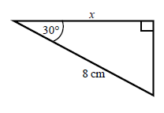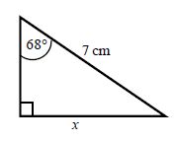 **a b**

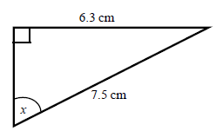**2** Calculate the size of angle *x* in each triangle.  
 Give your answers correct to 1 decimal place.

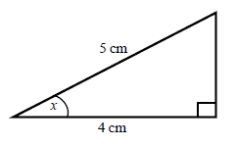 **a b**

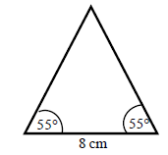**3** Work out the height of the isosceles triangle.  
 Give your answer correct to 3 significant figures.

**Hint:**

Split the triangle into two right-angled triangles.

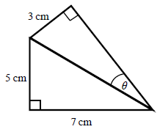**4** Calculate the size of angle *θ*.  
 Give your answer correct to 1 decimal place.

**Hint:**

First work out the length of the common side to both triangles, leaving your answer in surd form.

**5** Find the exact value of *x* in each triangle.

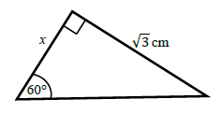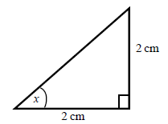 **a b**

**The cosine rule**

**6** Work out the length of the unknown side in each triangle.  
 Give your answers correct to 3 significant figures.

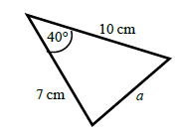 **a b**

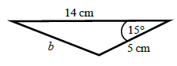

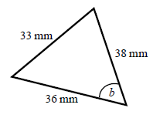**7** Calculate the angles labelled *θ* in each triangle.  
 Give your answer correct to 1 decimal place.

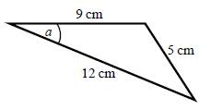 **a b**

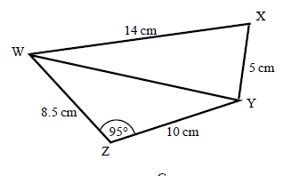**8 a** Work out the length of WY.  
 Give your answer correct to   
 3 significant figures.

**b** Work out the size of angle WXY.  
 Give your answer correct to   
 1 decimal place.

**The sine rule**

**9** Find the length of the unknown side in each triangle.  
 Give your answers correct to 3 significant figures.

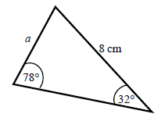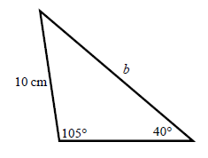

**a b**

**10** Calculate the angles labelled *θ* in each triangle.  
 Give your answer correct to 1 decimal place.

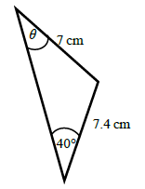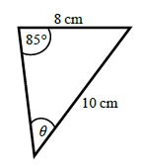

**a b**

**11** **a** Work out the length of QS.  
 Give your answer correct to 3 significant figures.

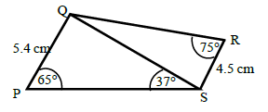 **b** Work out the size of angle RQS.  
 Give your answer correct to 1 decimal place.

**Areas of triangles**

**12** Work out the area of each triangle.  
 Give your answers correct to 3 significant figures.

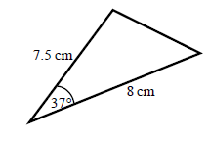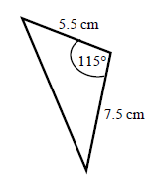 **a b**

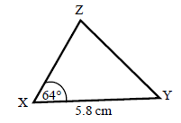

**13** The area of triangle XYZ is 13.3 cm2.  
 Work out the length of XZ.

**Hint:**

For each one, decide whether to use the cosine or sine rule.

**14** Find the size of each lettered angle or side.  
 Give your answers correct to 3 significant figures.

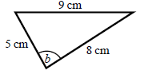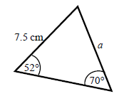 **a b**

**15** The area of triangle ABC is 86.7 cm2.  
 Work out the length of BC.  
 Give your answer correct to 3 significant figures.

