At St. David's we believe that creativity, challenge and inspiration are fundamental to the development of every child. Our Art Curriculum aims to develop a deep understanding and appreciation of the role creativity has played culturally and historically, through an exploration of key artists and craftsmen through time. We will provide high quality teaching and learning in drawing, painting and sculpture to enable children to invent and create their own works of art and design.
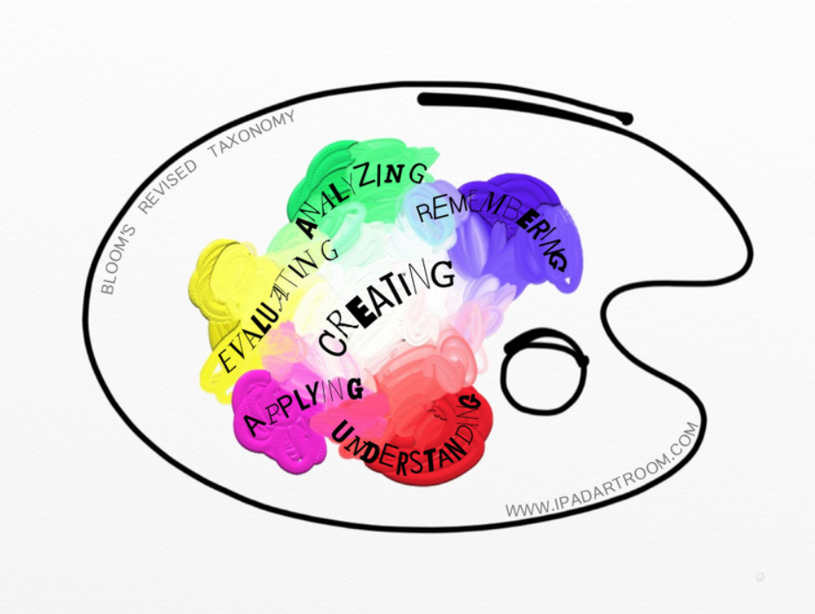

Children will also have regular opportunities to explore and develop a wide range of skills and techniques to express their ideas creatively across the curriculum.

