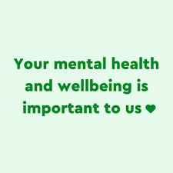

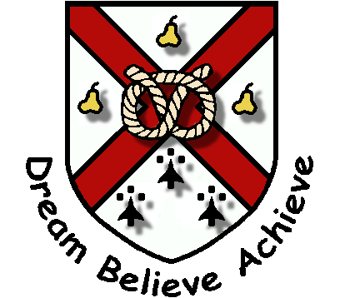
PERTON FIRST SCHOOL

MARKING AND FEEDBACK POLICY

Reviewed: 27/02/2025
Next Review: 31/09/2027
Statement of Intent

Giving feedback to children about their learning is fundamental.
It is an important part of the assessment process.

At Perton First School, feedback is meaningful and manageable. Marking and feedback are used to improve children’s learning. High quality feedback can be verbal or written, but should always be accurate, clear and encourage effort.

“Verbal [live] feedback is more efficient and can be more timely.” (EEF 2001)

This marking policy should be read in conjunction with the following Perton First school policies:
Assessment Policy
Teaching and Learning Policy

Children receive feedback in a range of ways:
- Live feedback (LF) which is in the moment and verbal. This is direct, supportive, challenging and moves the learning forward
- Peer marking
- Self-marking
- Written feedback
- Praise
- Stickers / stamps / thumbs up / house points
- Support to improve their outcomes
- Highlighting errors

Senior leaders understand that marking and feedback must be manageable and therefore recognise that teachers may use appropriate marking tools at their discretion from the list above.
Star Stamps – A Quick Method for Marking



We use assessment for learning to inform us about the children’s abilities. Teachers know their children well and aim to provide work which is achievable as well as challenging. The whole class will predominantly be working on the same objectives. However, there are some children who are working below their peers in some subjects. Teachers plan work which is pitched at the right level for the child.

A star stamp on work shows that a child has met the lesson objective. The star stamp is often placed next to the WALT (We are learning to…) in the child’s book. It acts as positive feedback for the child. There is no expectation for a written comment alongside the star but teachers may choose to write a comment.

A child who hasn’t met the WALT independently in a lesson will have an ‘S’ for support, written by the star, to show that they could achieve with additional scaffolds, resources or support over and above what was expected of them at the beginning of the lesson.

A child unable to achieve the WALT even with support won’t receive the stamp for that lesson. If a child is unable to achieve despite lots of support, the task was most likely too difficult for them. This will be unpicked by the teacher, made accessible and achievable and then celebrated. In the best lessons, all children will achieve in a way that works for them. There’s no limit on resources, scaffolds or support.
If live feedback has been given then ‘LF’ will be written.

Kelvin Jones and Emily Harris27/02/2025

