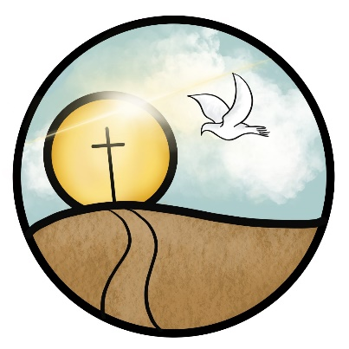
St. John The Baptist
Church of England (Aided) Primary School
Loving Learning, Building Community, Growing in Faith

Wednesday 11th June 2025

Tapestry – An Online Learning Journal

Dear Parents and Carers,

In Reception we use an online system of recording your child’s learning. ‘Tapestry’ is a website which can be accessed on a computer or laptop, and also on any Apple or Android device such as a tablet or smartphone. We have chosen this company because they are a secure and also exciting way of keeping track of your child’s development and their time with us.

Instead of using the old paper book style way of recording, we will be able to instantly upload photos, videos and observations of your children. You are then emailed to alert you that something new has been added to your child’s Learning Journal and can log on and view what your child has been up to. A massive advantage of this system is that you can instantly add your own comments to entries, and can show your child’s online book to members of the family.

The safeguarding of our children is very important to us. Everything that is added to Tapestry will be added to our school account and can only be viewed by school staff that use the system, and also yourself, using your own log on. You will only have access to your child’s own book and this cannot be seen by other parents. Also, it is crucial that you do not share photos or videos from your child’s book on social media or through other online platforms. Any incidents where this confidentiality is broken will be dealt with very seriously and will result in your access to the system being withdrawn.

On the back of this letter you will find some Frequently Asked Questions about the system. I would also like to signpost you to Tapestry’s website where you will find lots of information and videos: http://eyfs.info/tapestry-info/introduction

Attached to this letter is a permission and information slip to allow us to set up a Tapestry account for your child. Please sign and return it to your child’s teacher as soon as possible. You will be given your account details during the first two weeks of the Autumn term.

If you have any further questions please do not hesitate to contact us.

Kind regards

The EYFS Team



Frequently Asked Questions
Why use an online system?
Hand writing observations, printing out photos, cutting out and sticking all of these into a paper book is very time consuming. By taking photos and videos that can be instantly uploaded this increases the time that staff can spend with your children, supporting their learning.
We were also impressed with the way in which parents can instantly see what their child has been up to and can also share it with family members such as grandparents.
How do I get onto the system?
If you consent to us using Tapestry for your child, school will set up an account for you and provide you with log on details.
Tapestry can be accessed online at: http://eyfs.info/tapestry-info/introduction
It is available as a free app from the Apple Store and also on Android devices.
We will ask you to provide us with an email address so that we can set you up a personal account. This will be a secure way of logging in, and you will only be able to see your own child’s book.
I don’t have a computer, laptop, tablet or smartphone. How can I access Tapestry?
If you are unable to access the Internet on any device at home, then you will still be able to access your child’s book during Parent Café sessions where we will provide you with access to your child’s account and support you to use it if needed.
I am not very confident with computers or the Internet. How can I access Tapestry?
One of the reasons for us choosing Tapestry was ease of use. It is a very easy system to use, but should you have any problems, a member of the Early Years Team will be happy to support you.
Why do you need my email address?
Your email address is required in order to set you up with access to your child’s account. It is to ensure security on the site and also so that we can email you when a new entry has been added for your child.
Tapestry – An Online Learning Journal
Permission Slip
Please return this slip to your child’s teacher on the day of your visit.

Child’s Name:______________________________________________________________

Class (please circle):
The Owl Babies The Rainbow Fish The Hungry Caterpillars

- I do/ do not give permission for an online Tapestry Learning Journey to be maintained for my child.

- I do/ do not give permission for my child’s photo to appear in any group photos used in Learning Journeys.

- I agree not to electronically share, by social media or other platforms, any part of my child’s Learning Journey.

The email address I wish to use for my Tapestry account is (please print clearly):

____________________________________________________________________

Please use __________________________________________________ (parent’s first and surname) as my username.

Parent/Carer signature: _____________________________

Date:____________________

