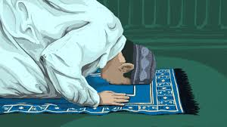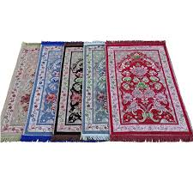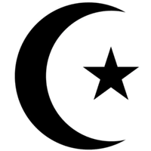

Muslims can pray anywhere that is clean and quiet.

A prayer mat is used and should face the holy city.

Prayer is the most important part of a Muslim’s day.

**OUR BIG QUESTION**

Why do people pray?

**Islam – Prayer mats**

EYFS

**KEY VOCABULARY**

prayer

mat

Makkah