










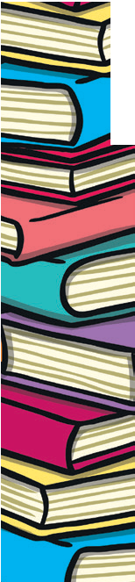



Reading Champion Badges
In order to encourage the children to read their levelled school book at home, we are rewarding regular readers with Reading Champion Badges.
For Reception and Key Stage 1 children, please log your child’s reading in their Reading Record. For Key Stage 2 children, please log using the BoomReader App (this is the new name for GoRead).
Staff check Reading Records/BoomReader regularly, and once you have have logged 50 reads at home they will receive their Bronze Reading Champion badge in Celebration Assembly. They can win further badges for 100 and 150 reads at home.

Q Can we log reading of other books, rather than the levelled school books?
We provide all children with a book that is carefully matched to their reading ability. It is vital that children read and re-read books at the correct level for them to develop fluency (reading without pausing to work out what a word says) We have invested in books that cover arrange of genres, with the ambitious vocabulary they need to understand in order to succeed in education. Think of reading their levelled books as “Reading Homework”
Q Can my Key Stage 2 child log their own reading?
We love to see children developing independence and taking ownership of their own reading journey, and so we encourage them to log reading either their own books from home, or the Reading for Pleasure/Library books they bring from school. However, for the Reading Champion Badges a parent/carer needs to log that the child has read to them.
Q My child has finished their book.
In Reception/Key Stage 1books are changed once a week. Re-reading the same text is important for developing fluency and confidence. In Key Stage 2, when you click that a book is completed on Boom Reader, they can change their book for a new one.

