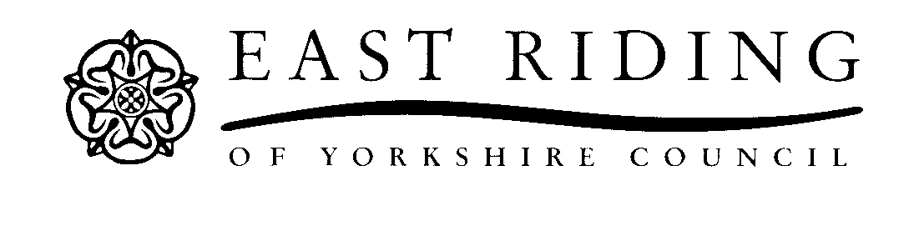

INSTRUMENT OF GOVERNMENT

1. The name of the school is Pocklington Church of England Voluntary Controlled Infant School.

2. The school is a voluntary controlled school.

3. The name of the governing board is The Governing Board of Pocklington Church of England Voluntary Controlled Infant School.

4. The governing board shall consist of:

1 Headteacher governor

2 Parent governors;

1 Local Authority governor;

1 Staff governor;

2 Foundation governors;

3 Co-opted governors.

5. The total number of governors is 10.

6. Foundation governors are appointed by the York Diocesan Board of Education after consultation with the Parochial Church Council of the Parish in which the school is situated.

7. (a) The holder of the following office shall be a foundation governor ex-officio:

The Principal Officiating Minister of the Parish in which the school is situated.

(b) The Archdeacon of York shall appoint a foundation governor to act in the place of the ex-officio foundation governor whose governorship derives from the office named in (a) above, in the event that the ex-officio foundation governor is unable or unwilling to act as a foundation governor, or where there is a vacancy in the office by virtue of which his or her governorship exists.

The Archdeacon of York is entitled to request the removal of any ex-officio foundation governor and to appoint a substitute governor.

8. The ethos of the school is as follows:

“Recognising its historic foundation, the school will preserve and develop its religious character in accordance with the principles of the Church of England and in partnership with the Church at parish and diocesan level.

The school aims to serve its community by providing an education of the highest quality within the context of Christian belief and practice. It encourages an understanding of the meaning and significance of faith and promotes Christian values through the experience it offers to all its pupils”.

9. The school has a trust deed dated 1852.

10. This Instrument of Government comes into effect 17 June 2024.

11. This Instrument was made by order of the East Riding of Yorkshire Local Authority on 9 May 2024.

12. A copy of the Instrument of Government must be supplied to every member of the governing board (and Headteacher if not a governor), the trustees under any trust deed and to the appropriate diocesan authority.

