

Assessment Policy

SUMMARY
This policy outlines the school’s approach to assessing the progress of children’s learning.

POLICY OWNER
Robert Howell
Headteacher

DELEGATION
Performance Enrichment Committee

DATE OF APPROVAL
29 March 2023

DATE OF NEXT REVIEW
29 March 2026

REVIEW CYCLE
Triennial

PUBLISHED ON WEBSITE
Yes

_________________________

Paper copies available by emailing admin@alfredsutton.reading.sch.uk

Alfred Sutton Primary School
148 Wokingham Road
Reading
RG6 7BL
DFE No: 870/2000
www.alfredsutton.primary.co.uk

Introduction

At Alfred Sutton, we use the three main forms of assessment:
in-school formative assessment, which is used by teachers to evaluate pupils’ knowledge and understanding on a day-today basis and to tailor teaching accordingly; in-school summative assessment, which enables schools to evaluate how much a pupil has learned at the end of a teaching period; and nationally standardised summative assessment, which is used by the Government to hold schools to account
Final report of the commission on assessment without levels, 2015
To use each form of assessment to best effect, the school follows the principles of Assessment for Learning. The approach can be summarised as a progression of using evidence from learning to adapt teaching in order to align to student needs.
Assessment for Learning is the process of seeking and interpreting evidence for use by learners and their teachers to decide where the learners are in their learning, where they need to go and how best to get there.
Assessment Reform Group, 2002
‘Formative assessment’, often used interchangeably with the term ‘Assessment for Learning’ (AfL), refers to any assessment activities undertaken by teachers—and by students themselves—that provide feedback, which are then used to adapt teaching methods to meet student needs and improve learning outcomes
Black and William, 1998
Black (2008) uses the term ‘Keeping learning on track’ to summarise the approach as follows:
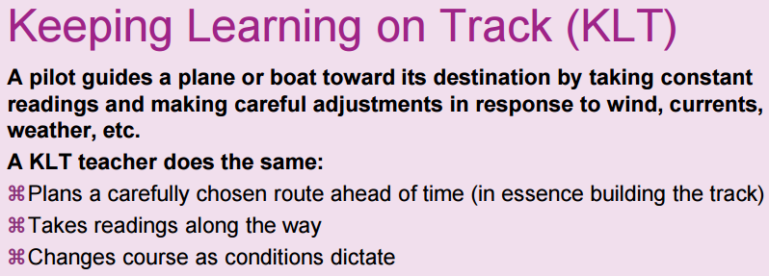

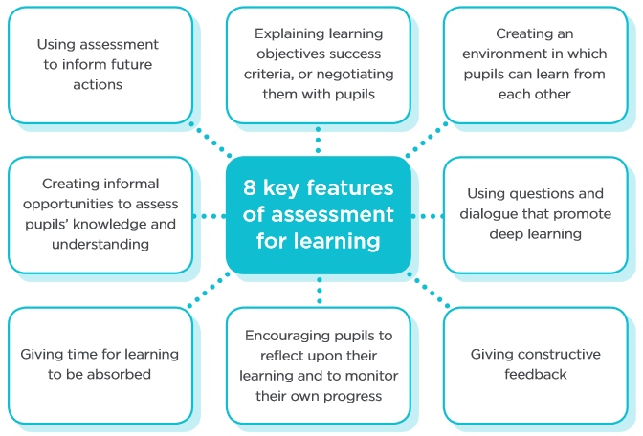
A summary of key features of effective Assessment for Learning

Aims
Through robust practices based on the key ideas of Assessment for Learning, as well as high-quality applied cognitive science, we look to ensure:
- Effective practices are in place for teaching and assessment that enable all pupils to make at least expected progress from their individual starting points
- A child centred learning community approach with pupil voice at the heart for co-ownership of their learning journey with the adults who support them
- Children are learning what we need them to learn and building effective schema around key substantive and disciplinary concepts
Schemas (sometimes referred to as mental models, scripts, or frames) are structures that organise knowledge in the mind. When learning, the mind connects new information with pre-existing knowledge, skills, and concepts thereby developing existing schemas.
Education Endowment Foundation, 2021
- Learning gaps are quickly identified and intent is adapted to immediately address them

Legislation and guidance
Schools have been free to develop their own approaches to assessment since the National Curriculum levels were removed in 2014.
This policy ensures, for best practice, that the following recommendations and guidance are followed:
- The recommendations in the final report of the Commission on Assessment without Levels
- Statutory reporting requirements set out in the Education (Pupil Information) (England) Regulations 2005: schedule 1

Principles

Our school devised formative and non-statutory summative assessment for learning model draws significantly on applied cognitive science research: we employ research driven strategies that are shown to maximise learning (such as retrieval practice and spacing) but also double up as assessment opportunities.
Retrieval practice ‘can be a strategy for learning in addition to being an assessment for learning’
EEF Cognitive science approaches in the classroom: a review of the evidence, July 2021
The evidence review underpinning the Ofsted inspection framework also draws on cognitive science approaches.
‘It is, for example, becoming increasingly clear that using spaced or distributed practice, where knowledge is rehearsed for short periods over a longer period of time, is more effective than so called massed practice.’
By incorporating the latest cognitive science research into our strategy, we eliminate wastage in teaching by focusing on practices which have strong evidence of being effective to the way the human brain learns. Key solutions from applied cognitive science which we have adopted are:
- Retrieval practice: to make use of the ‘testing effect’ – a finding which states that retrieval promotes retention more than restudying – we introduce informal, frequent assessment opportunities (e.g. maths arithmetic practice, cross-curriculum writing) as retrieval practice which are seamlessly interwoven into lessons. These follow several principles based on current research:
  - Preferring production tests which require effort (e.g. solving a problem) over recognition (picking the right answer)
  - Testing the same content multiple times in different contexts with relatively long intervals between tests
  - Producing feedback, even if it is casual such as pupil discussion
  - Applying the rule of three: research indicates that the optimal number of retrievals is three
  - Retrieval practice synergises with Assessment for Learning as a strategy for making the most effective use of assessment.
Retrieval practice produces greater long-term retention than studying alone. This finding suggests that testing, which is commonly conceptualized as an assessment tool, can be used as a learning tool as well.
The critical role of retrieval practice in long-term retention, Roediger and Butler, 2011
- Interleaving: by interspersing lesson content with opportunities to use previously acquired knowledge, we build pupils’ ability to independently make choices about the appropriate skills and information to solve a dilemma (e.g. a maths problem, a science investigation). There is extensive research demonstrating its usefulness in problem-solving subjects such as maths e.g. by introducing mixed-type problems which require previously taught content in addition to the lesson content to access. However, it is valuable across the curriculum: for example, asking pupils to design a science investigation using their knowledge from the unit as well as previously learnt scientific methods.
- Managing cognitive load: to avoid working memory overload, we focus learning on the most important information. This mastery approach supports transfer to long term memory. Strategies used include:
  - Chunking content into manageable pieces
  - Using worked examples
  - Providing ‘scaffolding’ and other forms of support such as prompts, cues, or targeted instructions to help learners navigate the working memory demands of tasks
  - Decluttering presentation materials
  - Using collaboration between pupils so they can share the demands of complex problem-solving tasks
- Schema cognitive development model: the schema model informs us that the brain is built to develop schemas around ‘big ideas’, i.e. if big ideas are retained, new information can be added over time. We employ a teaching, learning and Assessment for Learning strategy which prioritises the ‘big ideas’ enabling pupils to build effective schema.
We extract the ‘big ideas’ to form our learning objectives and supporting success criteria: this approach also lowers cognitive load by reducing the work the brain needs to put in to transform the information into schemas. Supporting subconcepts - information we do not expect pupils to retain in long term memory - aid the development of schemas by illustrating, adding interest to or providing opportunities for pupils to reason with top level concepts.
Strategies which promote the development of schemas are:
- Problem-based learning whereby pupils learn through their struggle to apply existing knowledge to a challenging task
- Using comparisons and analogies to add depth or address misconceptions
- Elaborating or questioning concepts and ideas to strengthen, develop, and transfer learning
Education Endowment Foundation, 2021

In-School summative

We work in partnership with parents as this optimises pupil outcomes. Attainment and effort gradings are reported on a mid-year report format ahead of parents’ meetings at the end of the autumn and spring terms.
The final report of the commission on assessment without levels (2015) emphasises the importance of recognising effort, particularly in relation to pupils who may not be able to achieve year group expectations due to SEND:
High expectations should apply equally to pupils with SEN and disabilities as to all other pupils. For many pupils with SEN and disabilities effort applied to learning is significant and assessment should recognise this alongside outcomes achieved whilst maintaining high aspirations and expectations.
A final report is produced at the end of an academic year in accordance with statutory expectations as follows:
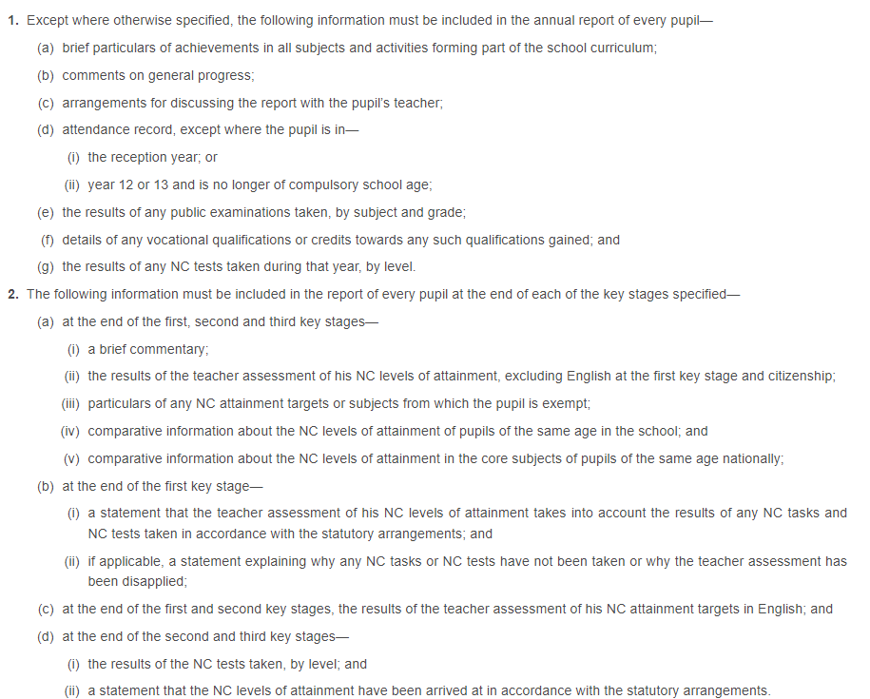
School agreed attainment gradings provide information of pupils’ attainment trajectories within an academic year. For most pupils this will fall into one of the following categories:
- Working towards the expected standard
- Achieving the expected standard
- Working at strength within the expected standard
- Working at greater depth within the expected standard (for English and maths only - in line with DfE KS1 and KS2 end points)

Attainment tracking
Term  End of year  predictions | Autumn 2 | Spring 2 | Summer 2
Working towards the expected standard | B | B+ | W
Expected standard | B+ | W | W+
Strong expected | W | W+ | S
Greater depth within the expected standard  (English and maths only) | W+ | S | S+

Attainment band | Children are:
B/B+ | Beginning to access/ confidently accessing the year group’s curriculum
W/W+ | Moving towards/achieving the expected standard for the year group
S/S+ | Working at strength within the expected standard/at greater depth within the expected standard

Statutory summative
In accordance with statutory reporting requirements, this information is sent out to parents with pupils associated end of year reports.

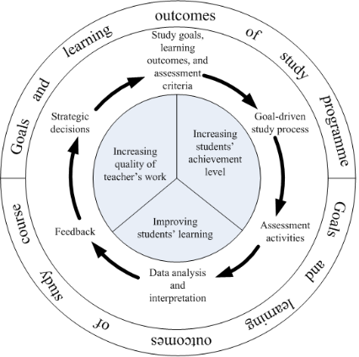
The approach in practice
We aim to maximise the effectiveness of our assessment strategy whilst being mindful of teacher workload. We therefore have agreed Assessment for Learning processes in place that have the full support of staff. Our approach is heavily weighted towards formative assessment to enable a needs driven, dynamic approach to aligning teaching to meet pupil needs through clear identification of next steps.
Formative and summative assessment for learning outcomes are used in a cycle of improvement and refinement as illustrated in the diagram and table below
Frequency | Short term/  Every lesson | Medium term/  Within a unit | Long term/  Within a term
Type of assessment | In school formative  to evaluate pupils’ knowledge and understanding on a day-to-day basis and to tailor teaching accordingly | In school formative  to evaluate pupils’ knowledge and understanding within a unit to tailor teaching accordingly to achieve curriculum end points. | In school summative  to evaluate how well pupils are building strong conceptual schemas which provide starting points for new learning to be more successfully embedded in long term memory; it informs and shapes future planning and targets for improvement. These judgements and insights are shared to inform and evaluate e.g. to ensure an in-house test is well-grounded, ethical and supports teaching and learning | National summative  The results are reported to students and parents, inform the next phase of a child’s education and are used as analysis tools by LAs and the DfE. They also provide pupil starting point assessment judgements for their next phases.
Staff involved in monitoring | Class teachers, phase and subject leads | Class teachers, phase and subject leads | Class teachers, phase subject leads and SLT  Moderation with other schools/LA | Class teachers, phase subject leads and SLT  Moderation with other schools/LA
Examples | Rich question and answer opportunities every lesson: tell your partner; choral response; responses held up on whiteboards; apply learning in short/longer answer questions – written and verbal –  To maximise learning alongside, these approaches are retrieval based and used with feedback – e.g. class, group and personalised learning dialogue, both verbal and written | Hot retrieval tasks e.g. longer cross-curricular writes  End of unit concept mapping and quizzes  Text abased retrieval  Maths reasoning and problem solving  Reading vocabulary synonym retrieval tasks  To maximise learning alongside, these approaches are retrieval based and used with feedback – e.g. class, group and personalised learning dialogue, both verbal and written | Cold, spaced retrieval tasks  NFER reading assessments, DfE produced tests (old SATs/optional SATs papers)  In creative subjects, a piece of independently conceived work such as an artwork or (in PE) gymnastics routine/dance/mini game  To maximise learning alongside, these approaches are retrieval based and used with feedback – e.g. class, group and personalised learning dialogue, both verbal and written | EYFS: GLD  Y1: summer term assessments: teacher assessments/tests (phonics screening)  Y2: KS1 SATs  Y3,4,5: summer term teacher assessments/tests  Y6: KS2 SATs
End goal | Mastery is the target rather than recall. This means that deep, secure understanding of big ideas is assessed and targeted in learning rather than recall of peripheral detail. |  |  | Provides a measure of pupil end point progress and attainment achieved over a longer time frame.  Enable robust starting point data to provide accurate future measures of pupil progress
Monitoring impact and staff involved | Pupil voice  Pupil work  Phase and subject leader monitoring |  | Pupil voice  Pupil work and assessments  Class teachers, phase subject leads and SLT monitoring/moderation  Moderation with other schools/LA | Pupil voice  Pupil notes  Subject leader monitoring  Moderation – phase, school, external  LA and National data comparisons
Use of evidence | To enable pupils and teachers to identify next steps/close gaps in learning |  | To monitor pupil cohorts and inform future planning/interventions/areas of support | To evaluate their performance against national expectations and inform future planning/interventions/areas of support

CPD
We recognise that Assessment for Learning works in synergy with intent and implementation to maximise outcomes for pupils.
The three essential strands of teacher expertise relate to pedagogy, curriculum and assessment
Final report of the commission on assessment without levels, 2015
Making sound judgements about learners’ progress is a key skill for teachers. We work together to build a level of expertise across these 3 strands amongst our staff that ensures all pupils make progress. Staff regularly engage in associated CPD at phase, school and LA level. This process enables confidence in our judgements (e.g. 100% accuracy in end of Key Stage LA moderation).
Through shared ownership underpinned by CPD, we ensure:
- A shared understanding of AfL, that continues to become ever more insightful, ensures pupils make very good progress from their starting points and and attain well
- The school remains up-to-date at the top level regarding the state of cognitive science for education and reliably disseminates practices based on new research from the leadership downward
- All staff and pupils reflect critically about their ways of working and ‘think outside the box’ if necessary i.e. flex & change through learning from others to take intelligent informed risks
- Established structures and mechanisms are used for encouraging and facilitating sustained professional dialogue between all staff
- All pupils are fully engaged in processes to monitor and evaluate their progress
- All staff engage in enquiry-based monitoring and evaluation which informs CPD
- All staff work collaboratively in house within & across year groups/phases, sharing their practice and learning from what they and their peers do well
- Cross school collaboration is part of the culture, generating professional challenge
- Parents/carers are proactively engaged in supporting learning in and outside of school
Our assessment policy ensures that our Assessment for Learning is:
- Accurate – knowing what the standards are, judging pupils’ work correctly, and making accurate assessments linked to National Curriculum grasp
- Fair – knowing the methods used are valid
- Reliable – ensuring that judgements are consistent and based on a range of evidence
- Useful – identifying barriers to pupil progress and using that information to plan and discuss the next steps in learning
- Focused – identifying areas of a child’s learning where there are blocks to progression ensuring a for every pupil
- Continuity driven – enabling better transfer between years and schools

Inclusion

The principles of this assessment policy apply to all pupils, including those with special educational needs or disabilities.
Assessment will be used diagnostically to contribute to the early and accurate identification of pupils’ special educational needs and any requirements for support and intervention.
We will use meaningful ways of measuring all aspects of progress, including communication, social skills, physical development, resilience and independence. We will have the same high expectations of all pupils. However, this should account for the amount of effort the pupil puts in as well as the outcomes achieved.
For pupils working below the national expected level of attainment, our assessment arrangements will consider progress relative to pupil starting points, and take this into account alongside the nature of pupils’ learning difficulties.

Roles and responsibilities
The governing board will monitor the effectiveness of this policy and hold the headteacher to account for its implementation by:
- Being familiar with statutory assessment systems as well as how the school’s own system of non-statutory assessment captures the attainment and progress of all pupils
- Holding school leaders to account for improving pupil and staff performance by rigorously analysing assessment data
- Monitoring that school staff are receiving the appropriate support and training on pupil assessment, to ensure consistent application and good practice across the school

The headteacher and senior staff, including inclusion, subject and phase leads work collaboratively with all staff, governors and other stakeholders, where appropriate, by:
- Ensuring that the policy is adhered to
- Monitoring standards in core and foundation subjects
- Analysing pupil progress and attainment, including individual pupils and specific groups
- Prioritising key actions to address underachievement
- Reporting to governors on all key aspects of pupil progress and attainment, including current standards and trends over previous years
- Making sure arrangements are in place so teachers can conduct assessment competently and confidently, including training and moderation opportunities

Monitoring
This policy will be reviewed triennially by the PEC. At every review, the policy will be shared with the governing board.
All teaching staff are expected to read and follow this policy.

Links with other policies
This assessment policy is linked to:
- Curriculum policy
- SEND policy
- Marking and feedback policy
- Early Years Foundation Stage policy and procedures

