



The Knowledge of Kings
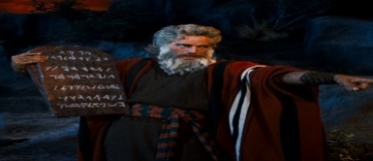
What can we learn from religions when deciding what is right and wrong?
Subject Specific Vocabulary
Neighbour | Everyone else. Not just the person who lives next to you.
Torah | A holy book followed by Jewish people.
Conscience | A person’s moral sense of right and wrong.
Beatitudes | Eight blessings given by Jesus to help Christians to reach heaven.
Temptation | Wanting something that is forbidden or you should not have.
Apartheid | A system of racial segregation in South Africa from 1948 – 1990s.
Serpent | A snake
Nobel peace prize | A prize given to people who have done the most they can to hold peace between people and nations.
Opposition | Resistance against something.



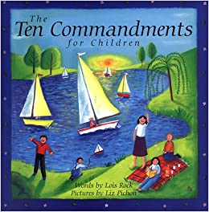
RE
Royal Charter

Books for hooks

The three temptations of Jesus while he was in the desert were:
- to change stone into bread
- to throw himself down from a temple
- to be given kingdoms if he worshipped Satan
God gave the ten commandents to Moses on Mount Sinai. They were written on blocks of stone.
Desmund Tutu received the nobel prize for peace in 1984 for his role in the opposition to apartheid in South Africa.
Trevor Huddleston was the former president of the anti apartheid movement.
A serpent tempted Adam and Eve to eat fruit from a tree in the garden of Eden.

