Transition work: A level Law Name:

Introduction

The aim of this booklet is to ease you into A level law, the course we follow at Wigston College is AQA A level Law. There is a link to the specification at the bottom of this page. There is included in this booklet some recommended reading and viewing to give you a basic understanding as well as a link to the revision guide which will be essential to the course.
Law at A level is an exciting and interesting course which covers the English Legal System, Criminal Law, Human Rights and the Law of Tort (Negligence). The course will give you an understanding of the law; how laws are made and enforced through the Courts as well as peoples’ civil and criminal rights and responsibilities.
Have a go at the activities in this booklet and feel free to use the internet to assist you and in particular the link in the useful websites page to support you with these activities.
Once you have completed the transition activities, look up the real life cases listed on page 15 and make notes.
Please bring your answers to the activities as well as your research on your chosen case to your first law lesson in September.
See you there!

REVISION GUIDES
AQA LAW SPECIFICATION
This is a two year linear course that comprises four topics that will be formally assessed at the end of the two year course. Students will also be assessed throughout the course by way of formal and informal testing.
https://www.aqa.org.uk/subjects/law/as-and-a-level/law-7162/specification-at-a-glance

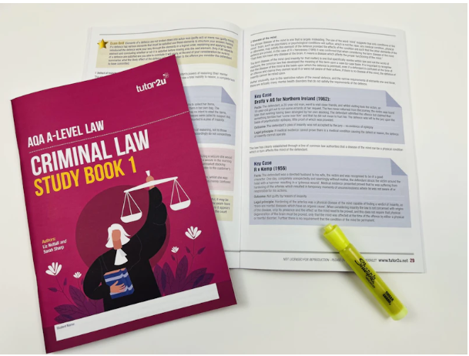Tutor2U study books: Criminal Law (AQA)
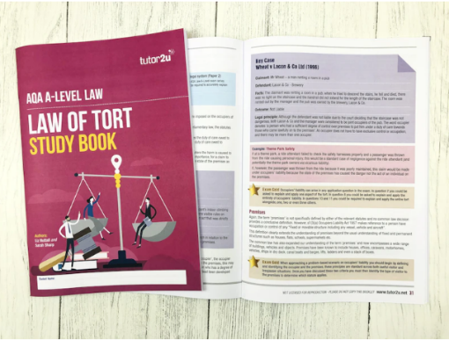Tutor2U study book: Tort (AQA)

My Revision Notes: AQA A Level Law Second Edition: Amazon.co.uk: Beauman, Craig, Wilson, Clare: 9781398352049: Books
TASK ONE:
One of the first things we would encourage you to do before starting in the autumn term is organise your folder with dividers labelled as below which you can file your class notes in to during the autumn term. You will need 3 folders for your A Level law studies overall, 2 of which will be needed in Year 12.
Paper 1: Criminal Law
- Nature and rule of law
- Law making
- Legal system
- Rules of criminal law
- Theory of criminal law
- General elements of liability
- Fatal offences against the person
- Non-fatal offences against the person
- Property offences
- Preliminary offences- attempts
- Defences
TASK TWO: Research: roles within the legal system
We would like you to do some research on professions within the field of Law. We would like you to create a booklet which we will take in email or you can hand in on your first law lesson. We will need you to have a copy of it within your folder after it has been completed.
1. | Magistrates | - General information (what are they, how many are there)  - Qualifications needed to become one (& restrictions on appointment)  - Appointment (How they are appointed & the process)  - Training (How they are trained, & appraised).
2. | Barristers | - General information (what are they, how many are there)  - Training (How they are trained, & appraised).  - The role that they play within the justice system  - The overlap/difference between them and solicitors
3. | Solicitors | - General information (what are they, how many are there)  - Training (How they are trained, & appraised).  - The role that they play within the justice system  - Areas which they can specialise in  - The overlap/difference between them and barristers
4. | King’s Counsel | - How long/what experience do you need before you can apply to be a KC?  - What is it known as?  - What do KCs do?
5. | Legal Executives | - General information (what are they, how many are there)  - Training (How they are trained, & appraised).  - The role that they play within the justice system
6. | Judges | - What are the different types of judges?  - What qualifications do they need?  - How are they selected/appointed?  - What role do they have?
We would also like you to find out what these words mean:
1 | The General Council of the Bar
2 | Bar Standards Board
3 | The Law Society
4 | Solicitors Regulatory Authority
5 | Chartered Institute of Legal Executives
6 | CILEx Regulation Board
7 | The legal ombudsman
TASK THREE:
Explain two of the key roles of a barrister as a member of the legal profession. [5]
_____________________________________________________________________________________________________________________________________________________________________________________________________________________________________________________________________________________________________________________________________________________________________________________________________________________________________________________________________________________________________________________________________________________________________________________________________________________________________________________________________________________________________________________________________________________________________________________________________________________________________________________________________________________________________________________________________________________________________________________________________________________________________________________________________________________________________________________________________________________________________
What to do if you have any questions?
Please get in contact with either of us, email addresses are below:
Head of Social Science: Mrs E Sperring esperring@wigstonmat.org
Head of Social Science: Mrs N Espiner nespiner@wigstonmat.org

