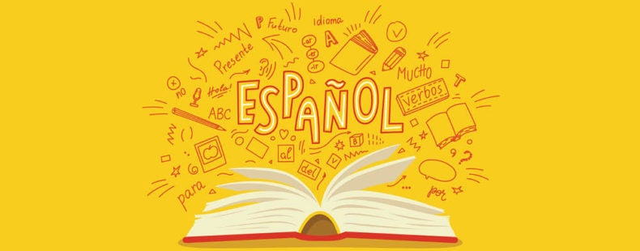

Year 9
Spanish Knowledge Organisers
Student Name:
Teacher: Room:

- Year 7 Learning Cycle 1 Sentence Builder 1: Greetings
- Year 7 Learning Cycle 1 Sentence Builder 2: Ages and birthday
- Year 7 Learning Cycle 1 Sentence Builder 3: Friends and personality
- Year 7 Learning Cycle 1 Sentence Builder 4: Family and physique
- Year 7 Learning Cycle 1 Sentence Builder 5: Hair and eyes
- Year 7 Learning Cycle 2 Sentence Builder 1: Favourite teacher
- Year 7 Learning Cycle 2 Sentence Builder 2: Opinions on lessons
- Year 7 Learning Cycle 2 Sentence Builder 3: Lesson activities
- Year 7 Learning Cycle 2 Sentence Builder 4: Future studies
- Year 7 Learning Cycle 2 Sentence Builder 5: Breaktime
- Year 7 Learning Cycle 3 Sentence Builder 1: House
- Year 7 Learning Cycle 3 Sentence Builder 2: Weather
- Year 7 Learning Cycle 3 Sentence Builder 3: Weekend
- Year 7 Learning Cycle 3 Sentence Builder 4: Local area
- Year 7 Learning Cycle 3 Sentence Builder 5: Opinion on region
- Year 8 Learning Cycle 1 Sentence Builder 1: Current jobs
- Year 8 Learning Cycle 1 Sentence Builder 2: future jobs
- Year 8 Learning Cycle 1 Sentence Builder 3: Advantages of different jobs
- Year 8 Learning Cycle 1 Sentence Builder 4: Skills
- Year 8 Learning Cycle 1 Sentence Builder 5: Ideal jobs
- Year 8 Learning Cycle 2 Sentence Builder 1: Reading
- Year 8 Learning Cycle 2 Sentence Builder 2: Music
- Year 8 Learning Cycle 2 Sentence Builder 3: TV
- Year 8 Learning Cycle 2 Sentence Builder 4: Voces Inocentes
- Year 8 Learning Cycle 2 Sentence Builder 5: Technology
- Year 8 Learning Cycle 3 Sentence Builder 1: Ordering food
- Year 8 Learning Cycle 3 Sentence Builder 2: A healthy diet
- Year 8 Learning Cycle 3 Sentence Builder 3: Food frequency
- Year 8 Learning Cycle 3 Sentence Builder 4: Daily routine
- Year 8 Learning Cycle 3 Sentence Builder 5: Sport
- Year 9 Learning Cycle 1 Sentence Builder 1: Physical appearance
- Year 9 Learning Cycle 1 Sentence Builder 2: Getting on with people
- Year 9 Learning Cycle 1 Sentence Builder 3: Meeting people
- Year 9 Learning Cycle 1 Sentence Builder 4: Future celebrations
- Year 9 Learning Cycle 2 Sentence Builder 1: Holidays
- Year 9 Learning Cycle 2 Sentence Builder 2: Holiday activities
- Year 9 Learning Cycle 2 Sentence Builder 3: Holiday problems
- Year 9 Learning Cycle 2 Sentence Builder 4: Future travel
- Year 9 Learning Cycle 3 Sentence Builder 1: Daily routine
- Year 9 Learning Cycle 3 Sentence Builder 2: Best and worst of school
- Year 9 Learning Cycle 3 Sentence Builder 3: School rules
- Year 9 Learning Cycle 3 Sentence Builder 4: Importance of languages
- High Impact Vocabulary
- High Frequency Verbs
- Verb Tables Present
- Verb Tables: Future and Past
- Golden Phrases
- Chatty Mat 1& 2

Year 7 Learning Cycle 1 Sentence Builder 1:
¿Cómo estás? – How are you?
Salutation | Verb | Adjective | Connective | Adjective | Salutation
Buenos días =  Good day  Buenas tardes =  Good afternoon  Buenas noches =  Good night  Mucho gusto =  Pleased to meet you | estoy =  I am (feeling) | fenomenal = amazing  bien = well  regular = ok  mal = bad  fatal =terrible  triste= sad  alegre = happy  cansad@ = tired  motivad@ = motivated  hart@ = fed up | y = and  pero = but | fenomenal = amazing  bien = well  regular = ok  mal = bad  fatal =terrible  triste= sad  alegre = happy  cansad@ = tired  motivad@ = motivated  hart@ = fed up | Adiós = goodbye  Hasta luego =  until later  Hasta pronto =  until soon

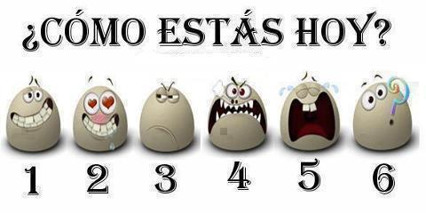

Year 7 Learning Cycle 1 Sentence Builder 2: ¿Cuántos años tienes? – How many years do you have?
Verb | Number | Noun | Connective | Phrase | Number |  | Month
Tengo = I have | uno = 1  dos = 2  tres = 3  cuatro = 4  cinco = 5  seis = 6  siete = 7  ocho = 8  nueve = 9  diez = 10  once = 11  doce = 12  trece = 13  catorce = 14  quince = 15  dieciséis = 16  diecisiete = 17  dieciocho = 18  diecinueve = 19  veinte = 20  veintiuno =21  veintidós = 22  veintitrés = 23  veinticuatro = 24  veinticinco = 25  veintiséis = 26  veintisiete = 27  veintiocho = 28  veintinueve = 29  treinta = 30  treinta y uno = 31 | años = years |   y = and | mi cumpleaños es el =  my birthday is the | uno = 1  dos = 2  tres = 3  cuatro = 4  cinco = 5  seis = 6  siete = 7  ocho = 8  nueve = 9  diez = 10  once = 11  doce = 12  trece = 13  catorce = 14  quince = 15  dieciséis = 16  diecisiete = 17  dieciocho = 18  diecinueve = 19  veinte = 20  veintiuno =21  veintidós = 22  veintitrés = 23  veinticuatro = 24  veinticinco = 25  veintiséis = 26  veintisiete = 27  veintiocho = 28  veintinueve = 29  treinta = 30  treinta y uno = 31 | de = of | enero = January  febrero = February  marzo = March  abril = April  mayo = May  junio = June  julio = July  agosto = August  septiembre = September  octubre = October  noviembre = November  diciembre = December
Year 7 Learning Cycle 1 Sentence Builder 3:
¿Cómo es tu mejor amigo? – What is your best friend like?
Adjective | Noun | Verb | Modifier | Adjective
mi = my | amigo = friend (male)  amiga = friend (female)  mejor amigo = best friend (male)  mejor amiga = best friend (female)  novio = boyfriend  novia = girlfriend  media naranja = half orange | es = (he/she/it) is | (muy) = very  (bastante) = quite   | sincer@ = sincere  tímid@ = shy  tranquil@ = calm  divertid@ = fun  gracios@ = funny  seri@ = serious  simpátic@ = kind  tont@ = silly  list@ = smart  loc@ = crazy  rar@ = weird
mis = my | amigos = friends (all male or mixed)  amigas = friends (all female) | son = (they) are |  | sincer@s -sincere  tímid@s = shy  tranquil@s = calm  divertid@s = fun  gracios@s = funny  seri@s = serious  simpátic@s = kind  tont@s = silly  list@s = smart  loc@s = crazy  rar@s = weird

Year 7 Learning Cycle 1 Sentence builder 4:
¿Cómo es tu familia? – What is your family like?
Verb | Connective | Possessive | Verb |  | Adjective | Connective
Creo=  I believe  Pienso =  I think  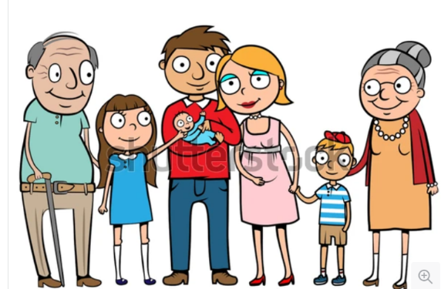 | que = that | soy = I am |  |  | alt@ = tall  baj@ = short  gord@ = fat  delgad@ = thin  guap@ = good looking  fe@ = ugly | y = and  pero = but  también = also
 | que = that | mi =my | padre = dad  madre = mum  padrastro = stepdad  madrastra = stepmother  hermano = brother  hermana = sister  hermanastro = stepbrother  hermanastra = stepsister  abuelo = grandpa  abuela = grandma  perro = dog  gato = cat  conejo = rabbit  cobayo = guinea pig  serpiente = snake  ratón = mouse | es = (he/she/it) is | alt@ = tall  baj@ = short  gord@ = fat  delgad@ = thin  guap@ = good looking  fe@ = ugly | y = and  pero = but  también = also
 | que = that | mis =my | padres = parents  hermanos = siblings  abuelos = grandparents  mascotas = pets | son = (they) are | alt@s = tall  baj@s = short  gord@s = fat  delgad@s = thin  guap@s = good looking  fe@s = ugly | y = and  pero = but  también = also
Year 7 Learning Cycle 1 Sentence builder 5: ¿De qué color son tus ojos y tu pelo? – Of what colour are your eyes and hair?
Subject | Verb | Noun | Adjective
(yo) = I | tengo = I have | el pelo = the hair | negro = black  rubio = blond  castaño = brown  pelirrojo = red  largo = long  corto = short
(yo) = I | tengo = I have | los ojos = the eyes | azules = blue  grises = grey  marrones = brown  verdes = green
(él) = he  (ella) = she  mi madre = my mum  mi padre = my dad  mi hermano = my brother  mi hermana = my sister  mi mejor amigo = my best friend  mi familia = my family | tiene = he/she/it has |   el pelo = the hair | negro = black  rubio = blond  castaño = brown  pelirrojo = red  largo = long  corto = short
 | tiene = he/she/it has | los ojos = the eyes   | azules = blue  grises = grey  marrones = brown  verdes = green
mis hermanos = my siblings  mis padres = my parents  mis amigos = my friends | tienen = they have | el pelo = the hair | negro = black  rubio = blond  castaño = brown  pelirrojo = red  largo = long  corto = short
 | tienen = they have | los ojos = the eyes | azules = blue  grises = grey  marrones = brown  verdes = green

Year 7 Learning Cycle 2 Sentence Builder 1:
¿Quién es tu profesor favorito? – Who is your favourite teacher?
Noun | Noun | Verb | Adjective | Connective | Indirect Object Pronoun | Verb
Mi profesor de  Mi profesora de  =  my teacher of | inglés = English  matemáticas = maths  ciencias = science  geografía = geography  historia = history  religión = BVC  español = Spanish  francés = French  deporte = PE  dibujo = art  música = music  teatro = drama  tecnología = technology  informática = IT | es = is |   sincer@ = sincere  tímid@ = shy  tranquil@ = calm  divertid@ = fun  gracios@ = funny  seri@ = serious  simpátic@ = kind  tont@ = silly  list@ = smart  loc@ = crazy  rar@ = weird  interesante = interesting  aburrid@ = boring  simpático = kind  antipático = unkind | y = and  pero = but | me = (to) me  te = (to) you  le = (to) him/her  nos = (to) us  os (to) you  les = (to) them | ayuda = helps  apoya = supports  grita = shouts  da miedo = scares

Year 7 Learning Cycle 2 Sentence Builder 2:
¿Qué opinas de tus clases? – What is your opinion on your lessons?
Verb | Noun | Connective | Verb | Modifier | Adjective
Me encanta… =  … is loveable to me  Me gusta… =  …is likeable to me | el inglés = English  la geografía = geography  la historia = history  la religión = BVC  el español = Spanish  el francés = French  el deporte = PE  el dibujo = art  la música = music  el teatro = drama  la tecnología = technology  la informática = IT |   porque =because | es =  it is | demasiado = too  tan = so  muy = very  bastante = quite  un poco = a bit | divertid@ = fun  interesante = interesting  fascinante = fascinating  guay = cool  práctic@ = practical  creativ@ = creative  aburrid@ = boring  tedios@ = tedious  repetitiv@ = repetitive  difícil = difficult  fácil = easy
Me encantan… =  … are loveable to me  Me gustan… =  …are likeable to me | las matemáticas = maths  las ciencias = sciences |  | son = they are |  | divertid@s = fun  interesantes = interesting  fascinantes = fascinating  guay = cool  práctic@s = practical  creativ@s = creative  aburrid@s= boring  tedios@s = tedious  repetitiv@s = repetitive  difíciles = difficult  fáciles = easy

Year 7 Learning Cycle 2 Sentence Builder 3:
¿Qué haces en tus clases? – What do you do in your lessons?
 | Noun | Auxiliary Verb | Infinitive phrase | Time marker
En mi clase de =  In my … class of | inglés = English  matemáticas = maths  ciencias = science  geografía = geography  historia = history  religión = BVC  español = Spanish  francés = French  deporte = PE  dibujo = art  música = music  teatro = drama  tecnología = technology  informática = IT | Me encanta =… is loveable to me  Me gusta = …is likeable to me | escribir =  to write  escuchar al profesor =  to listen to the teacher  tocar un instrumento =  to play an instrument  hacer experimentos =  to do experiments  estar en una obra =  to be in a play  jugar a los deportes =  to play at sports  crear algo =  to create something  hablar = to talk  usar los ordenadores =  to use the computers  ser activ@ =  to be active  trabajar en equipo =  to work in team  trabajar en silencio =  to work in silence | siempre = always  a menudo = often  a veces = sometimes  mucho = lots  poco= little
En mi clase de =  In my … class of |  | puedo = I can/am able to  debo = I must  quiero = I want  

Year 7 Learning Cycle 2 Sentence Builder 4:
¿Qué vas a estudiar en el futuro? – What are you going to study in the future?
Time Phrase | Auiliary Verb | Infintive | Noun | Connective | Verb | Adjective
en el futuro =  in the future | voy a = I am going to   | estudiar = to study  hacer = to do | inglés = English  matemáticas = maths  ciencias = science  geografía = geography  historia = history  religión = BVC  español = Spanish  francés = French  deporte = PE  dibujo = art  música = music  teatro = drama  tecnología = technology  informática = IT  biología = biology  química = chemistry  física = physics  cocina = cooking  negocios = business studies | porque | (no) es | divertid@ = fun  interesante = interesting  aburrid@ = boring  tedios@ = tedious  repetitiv@ = repetitive  exigente = demanding  difícil = difficult  fácil = easy  útil = useful  importante = important

Year 7 Learning Cycle 3 Sentence Builder 5:
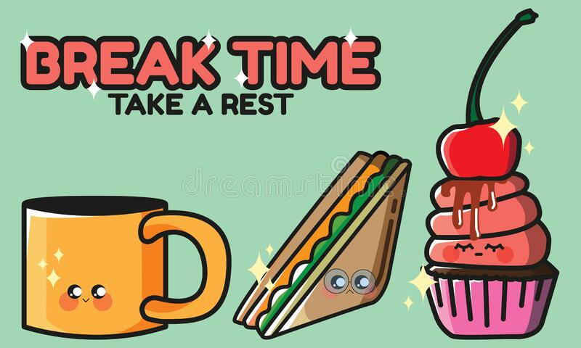
¿Qué haces durante el recreo? – What do you do during break?
Time phrase | Verb | Noun | Detail
Durante el recreo = During the break | charlo/ hablo = I chat/ I talk |  | con mis amigos = with my friends  con mi novio = with my boyfriend  con mi novia = with my girlfriend
Durante el recreo = During the break | como = I eat | comida rápida = fast food  una comida sana = a healthy meal  una bolsa de almuerzo = a packed lunch
Durante el recreo = During the break | bebo = I drink | un refresco = a fizzy drink
Durante el recreo = During the break | juego = I play | al fútbol = to the football  a los deportes = (to the) sports
Durante el recreo = During the break | hago = I do | mis deberes = my homework  ejercicio = exercise
Durante el recreo = During the break | estoy = I am (located) | en un castigo = in a detention
Durante el recreo = During the break | voy = I go | a la biblioteca = to the library  al gimnasio = to the gym
Durante el recreo = During the break | voy a charlar/hablar = I am going to chat/talk
Durante el recreo = During the break | voy a comer = I am going to eat | comida rápida = fast food  una comida sana = a healthy meal  una bolsa de almuerzo = a packed lunch
Durante el recreo = During the break | voy a beber = I am going to drink | un refresco = a fizzy drink
Durante el recreo = During the break | voy a jugar = I am going to play | al fútbol = to the football  a los deportes = (to the) sports
Durante el recreo = During the break | voy a hacer = I am going to do | mis deberes = my homework  ejercicio = exercise
Durante el recreo = During the break | voy a estar = I am going to be (located) | en un castigo = in a detention
Durante el recreo = During the break | voy a ir = I am going to go | a la biblioteca = to the library  al gimnasio = to the gym

Year 7 Learning Cycle 3 Sentence Builder 1:
¿Dónde está tu casa? – Where is your house?
Verb | Noun | Noun | Preposition | Noun
Vivo en =  I live in  Vives en =  You (s) live in  Vive en =  He/she it lives in  Vivimos en =  We live in  Vivís en =  You (pl) live in  Viven en =  They live in | una casa = a house  una granja = a farm  un piso = a flat | en Inglaterra = in England  en Escocia = in Scotland  en Gales = in Wales  en Irlanda = in Ireland  en España = in Spain  en México = in Mexico  en Argentina = in Argentina  en Costa Rica  en Cuba  en Perú  en Colombia  en Chile  en Ecuador  en los Estados Unidos =in the US | cerca de = near to  lejos de = far from  en = on/in | la playa = the beach  la costa = the coast  la montaña = the mountain  el campo = the countryside  una ciudad = a city  un pueblo = a town  un pueblito = a village
Voy a vivir en =
I am going to live in



Year 7 Learning Cycle 3 Sentence Builder 2:
¿Qué haces cuando hace buen/mal tiempo? – What do you do when its good/bad weather
Preposition | Weather idiom | Verb | Detail
cuando = when  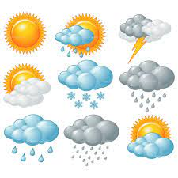  si = if | hace buen tiempo = it’s nice weather  hace mal tiempo = it’s bad weather  hace sol = it’s sunny  hace calor = it’s hot  hace frío = it’s cold  llueve = it’s raining  nieva = it’s snowy | bailo = I dance  bailamos = we dance  voy a bailar = I am going to dance  escucho música = I listen to music  escuchamos música = we listen to music  voy a escuchar música = I am going to listen to music  leo = I read  leemos = we read  voy a leer = I am going to read  juego al fútbol = I play football  jugamos al fútbol = we play football  voy a jugar al fútbol = I am going to play football  juego a los videojuegos = I play at the videogames  jugamos a los videojuegos = we play at the videogames  voy a jugar a los videojuegos = I am going to play at the videogames  hago mis deberes = I do my homework  hacemos nuestros deberes = we do our homework  voy a hacer mis deberes = I am going to do my homework  monto en bici = I ride on bike  montamos en bici = we ride on bike  voy a montar en bici = I am going to ride on bike  tomo el sol = I take the sun  tomamos el sol = we take the sun  voy a tomar el sol = I am going to take the sun | con mis amigos = with my friends  con mi familia = with my family  con mi novio =  with my boyfriend  con mi novia =  with my girlfriend

Year 7 Learning Cycle 3 Sentence Builder 3:
¿Qué haces los fines de semana – What do you do at the weekend?
Time phrase | Verb |  | Connective | Verb | Adjective
los fines de semana  = at the weekend  los sábados = the Saturdays  los domingos = the Sundays | (yo) bailo = I dance  (tú) bailas = you (singular) dance  (él/ella) baila = he/she/it dances  (nosotros) bailamos = we dance  (vosotros) bailáis = you (plural) dance  (ellos/ellas) bailan = they dance  (yo) escucho música = I listen to music  (tú) escuchas música = you (sing) listen to music  (él/ella) escucha música = he/she/it listens to music  (nosotros) escuchamos música = we listen to music  (vosotros) escucháis música = you (pl) listen to music  (ellos/ellas) escuchan música = they listen to music  (yo) leo = I read  (tú) lees = you (sing) read  (él/ella) lee = he/she/it reads  (nosotros) leemos = we read  (vosotros) leéis = you (pl) read  (ellos/ellas) leen = they read |  | porque = because | es = it is | divertid@ = fun  interesante = interesting  aburrid@ = boring  tedios@ = tedious  repetitiv@ = repetitive  difícil = difficult  fácil = easy  útil = useful  importante = important  guay = cool  
el fin de semana próximo =  next weekend  el fin de semana que viene =  next weekend | (yo) voy = I am going  (tú) vas = you (sing) are going  (él/ella) va = he/she/it is going to  (nosotros) vamos = we are going  (vosotros) vais = you (pl) are going  (ellos/ellas) van = they are going | a bailar  = to dance  a escuchar = to listen  a leer  = to read | porque = because | es = it is

Year 7 Learning Cycle 3 Sentence Builder 4:
¿Qué hay en tu zona? – What is there in your area?
Detail | Verb | Article | Noun | Connective | Verb | Infinitive
En mi región =  in my región  En mi pueblo =  In my town | hay = there is/are | un = a | parque = park  centro comercial = mall  polideportivo = sports centre  museo = museum  ayuntamiento = town hall  teatro = theatre  cine = cinema | donde = where | puedo =  I can  puedes =  You (s) can  (mi madre) puede =  (my mum) can  podemos =  we can  podéis =  you (pl) can  pueden =  they can | jugar = to play  descansar = to rest
En mi región =  in my región  En mi pueblo =  In my town | hay = there is/are | el = the
En mi región =  in my región  En mi pueblo =  In my town | hay = there is/are | una = a | piscina = swimming pool  playa = beach  biblioteca = library  plaza = town square  bolera = bowling alley | donde = where |  | jugar = to play  descansar = to rest
En mi región =  in my región  En mi pueblo =  In my town | hay = there is/are | la =the

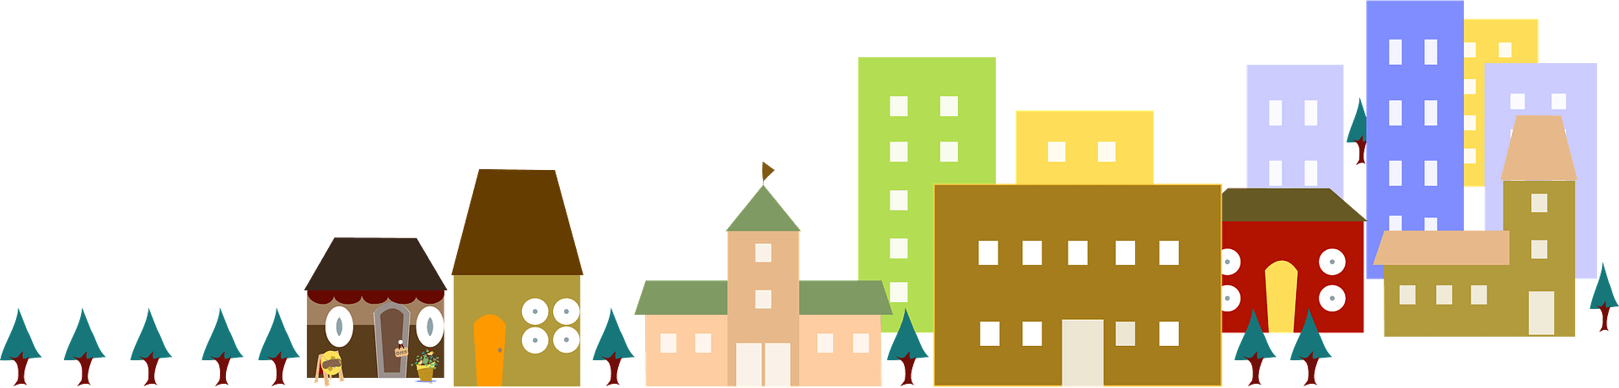

Year 7 Learning Cycle 3 Sentence Builder 5:
¿Como es tu zona? – What is your area like?
Opinion | Noun | Connective | Verb |  | Connective
me encanta = I love  me gusta = I like  no me gusta = I don’t like  odio = I hate  Vivo en = I live in  Vives en = You (s) live in  Vive en = He/she it lives in  Vivimos en = We live in  Vivís en = You (pl) live in  Viven en = They live in  Voy a vivir en =  I am going to live in  Vas a vivir en =  You are going to live in  Va a vivir en =  He/she/it is going to live in  Vamos a vivir en =  We are going to live in  Vais a vivir en =  You are going to live in  Van a vivir en =  They are going to live in | mi país =  my country  Inglaterra =  England  España =  Spain  mi región =  my región  mi pueblo =  my town  donde vivo= where I live   | porque = because | es = it is | animad@ = lively  tranquil@ = peaceful  históric@ = historical  industrial =industrial  bonit@ =pretty  fe@ = ugly | y =  and  pero =  but  sin embargo = however  también =  also
 |  | porque = because | está = it is (located) | en la playa = on the beach  en el campo = in the countryside  en la costa = on the coast  en la montaña = in the mountains
 |  | porque = because | hay = there is | mucho que hacer = lots that to do  una playa = a beach  una piscina = a swimming pool  un cine = a cinema  un parque = a park  un centro comercial = a shopping centre
 |  | porque = because | no hay = there isn’t | nada que hacer = nothing that to do
 |  | porque = because | hace = it makes | buen tiempo = good weather  mal tiempo = bad weather

Year 8 Learning Cycle 1 Sentence Builder 1:
¿En qué trabajas? – In what do you work?
Subject | Verb | Preposition | Noun | Connective | Verb | Adjective
(Yo) = I | trabajo = I work | como = as | camarer@ = waiter/waitress  canguro = babysitter  cajer@= cashier  repartidor de periódicos = paper deliverer | porque = because  pero = but | es = it is  no es = it is not | divertido =  fun  interesante = interesting  emocionante = exciting  útil =  useful  bien pagado =  well paid  mal pagado =  badly paid
(Tú) = You (sing) | trabajas = you (sing) work
(Él) = He  (Ella) = She  Mi padre = my dad  Mi madre = my mum | trabaja = he/she/it works
Nosotros = we | trabajamos = we work
Vosotros = you (pl) | trabajáis =  you (pl) work
Ellos/Ellas = they | trabajan = they work


Year 8 Learning Cycle 1 Sentence Builder 2:
¿Qué vas a ser en el futuro? – What are you going to be in the future?
Verb | Noun | Connective | Verb | Noun
Voy a ser =  I am going to be  Quisiera ser =  I would like to be | médic@ = doctor  ingenier@ = engineer  arquitect@ = architect  abogad@ = lawyer  carpinter@ = carpenter  secretari@ = secretary  mecánic@ = mechanic  músic@ = musician  enfermer@ = nurse  polític@ = politician  cociner@ = cook/chef  granjer@ = farmer  policía = police officer  cantante = singer  estrella = star  futbolista = footballer  detective = detective  florista = florist  contable = accountant  guía túristica = tour guide  azafata = air host(ess)  actor/actriz = actor/actress  profesor(a) (de…) = (…) teacher | porque =  because | me encanta = I love  me gusta = I like  me interesa = I’m interested in  se me da bien = I’m good at | el inglés = English  el español = Spanish  el francés = French  la química = chemistry  la física = physics  la biología = biology  psicología = psychology  la historia = history  la geografía = geography  la religión = RE/BVC  el derecho = law  la tecnología = technology  la informática = IT  la cocina = cookery  el deporte = sport  la educación física = PE  la música = music  el teatro = drama  el dibujo = art
 |  | porque =  because | me encantan = I love  me gustan = I like  me interesan = I’m interested in  se me dan bien = I’m good at | las matemáticas = maths  las ciencias = sciences  los idiomas = languages  los negocios = business studies

Year 8 Learning Cycle 1 Sentence Builder 3:
¿Cuáles son las ventajas y desventajas de ser profesor? What are the advantages and disadvantages of being a teacher?
Noun | Prep | Infinitive | Noun | Verb | Connective | Verb | Noun | Adjective
Una ventaja =  an advantage | de = of | ser =  to be | médic@ = doctor  ingenier@ = engineer  arquitect@ = architect  abogad@ = lawyer  carpinter@ = carpenter  secretari@ = secretary  mecánic@ = mechanic  músic@ = musician  enfermer@ = nurse  polític@ = politician  cociner@ = cook/chef  granjer@ = farmer  policía = police officer  cantante = singer  estrella = star  futbolista = footballer  detective = detective  florista = florist  actor/actriz = actor/actress  profesor = teacher | es = is | que = that   | es = is | un trabajo =  a job | artístico =  artisitic  emocionante = exciting  exigente = demanding  importante =  important  fácil =  easy  difícil =  difficult  duro =  hard  variado =  varied  repetitivo =  repetitive  responsable =  responsable  útil =  useful  cómodo =  comfy/convenient  bien pagado =  well paid  mal pagado =  badly paid
Una desventaja =
a disadvantage

Year 8 Learning Cycle 1 Sentence Builder 4:
¿Qué debes hacer para ser policía? = What do you need to do to be a policeman?
Connective | Verb | Noun | Auxiliary verb | Verb | Quantifier
Para =  (in order) to   | ser = to be | médic@ = doctor  ingenier@ = engineer  arquitect@ = architect  abogad@ = lawyer  carpinter@ = carpenter  secretari@ = secretary  mecánic@ = mechanic  músic@ = musician  enfermer@ = nurse  polític@ = politician  cociner@ = cook/chef  granjer@ = farmer  policía = police officer  cantante = singer  estrella = star  futbolista = footballer  detective = detective  florista = florist  contable = accountant  guía túristica = tour guide  azafata = air host(ess)  actor/actriz = actor/actress  profesor(a) = (…) teacher | necesito = I need  necesitas = you (s) need  necesita = he/she/it needs  necesitamos = we need  necesitáis = you (pl) need  necesitan = they need  voy a necesitar = I am going to need  vas a necesitar = you (s) are going to need  va a necesitar he/she/it is going to need  vamos a necesitar = we are going to need  vais a necesitar = you (pl) are going to need  van a necesitar = they are going to need  debo = I must/have to  debes = you(s) must/have to  debe = he/she/it must/have to  debemos = we must/have to  debéis = you (pl) must/have to  deben = they must/have to  voy a deber = I am going to have to  vas a deber = you (s) are going to have to  va a deber = he/she/it is going to have to  vamos a deber = we are going to have to  vais a deber = you (pl) are going to have to  van a deber = they are going to have to | estudiar =  to study  trabajar =  to work  repasar =  to revise  construir =  to construct  escribir =  to write  reparar =  to repair  curar =  to heal  hablar =  to talk  cocinar =  to cook  practicar =  to practice  diseñar =  to design  pensar =  to think  saber = to know | mucho = a lot  poco= not at all

Year 8 Learning Cycle 1 Sentence Builder 5:
¿Qué es el trabajo ideal para ti? – What is the ideal job for you?
Verb | Noun | Verb | Adjective | Prep | Pronoun | Connective | Auxiliary Verb | Verb | Adverb
Ser = to be | médic@ = doctor  ingenier@ = engineer  arquitect@ = architect  abogad@ = lawyer  carpinter@ = carpenter  secretari@ = secretary  mecánic@ = mechanic  músic@ = musician  enfermer@ = nurse  polític@ = politician  cociner@ = cook/chef  granjer@ = farmer  policía = police officer  cantante = singer  estrella = star  futbolista = footballer  detective = detective  florista = florist  contable = accountant  guía túristica = tour guide  azafata = air host(ess)  actor/actriz = actor/actress  profesor(a) = (…) teacher | es = is | ideal =  ideal  perfecto = perfect | para = for | mí = me  tí= you  él = him  ella = her  nosotros = us  vosotros = you  ellos/ellas = them | porque = because | puedo =  I can  puedes =  you (s) can  puede =  he/she/it can  podemos =  we can  podéis =  you (pl) can  pueden =  they can   | reparar =  to repair  trabajar =  to work  cuidar =  to care for  construir =  to construct  escribir =  to write  cultivar =  to grow  entretenar =  to entertain  curar =  to heal  hablar =  to talk  cocinar =  to cook  practicar =  to practice  diseñar =  to design  pensar =  to think  saber =  to know | bien = well  mal = badly  facilmente = easily  rapidamente = quickly  perfectamente = perfectly

Year 8 Learning Cycle 2 Sentence Builder 1:

¿Por qué lees? – Why do you read?
Pronoun | Verb | Noun | Time phrase | Connective | Verb
(Yo) = I | leo =  I read | novelas = novels  biografías = biographies  revistas = magazines  periódicos = newspapers  blogs = blogs  libros de… = the books of… | todos los días =every (the) day  cada día = each day  dos veces a la semana =  two times a week  tres veces al mes =  three times a month  a menudo = often  a veces = at times (sometimes)  de vez en cuando =  now and again  casi nunca = almost never  nunca = never | y = and  también = also  pero = but  sin embargo = however  porque = because  ya que = since  dado que = given that | me encantan =  I love them  me gustan =  I like them  me inspiran =  they inspire me  me interesan =  they interest me  me fascinan =  they fascinate me  me preocupan =  they worry me  me aburren =  the bore me  me fastidian =  they irritate me  me obligan =  they make me
(Tú) = You (sing) | lees =  you (s) read
(Él) = He  (Ella) = She  Mi padre = my dad  Mi madre = my mum | lee =  he/she/it reads
Nosotros = we | leemos =  we read
Vosotros = you (pl) | leéis =  you (pl) read
Ellos/Ellas = they | leen =  they read

Year 8 Learning Cycle 2 Sentence Builder 2:

¿Qué música escuchaste recientemente? – What music did you listen to recently?
Time phrase | Verb | Noun | Connective | Noun | Verb | Qualifier | Adjective
Ayer =  Yesterday  Anoche =  Last night  Recientemente = Recently | escuché =  I listened  escuchaste =  you (s) listened  escuchó =  he/she/it listened  escuchamos =  we listened  escuchastéis =  you (pl) listened  eschucharon =  they listened | pop  rock  rap  RnB  música clásica = classical music  música latina =  latin music  la música de … =  the music of …  de todo =  everything | porque = because | el ritmo =  the rhythm  la letra =  the lyrics  la melodía =  the tune | es =  (he/she/it) is | muy =  very  bastante =  quite  más =  more  menos =  less | buen@ =  good  mal@ =  bad  guay/chul@ = cool  interesante = interesting  gracios@ =  funny  aburrid@ =  boring  repetitiv@ =repetitive  fatal =  terrible  triste =  sad  alegre =  happy  deprimente = depressing  entretenid@ = entertaining  informativ@ = informative

Year 8 Learning Cycle 2 Sentence Builder 3:
¿Qué viste en la tele anoche? = What did you watch on TV last night?
Time Phrase | Verb | Noun | Verb | Quantifier | Adjective | Con. | Noun
Ayer =  Yesterday  Anoche =  Last night | vi = I watched | los programas de música = music shows  los programas de deportes = sports shows  los realities =  reality TV shows  los concursos = gameshows  los documentales = documentaries  las comedias =  comedies  las series policiacas =  cop shows  las telenovelas =  soap operas  las noticias =  the news | son = (they) are | más = more  menos = less | interesantes =  interesting  informativ@s =  informative  entretenid@s =  entertaining  divertid@s =  fun  gracios@s =  funny  aburrid@s =  boring  rar@s =  weird  emocionantes =  exciting  deprimentes =  depressing | que = than | los programas de música  los programas de deportes  los realitys  los concursos  los documentales  las comedias  las series policiacas  las telenovelas  las noticias
Normalmente=  Normally | veo= I watch

Year 8 Learning Cycle 2 Sentence Builder 4:
¿Te gusto Voces Inocentes? = Did you like Innocent Voices?
Time Phrase |  | Opinion | Verb | Adjective | Noun | Verb | Noun
Ayer =  yesterday  Hace dos días =  two days ago  La semana pasada = last week | vi <<Voces Inocentes>> con mi clase de español  =  I watched “Innocent Voices” with my class of Spanish | para mí = for me  creo que =  I think that | fue = it was | emotivo =  emotional  deprimente = depressing  interesante =  interesting  educativo = educational  aburrido =  boring  raro =  weird  alegre =  happy  triste =  sad  histórico =  historical | lo mejor =  the best thing  lo peor =  the worst thing | fue = was | el argumento = the plot  el ambiente = the atmosphere  los actores = the actors  la banda sonora = the soundtrack  los personajes = the characters  el protagonista = the main character  los efectos especiales = the special effects  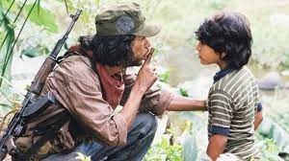

Year 8 Learning Cycle 2 Sentence Builder 5:
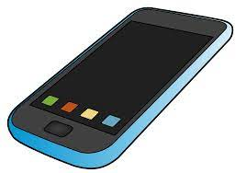
¿Cuándo usas la tecnología? – When do you use technology?
Time Phrase | Verb | Noun | Prep
todos los días =  every day  cada día = each day  dos veces a la semana =  two times a week  tres veces al mes =  three times a month  a menudo = often  a veces = sometimes  de vez en cuando =  now and again  casi nunca = almost never  nunca = never  normalmente = normally  ayer = yesterday | Uso = I use  Usas = you (s) use  Usa = he/she/it uses  Usamos = we use  Usáis =you (pl) use  Usan = they use | mi móvil = my mobile  mi ordenador = my computer | para = (in order) to | sacar fotos =  to take photos  hablar por Skype =  to talk on Skype  mandar SMS =  to send texts  jugar = to play  leer = to read  descargar melodías =  download ringtones  chatear =  to chat (online)  compartir vídeos =  to share videos  ver películas =  to watch films  estudiar =  to study  escuchar música =  to listen to music  organizar las salidas =  to organise going out  hacer compras =  to do shopping
 |  | tu móvil = your (s) phone  tu ordenador = your (s) computer | para = (in order) to
 |  | su móvil = his/her phone  su ordenador = his/her computer | para = (in order) to
 | Usé = I used  Usaste = You (s) used  Usó = he/she/it used  Usamos = we used  Usásteis = you (pl) used  Usaron = they used | nuestros móviles = our phones  nuestros ordenadores = our computers | para = (in order) to
 |  | vuestros móviles = your (pl) phones  vuestros ordenadores = your (pl) computers | para = (in order) to
 |  | sus móviles = their phones  sus ordenadores = their computers | para = (in order) to

Year 8 Learning Cycle 3 Sentence Builder 1: ordering food in a café
¿Cuánto cuesta una pizza por favor? – How much does a pizza cost please?
Verb | Article | Noun | Manners | Question | Answer | Manners
quisiera = I would like  tomo= I take | un = a  el = the | bocadillo de queso = cheese sandwich  bocadillo de jamón = ham sandwich  refresco = fizzy drink  zumo de naranja = orange juice  zumo de manzana = apple juice  plátano = banana  pastel = cake  helado de chocolate = chocolate icecream  helado de fresa = strawberry icecream | por favor = please | ¿Cuánto cuesta?  =  How much is it? | Cuesta…euros  =  it costs … euros | gracias = thank you
quisiera = I would like  tomo= I take | una = a  la = the | hamburguesa = hamburger  pizza = pizza  ensalada = salad  sopa de tomate = tomato soup  paella = paella
quisiera = I would like  tomo= I take | unos = some  los = the | caramelos = sweets | por favor = please | ¿Cuánto cuestan?  =  How much are they? | Cuestan… euros =  they cost … euros | gracias = thank you
quisiera = I would like  tomo= I take | unas = some  las = the | patatas fritas = chips  tapas = tapas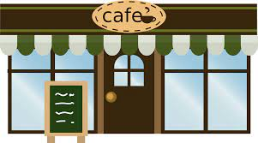
Year 8 Learning Cycle 3 Sentence Builder 2: Describing Healthy and Unhealthy Diets
¿Por qué comes este? – Why do you eat this?
Time Phrase | Verb | Demonstrative | Noun | Con | Verb | Adjective
Normalmente  = normally | como = I eat  bebo = I drink  evito = I avoid | este/esta/estos/estas  = this (thing/stuff)  ese/esa/esos/esas  = that (thing/stuff) | fruta = fruit  verdura = veg  pescado = fish  carne = meat  hidratos de carbono = carbs  agua = water  carne roja = red meat  comida basura = junk food  comida rápida = fast food  postres = puddings  patatas fritas = chips  refrescos = fizzy drinks  caramelos = sweets  grasa = fat  azúcar =sugar  sal = salt  vitaminas = vitamins | porque = because | (no) es=  it is(n’t)  (n) son = they are(n’t) | san@ =  healthy  malsan@ = unhealthy  delicio@ =  delicious  sabros@ =  tasty
Ayer =  yesterday | comí = I ate  bebí = I drank  evité = I avoided
En el futuro =  In the future | voy a comer =  I am going to eat  voy a beber =  I am going to drink  voy a evitar =  I am going to avoid

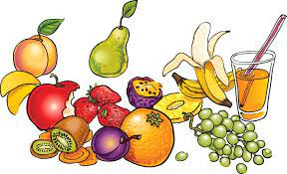
Year 8 Learning Cycle 3 Sentence Builder 3:
¿Con qué frecuencia lo comes? – How often do you eat it?
Direct Object Pronoun | Verb | Time Phrase | Connective | Indirect Object Pronoun | Verb
lo = it (masc sing)  la = it (fem sing)  los = them (masc pl)  las = them (fem pl) | como = I eat  bebo = I drink  tomo = I take  evito = I avoid  comí = I ate  bebí = I drank  tomé = I took  evité = I avoided  voy a comer =  I am going to eat  voy a beber =  I am going to drink  voy a tomar =  I am going to take  voy a evitar =  I am going to avoid | todos los días =  every day  cada día = each day  dos veces a la semana =  two times a week  tres veces al mes =  three times a month  a menudo = often  a veces = sometimes  de vez en cuando =  now and again  casi nunca = almost never  nunca = never  normalmente = normally  ayer = yesterday  en el futuro = in the future | porque = because | me = (to/for) me  te = (to/for) you (s)  le = (to/for) him  nos = (to/for) us  os= (to/for) you (pl)  les = (to/for) them | ayuda =  he/she/it  helps  daña =  he/she/it  damages


Year 8 Learning Cycle 3 Sentence Builder 4:
¿Cómo es tu rutina diaria? – What is your daily routine like?
Time Phrase | Verb | Time Phrase | Verb | Time Phrase
Todos los días  = every day  Normalmente  = normally | me despierto = I wake myself up  me levanto = I get myself up  me ducho = I shower myself  me visto = I dress myself  me lavo = I wash myself  me acuesto = I put myself to bed  desayuno = I breakfast  ceno = I dine | Antes de = Before  Después de = After | Despertarse = to wake self  Levantarse = to get self up  Ducharse = to shower self  Vestirse = to dress self  Lavarse = to wash self  Acostarse = to put self to bed  Desayunar = to breakfast  Cenar = to dine  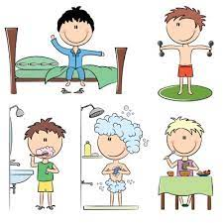 | luego = then  más tarde = later  a la una =  at one o’clock  a las dos =  a two o’clock  a las tres =  at three o’clock  a las cuatro =  at four o’clock  a las cinco =  at five o’clock  a las seis =  at six o’clock  a las siete =  at seven o’clock  a las ocho =  at eight o’clock  a las nueve =  at nine o’clock  a las diez =  at ten o’clock  a las once =  at eleven o’clock  a mediodía =  at midday  a medianoche =  at midnight
Ayer  = Yesterday | me desperté = I woke myself up  me levanté = I got myself up  me duché = I showered myself  me vestí = I got myself dressed  me lavé = I washed myself  me acosté = I put myself to bed  desayuné = I had breakfast  cené = I had dinner | Antes de = Before  Después de = After
Mañana  = Tomorrow  En el futuro  = In the future | voy a despertarme = I am going to wake myself up  voy a levantarme = I am going to get myself up  voy a ducharme = I am going to shower myself  voy a vestirme = I am going to dress myself  voy a lavarme = I am going to wash myself  voy a acostarme = I am going to put myself to bed  voy a desayunar = I am going to breakfast  voy a cenar = I am going to dine | Antes de = Before  Después de = After
Year 8 Learning Cycle 3 Sentence Builder 5:
¿Cuáles deportes haces? – What sports do you do?
Time Phrase | Verb | Noun | Location | People
todos los días =  every day  cada día = each day  dos veces a la semana =  two times a week  tres veces al mes =  three times a month  a menudo = often  a veces = sometimes  de vez en cuando =  now and again  casi nunca = almost never  nunca = never  normalmente = normally  ayer = yesterday  mañana = tomorrow  en el futuro =  in the future | juego = I play  jugué = I played  voy a jugar =  I am going to play | al fútbol = at football  al tenis = at tennis  al golf = at golf  al béisbol = at baseball  al baloncesto = at basketball  al rugby = at rugby  al críquet = at cricket  al voleibol = at volleyball | en el instituto =  in the school  en el parque =  in the park  en la playa =  on the beach  en la piscina =  in the swimming pool  en la pista de patinaje =  in the skatepark  en el polideportivo =  in the sports centre   | con mis amigos =  with my friends  con mi equipo =  with my team  con mi escuela =  with my school  con mi familia =  with my family
 | hago = I do  hice = I did  voy a hacer =  I am going to do | deporte = sport  natación = swimming  equitación = horseriding  surf = surfing  ciclismo = cycling  esquí = skiing  escalada = climbing  senderismo = hiking  atletismo = athletics  boxeo = boxing  buceo = diving  remo = rowing  skate = skateboarding  patinaje (sobre hielo)  = (ice) skating  artes marciales =  martial arts

Year 9 Learning Cycle 1 Sentence Builder 1:
¿Cómo es tu familia? – What are your family like?
(Yo)  Mi madre = my mother  Mi padre = my father  Mi madrastra = my step mother  Mi padrastro = my stepfather  Mi hermana mayor = my older sister  Mi hermana menor = my younger sister  Mi hermano mayor = my older brother  Mi hermano menor = my younger brother  Mi hermanastra = my stepsister  Mi hermanastro = my stepbrother  Mi prim@ = my cousin  Mi tía = my aunt  Mi tío = my uncle  Mi abuelo = my grandfather  Mi abuela = my grandmother  Mi bisabuelo = my great grandfather  Mi bisabuela = my great grandmother  Mi mejor amig@ = my best friend  Mi novio = my boyfriend  Mi novia = my girlfriend  Mi media naranja = my soulmate | tengo = I have  tuve = I had  voy a tener = I am going to have  tiene = (he/she/it) has  tuvo = (he/she/it) had  va a tener = (he/she/it) is going to have | el pelo = (the) hair | rubio = blond  castaño = light brown  corto = short  largo =long  ondulado = wavy  rizado = curly  liso = straight | y = and  también = also  además = furthermore  pero = but  sin embargo =  however  al contrario =  on the contrary  por otro lado =  on the other hand  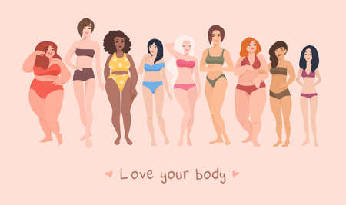
 |  | los ojos = (the) eyes | marrones = brown  azules = blue  verdes = green  grises = grey
la piel blanca/morena = fair/dark skin
gafas = glasses
pecas = freckles
los aparatos = braces
barba = a beard
bigote = a moustache
una tableta de chocolate = a six pack
 | soy = I am  fui = I was  voy a ser = I am going to be  es = (he/she) is  fue = (he/she) was  va a ser = es = (he/she) is going to be | demasiado = too  tan = so  muy = very  bastante = quite  un poco = a bit | alt@ = tall  baj@ = short  gord@ = fat  delgad@ = thin  flac@ = skinny  guap@ = hot  hermos@ = beautiful  lind@ = cute  bonit@ = pretty  fe@ = ugly  pelirroj@ = redhaired  calvo = bald
Year 9 Learning Cycle 1 Sentence Builder 2:
¿Por qué te llevas bien con él/ella? – Why do you get on well with him/her?
Me llevo bien con… = I get on well with…  Me llevo superbién con… = I get on really well with…  Me peleo con… = I fight with…  Me divierto con… = I have fun with…  … y yo, nos llevamos como el perro y el gato = …  and I, we fight like cats and dogs  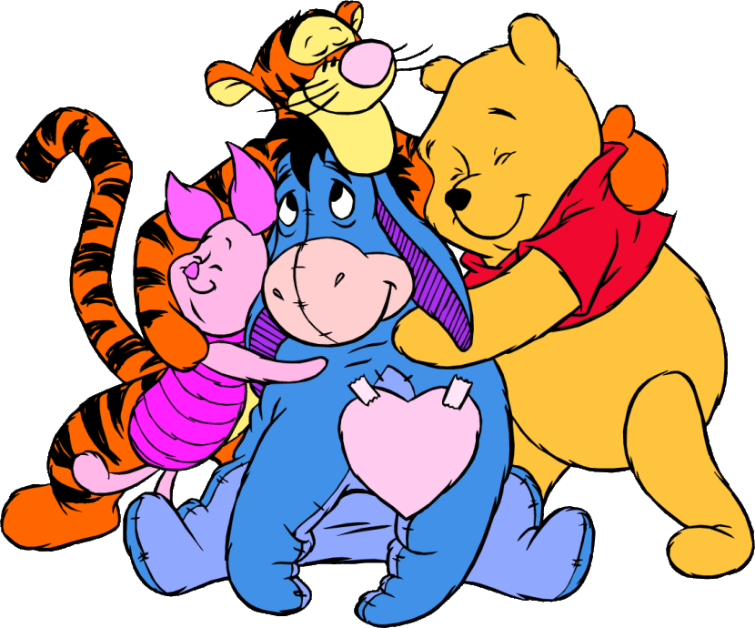 | porque = because | es = he/she is | demasiado= too  tan= so  muy= very  bastante= quite  un poco = a bit | optimista/ pesimista = optimistic/pessimistic  simpátic@/ antipátic@ = kind/unkind  trabajador(a)/ perezos@ = hardworking/lazy  generos@/tacañ@ = generous/mean hablador(a)/callad@ = chatty/quiet  gracioso@/ seri@ = funny/serious  fiel/ infiel = loyal/disloyal  feliz/ triste = happy/ sad  ordenad@/caótic@ = organised/ chaotic  énergic@/ tranquil@ = energetic/ calm  animad@ = lively  atent@/ egoista = thoughtful/ selfish  comprensiv@ = understanding  molest@ = annoying  ambicios@ = ambitious
 | porque = because | siempre = always  nunca = never | me apoya = (he/she/it) support me  me ayuda = (he/she/it) helps me  me escucha = (he/she/it) listens to me  me critica = (he/she/it) criticises me  me acepta como soy = (he/she/it) accepts me as I am  me da consejos = (he/she/it) gives me advice  me hace reír/ llorar = (he/she/it) makes me laugh/ cry  me juzga = (he/she/it) judges me
 | porque = because | tenemos mucho en común = we have lots in common
un buen amig@ es alguien quien =  a good friend is someone who |  | te apoya = supports you  te ayuda = helps you  te escucha = listens to you  no te critica = doesn’t criticise you  te conoce bien = knows you well  no te juzga = doesn’t judge you
Year 9 Learning Cycle 1 Sentence Builder 3:
¿Cómo conociste a tu mejor amigo? – How did you meet your best friend?
Conocí a mi mejor amig@  = I met my best friend | el año pasado  = last year  el verano pasado  = last summer  hace dos años  =two years ago  hace mucho tiempo  =a long time ago  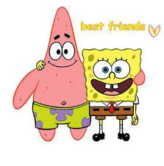 | en la playa  = on the beach  en el parque  = in the park  en el gimnasio  = in the gym  en mi equipo de…  = in my team of…  en mi escuela primaria  = in my primary school  en mi clase de…  = in my class of…  en línea  = online  en un viaje escolar  = on a school trip  de vacaciones  = on holidays  su madre es amiga de mi madre  = his/her mum is friend of my mum | donde = where | jugamos al fútbol.  = we played football  jugamos al voleibol.  = we played volleyball  montamos en bici.  = we rode on bikes  vimos una comedia.  = we saw a comedy  hicimos ejercicio.  = we did exercise  perdimos cada partido.  = we lost every game  fuimos a España.  = we went to Spain  nos comportamos mal  = we behaved badly  nos comportamos bien  = we behaved well  chateamos  = we chatted (online)  compartimos vídeos  = we shared videos  aprendimos mucho  = we learnt a lot  no aprendimos nada  =we didn’t learn nothing  tomamos el sol  = we sunbathed  comimos juntos = we ate together | luego =  then  más tarde =  later | nos hicimos amigos = we became friends  nos hicimos novios = we became boyfriend and girlfriend  convivimos  = we lived together  nos casamos  = we got married  viajamos juntos  = we travelled together  fuimos a la universidad juntos  =we went to the university together
 |  |  |  |  | ahora = now  hoy en día = nowadays  actualmente =  at the moment | es el amor de mi vida = he/she is the love of my life  tenemos… en común = we have … in common  nos gustan las mismas cosas  = we like the same things
Year 9 Learning Cycle 1 Sentence Builder 4:
¿Cómo vas a celebrar tu próximo cumpleaños?
El año que viene = next year  El año próximo = next year  En el futuro = in the future  Cuando termine el instituto = when school finishes | para = for | Nochebuena = Christmas eve  el día de Navidad = Christmas day  Semana Santa = Easter week  Pascua = Easter (also Passover)  mi cumpleaños = my birthday  el cumpleaños de… =  the birthday of…  mi quinceañera = my 15th birthday (girls only)  el baile de fin de curso = the prom  Nochevieja = New Year’s Eve  carnaval = carnival | voy a = I am going to  mi familia y yo vamos a = my family and I are going to  mis amigos y yo vamos a = my friends and I are going to  mi novio y yo vamos a = my boyfriend and I are going to  mi novia y yo vamos a = my girlfriend and I are going to | dar regalos =  to give presents  recibir regalos  = to receive presents  abrir regalos  = to open presents  cantar villancicos  = to sing carols  cenar pavo  = to have turkey for dinner  comer pudin  = to eat pudding  despertarme/nos temprano  = to get up early  acostarme/nos tarde  = to go to bed late  buscar huevos de chocolate  = to look for chocolate eggs  ir a la iglesia  = to go to the church  ir a la mezquita  = to go to the mosque  ir a la misa  = to go to the mass  comer doce uvas  = to eat 12 grapes  llevar disfraces  = to wear fancy dress  bailar = to dance
Lo bueno de = the good thing about  Lo malo de = the bad thing about  Lo mejor de = the best thing about  Lo peor de = the worst thing about  Lo que más me gusta de = the thing I like the most about  Lo que menos me gusta de = the thing I like the least about |  |  | es = is  

Year 9 Learning Cycle 2 Sentence Builder 1:
¿Adónde fuiste de vacaciones el año pasado?
Normalmente = Normally | voy de vacaciones =  I go on holiday | a Gales = to Wales  a Escocia = to Scotland  a Francia = to France  a España = to Spain  a Londres = to London  a los Estados Unidos = to the USA  en una caravana = in a caravan | vamos = we go  viajamos = we travel | en coche = by car  en autocar = by coach  en tren = by train  en barco = by boat  en avión = by plane
Normalmente = Normally | visito = I visit | mis abuelos = my grandparents  los amigos de mis padres =  the friends of my parents | vamos = we go  viajamos = we travel
Normalmente = Normally | me quedo en casa = I stay at home  nos quedamos en casa = we stay at home |  | vamos = we go  viajamos = we travel
El verano pasado =  Last summer  El año pasado =  Last year  Hace dos años =  Two years ago  Cuando era joven =  When I was young | fui = I went  fuimos = we went  viajé = I travelled  viajamos = we travelled | a México = to Mexico  a Cuba = to Cuba  a Chile = to Chile  a los Estados Unidos = to the USA   | donde = where | visité un castillo =  I visited a castle  hice turismo =  I did sightseeing  compré recuerdos =  I bought souvenirs  tomé el sol =  I took the sun (sunbathed)  nadé en el mar =  I swam in the sea  descansé = I relaxed  comí muchos helados =  I ate lots of icecream  saqué fotos = I took photos  aprendí a bailar flamenco =  I learnt to dance flamenco  di un paseo por… =  I gave a wander through…
Year 9 Learning Cycle 2 Sentence Builder 2:
¿Qué haces de vacaciones? – What do you do on holiday?
Cuando = when  Si = if | hace buen tiempo = it’s good weather  hace mal tiempo = it’s bad weather  hace calor = it’s hot  hace frio = its cold  hace sol = it’s sunny  hace viento = it’s windy  hay tormenta = there’s storms  hay niebla = there’s fog  llueve = it rains  nieva = it snows | adoro = I adore  me encanta = I love  me chifla = I love  me mola = I love  me apasiona = I love  me gusta mucho = I really like  me gusta = I like  prefiero = I prefer  no me gusta = I don’t like  odio = I hate  detesto = I detest  no soporto = I can’t stand  no aguanto = I can’t stand | visitar un museo = to visit a museum  hacer esquí = to do skiing  hacer windsurf = to do windsurfing  cocinar = to cook  chatear en la red = to chat online  hacer una barbacoa = to do a bbq  montar a caballo = to ride a horse  montar en bici = to ride a bike  nadar en el mar = to swim in the sea  tocar la guitarra = to touch the guitar  ir al parque acuático/temático =  to go to the water/theme park  ir de paseo = to go of walk  tomar el sol = to take the sun  hacer turismo = to do sightseeing  disfrutar de… = to enjoy
Cuando = when  Si = if |  | voy a = I am going  espero = I hope  quisiera = I would like
Cuando = when  Si = if | hizo buen tiempo = it was good weather  hizo mal tiempo = it was bad weather  hizo calor = it was hot  hizo frio = it was cold  hizo sol = it was sunny  hizo viento = it was windy  hubo tormenta = there were storms  hubo niebla = there was fog  llovió = it rained  nevó = it snowed | visité un museo = I visited a museum  hice windsurf =I did windsurfing  cociné = I cooked  hice una barbacoa = I did a bbq  monté a caballo = I rode a horse  monté en bici = I rode a bike  nadé en el mar = I swam in the sea  toque la guitarra = I touched the guitar  fui al parque acuático/temático =  I went to the water/theme park  fui de paseo = I went of walk  tomé el sol = I took the sun  hice turismo = I did sightseeing  disfruté de… = I enjoyed |  | pero = but  sin embargo = however  al contrario = on the contrary  por otro lado = on the other hand  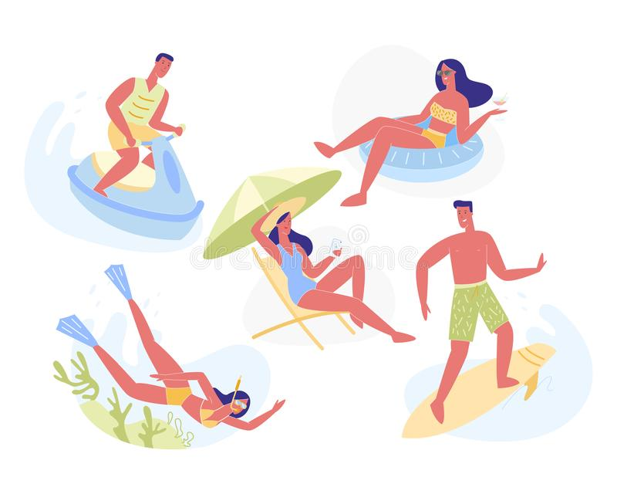
Year 9 Learning Cycle 2 Sentence Builder 3:
¿Qué te pasó durante las vacaciones? – What happened to you in the holidays?
lo malo = the bad bit  lo peor = the worst bit  lo que menos me gustó =  the bit I liked the least  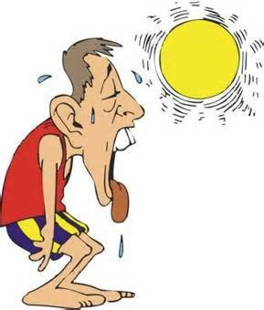 | fue cuando = was when | tuve =  I had  tuvimos =  we had | un accidente = an accident  un pinchazo = a puncture  un retraso = a delay  una avería = a breakdown
 | fue cuando = was when | tuve que =  I had to  tuvimos que = we had to | ir al hospital = to go to the hospital  ir a la comisaría =  to go to the police station  esperar mucho tiempo = to wait lots of time  volver =to return
 | fue cuando = was when | perdí =  I lost  perdimos =  we lost | el equipaje = the luggage  la cartera = the wallet  la maleta = the suitcase  las llaves = the keys
 | fue que = was that | el ascensor = the lift  la ducha =the shower  el aire acondicionado = the AC  la luz = the light |  |  | no funcionó = didn’t work
 | fue que = was that | hubo ratas en la cama = there were rats in the bed
 | fue que = was that | la habitación fue = the room was |  |  | sucia = dirty  asquerosa = disgusting
 | fue que = was that | la piscina fue = the pool was  el gimnasio fue = the gym was  el restaurante fue = the restaurant was |  |  |  | cerrad@ = closed
pues = so  por lo tanto = therefore | decidí = I decided  decidimos = we decided |  |  | cambiar.. = to change…  ir a otro… = to go to another…  [infinitive]

Year 9 Learning Cycle 2 Sentence Builder 4:

¿Quieres tomar un año sabático? – Do you want to take a gap year?
En el futuro =  In the future  Antes de trabajar =  Before working  Antes de la universidad =  Before the university  Después de estudiar =  After studying  Después del colegio =  After the school  Para un año sabático =  For a gap year | voy a = I am going  quiero = I want  quisiera = I’d like  espero = I hope | ir a … = go to …  viajar = to travel  viajar como mochilero = to travel as a backpacker  viajar alrededor del mundo = to travel around the world  visitar Latinoamérica = to visit Latin America  hacer un viaje por interrail por Europa = to do an Interrail in Europe  aprender a esquiar = to learn to ski  aprender a hacer vela = to learn to do sailing  aprender a tocar la guitarra = to learn to play the guitar  enseñar inglés = to teach English  mejorar mi español = to improve my Spanish  ganar dinero = to earn money  ayudar un proyecto medioambiental = to support an environmental project  ayudar a construir un colegio = to help to build a school  ayudar a salvar las tortugas = to save the turtles  trabajar = to work  trabajar en un orfanato = to work in an orphanage  trabajar como voluntari@ = to work as a volunteer  hacer algo diferente = to do something different | porque parece = because it looks

Year 9 Learning Cycle 3 Sentence Builder 1: Daily Routine
¿Cómo es tu rutina diaria? = What is your daily routine like?
Normalmente  =  Normally  Durante la semana =  During the week | me despierto = I wake up  me levanto = I get up  me cepillo los dientes =  I brush my teeth  me ducho = I shower  me baño = I bathe  me lavo = I wash  desayuno = I have breakfast  vuelvo a casa =I return home  salgo con amigos =  I go out with friends  ceno = I have dinner  me acuesto = I go to bed | temprano = early  tarde = late |  |  | y voy al colegio  =  and I go to school |  | en coche = by car  en autocar = by coach  en bus = by bus  en taxi = by taxi  en bici = by bike  en ciclomotor = by moped  en metro = by underground  en tren = by train
 |  | a la una = at 1  a las dos = at 2  a las tres = at 3  a las cuatro = at 4  a las cinco = at 5  a las seis = at 6  a las siete = at 7  a las ocho = at 8  a las nueve = at 9  a las diez = at 10  a las once = at 11  a las doce = at 12 | y media  = and a half  y cuarto  = and a quarter  menos cuarto  = less a quarter
El sábado pasado  =  Last Saturday  El domingo pasado  =  Last Sunday | me desperté = I woke up  me levanté = I got up  me cepillé los dientes =  I brushed my teeth  me duché = I showered  me bañé = I bathed  me lavé = I washed  desayuné = I had breakfast  volví a casa =  I returned home  salí con amigos =  I went out with friends  cené = I had dinner  me acosté = I went to bed | más temprano =  more early  menos temprano =  less early  más tarde = more late  menos tarde = less late  tan temprano como normal =  as early as normal  tan tarde como normal =  as late as normal |  | y fui = and I went  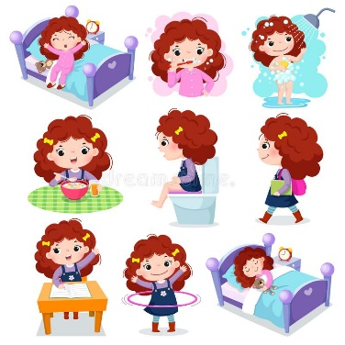 |  | al =  to the |  | centro commercial =  shopping centre  centro = town centre  estadio = stadium  polideportivo =  sports centre  teatro = theatre
 |  |  |  |  |  | a la = to the |  | pista de hielo =  ice rink  discoteca = disco
 |  |  |  |  |  | de |  | paseo = for a walk  compras = for a shop
Year 9 Learning Cycle 3 Sentence Builder 2: Best and worst of school life
Qué es lo que te más te gusta de tu insti? – What is it you like most about your school?
Lo mejor de mi insti  =  The best bit of my school  Lo bueno de mi insti  =  The good bit of my school  Lo peor de mi insti =  The worst bit of my school  Lo malo de mi insti =  The bad bit of my school | es = is | mi asignatura favorita =  my favourite lesson  mi clase menos favorita =  my least favourite lesson  mi clase de… = my … lessons  School subjects- see Y7 learning cycle 2 to revise   | porque  =  because  ya que  =  since  puesto que =  since  dado que  =  given that | es | útil = useful inútil = useless  fácil = easy difícil = difficult  práctic@ = practical creativ@ = creative  exigente = demanding relajante = relaxing
 |  |  |  | mi profesor  / mi profesora  =  my teacher |  | es paciente = is patient  es list@ = is smart  es perezos@ = is lazy  enseña bien = teaches well  explica bien = explains well  tiene buen sentido de humor =  has a good sense of humour  crea un buen ambiente de trabajo =  créate a good working atmosphere  me hace pensar = makes me think  nunca se enfada = never gets angry  grita mucho = shouts a lot  me da consejos = gives me advice  nos pone muchos deberes =  gives us lots of homework
 | es = is | las instalaciones de…  =  the …facilities |  | es  son = they are |  |  |  |  | anticuad@(s) = old fashioned  viej@(s) = old  nuev@(s) = new  de punta = latest (best)
 | es = is | el club de ajedrez = chess club  el club de futbol = football  el club de escritura = writing club  el club de japonés = Japanese club |  | te ayuda a =  it helps you |  |  | olvidar la presión=forget the pressure  hacer amigos = make friends
 |  |  |  | te da =  it gives you |  |  | más talentos = more talents  más confianza = more confidence
 | es = is | el acoso = the bullying  la presión = the pressure  el comportamiento = the behaviour |  | afecta a =  it affects |  |  |  | todo el mundo = everyone  mis amigos = my friends
Year 9 Learning Cycle 3 Sentence Builder 3: School rules
¿Qué opinas de las reglas escolares aquí y en España? – What do you think of the school rules here and in Spain?
En las escuelas en Inglaterra  =  In the schools in England  En las escuelas en España  =  In the schools in Spain  Aquí = here  Allá = there   | no se debe =  you mustn’t  no se permite =  you aren’t allowed  está prohibido =  it’s forbidden |  | comer chicle = to eat gum  usar el móvil en clase =  use the phone in lessons  dañar las instalaciones =  damage the facilities  ser agresivo o grosero =  be agressive or rude  correr en los edificios =  run in the buildings |  |  | las normas son necearias  = the rules are necessary  las normas son demasiado severas  = the rules are too strict  las normas fomentan la disciplina  = the rules encourage behaviour  las normas limitan el derecho de expresarte  = the rules limit the right to express yourself  las normas fastidian los alumnos  = the rules irritate the students  las normas resultan en notas buenas  = the rules bring about good grades  las normas resultan en notas malas  = the rules bring about bad grades
 | hay que =  you have to  es obligatorio =  it is compulsory |  | respetar a los demás =  respect others  ser punctual = be on time  respetar en turno de palabra =  wait for your turn to speak  mantener limpio el patio =  keep the playground clean
 | llevo = I wear  llevamos = we wear  llevan = they wear  tengo que llevar = I have to wear  tenemos que llevar = we have to wear  tienen que llevar = they have to wear |  |  | uniforme escolar = school uniform  ropa de calle = home clothes  una chaqueta = a blazer  una corbata = a tie  un vestido = a dress una falda = a skirt  una camisa = a shirt  pantalones = trousers vaqueros = jeans  zapatos = shoes |  |  | a rayas = striped  a cuadros = checked  de color … = of … colour  cómod@ = comfy  incómodo = uncomfy  elegante = smart  fea = ugly
Para mí =  in my opinión  Diría que =  I would say that | el uniforme  =  the uniform | es bueno porque = is good because |  |  | mejora la disciplina = it improves the discipline  da una imagen positiva = it gives a positve impression  ahorra tiempo por la mañana = it saves time in the morning  reduce el acoso = it reduces bullying
Para mí =  in my opinión  Diría que =  I would say that | el uniforme  =  the uniform | es malo porque = is bad because |  |  | limita tu individualidad = it limits your individuality  no afecta el aprendizaje = it doesn’t affect the learning
Year 9 Learning Cycle 3 Sentence Builder 4: Importance of languages
¿Por qué es importante aprender un idoma? – Why is it important to learn a language?
Es claro que =  it’s clear that  Es obvio que =  it’s obvious that | es importante estudiar los idiomas/lenguas  =  it’s important to study languages |  | porque  =  because | aumenta tu confianza = it increases your confidence  estimula el cerebro = it stimulates the brain  mejora tus perspectivas laborales = it improves your job prospects  te abre la mente = it opens your mind  te hace más atractivo = it makes you more attractive
 |  |  | porque  =  because | te permite = it lets you |  | apreciar otros países = appreciate other countries  conocer a gente distinta = get to know different people  conocer nuevos sitios = get to know new places  encontrar un trabajo = find a job  descubrir otras culturas = discover other cultures  hacer nuevos amigos = make new friends  mejorar el inglés = improve your English  trabajar en el extranjero = work abroad  estudiar en el extranjero = study abroad  encontrar tu media naranja = meet your soulmate
En el futuro = in the future  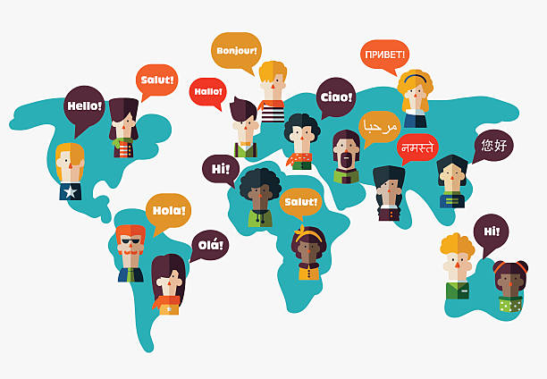 |  | quiero = I want to  voy a = I am going to |  |  | dominar = speak fluently  hablar = to speak |  | el español = Spanish  el francés = French  el alemán = German  el italiano = Italian  el árabe = Arabic  el ruso = Russian  el chino = Chinese  el coreano = Korean  el japonés = Japanese  el catalán = Catalan  el vasco = Basque  el gallego = Gallcian

High Impact Spanish Vocabulary for Key Stage 3
By The End of Year 7 | By the End of Year 8 | By the End of Year 9

Opinions
me encanta(n) = I love  me gusta(n) = I like  no me gusta(n) = I don’t like  odio = I hate  prefiero = I prefer  me da igual = it’s all the same to me | ¡Qué bien! = How great!  ¡Qué guay! = How cool!  ¡Qué suerte! = How lucky!  ¡Qué horror! = How dreadful!  ¡Qué lástima! = What a shame!  ¡Qué rollo! What a drag! | me encantaba(n) = I used to love  me gustaba(n) = I used to like  odiaba = I used to hate  lo pasé fatal = I had a terrible time  lo pasé bomba = I had a blast  tengo muchas ganas = I’m looking forward to it
Adjectives
grande = big  pequeñ@ = small  gord@ = fat  delgad@ = thin  guap@ = good looking  fe@ = ugly  divertid@ = fun  aburrid@ = boring  interesante = interesting  modern@ = modern  antigu@ = old  simpátic@ = kind  antipátic@ = unkind | gracios@ = funny  guay = cool  emocionante = exciting  fascinante = fascinating  estupend@ = brilliant  flipante = awesome  rar@ = weird  alegre = happy  triste = sad  delicios@ = delicious  asqueros@ = disgusting  cómod@ = comfy/ convenient  incómod@ = uncomfy/inconvenient | inolvidable = unforgettable  relajante = relaxing  impresionante = impressive  barat@ = cheap  car@ = expensive  lujos@ = luxurious  tranquil@ = peaceful  trabajador(a) = hard working  perezos@ = lazy  estrict@ = strict  anticuad@ = old fashioned  elegante = smart (looking)  peligros@ = dangerous
Connectives
y = and  o = or  pero = but  también = also  sin embargo = however  porque = because | luego = then  más tarde = later  ayer = yesterday  mañana = tomorrow  por la mañana = in the morning  por la tarde = in the afternoon | lo bueno/malo es que = the good/bad thing is that  lo mejor/peor es que = the best/worst thing is that  lo que más me gusta/ gustó es que = the thing I like/liked most is that
Other
siempre = always  todos los días = every day  a menudo = often  a veces = sometimes  de vez en cuando =now and again  nunca = never | ¿Quién? = Who?  ¿Qué? = What?  ¿Dónde? = Where?  ¿Por qué? = Why?  ¿Cuándo? = When?  ¿Cómo? = How? | me hace feliz = it makes me happy  me hace triste = it makes me sad  me hace relajarme = it makes me relax  me hace reír = it makes me laugh  me hace pensar = it makes me think  me hace llorar = it makes me cry
Sentence extenders
con mi familia = with my family  con mis amigos = with my friends  con mi hermano = with my brother  con mi hermana = with my sister  con mi clase = with my class | en mi casa = in my house  en mi colegio = in my school  en el parque = in the park  en la playa = on the beach  en el centro = in the town centre | cuando hace sol = when it’s sunny  cuando hace buen/mal tiempo = when its nice/ not nice weather  cuando llueve =when it rains  cuando puedo = when I can

High Impact Verbs
ser = to be | soy = i am | es = he/she is | somos = we are | fui = I was | fuimos = we were | voy a ser = I am going to be | vamos a ser = we are going to be
tener = to have | tengo = I have | tiene = he/she has | tenemos = we have | tuve = I had | tuvimos = we had | voy a tener = I am going to have | vamos a tener = we are going to have
hacer = to do | hago = I do | hace = he/she does | hacemos = we do | hice = I did | hicimos = we did | voy a hacer = I am going to do | vamos a hacer = we are going to do
ir = to go | voy = I go | va = he/she goes | vamos = we go | fui = I went | fuimos = we went | voy a ir = I am going to go | vamos a ir = we are going to go
estudiar = to study | estudio = I study | estudia = he/ she studies | estudiamos = we study | estudié = I studied | estudiamos = we studied | voy a estudiar = I am going to study | vamos a estudiar = we are going to study
jugar = to play | juego = I play | juega = he/she plays | jugamos = we play | jugué = I played | jugamos = we played | voy a jugar = I am going to play | vamos a jugar = we are going to play
ver = to see | veo = I see | ve = he/she sees | vemos = we see | ví = I saw | vimos = we saw | voy a ver = I am going to see | vamos a ver = we are going to see
comer = to eat | como = I eat | come = he/she eats | comemos = we eat | comí = I ate | comimos = we ate | voy a comer = I am going to eat | vamos a comer = we are going to eat
trabajar = to work | trabajo = I work | trabaja = he/she works | trabajamos = we work | trabajé = I worked | trabajamos = we worked | voy a trabajar = I am going to work | vamos a trabajar = we are going to work
salir = to go out | salgo = I go out | sale = he/she goes out | salimos = we go out | salí = I went out | salimos = we went out | voy a salir = I am going to go out | vamos a salir = we are going to go out

debo = I must | quiero = I want | tengo que = I have to | puedo = I can/am able to | suelo = I tend to | sé = I know

Verb Tables
Present Tense
Regular Verbs
-ar verbs | -er verbs | -ir verbs
o  as  a  amos  áis  an | o  es  e  emos  éis  en | o  es  e  imos  ís  en

Irregular verbs:
ser  to be | estar  to be (feeling) | ir  to go
soy  eres  es  somos  sois  son | estoy  estás  está  estamos  estáis  están | voy  vas  va  vamos  vais  van
jugar  to play | tener  to have | hacer  to do
juego  juegas  juega  jugamos  jugáis  juegan | tengo  tienes  tiene  tenemos  tenéis  tienen | hago  haces  hace  hacemos  hacéis  hacen
querer  to want | poder  to be able to | decir  to say
quiero  quieres  quiere  queremos  queréis  quieren | puedo  puedes  puede  podemos  podéis  pueden | digo  dices  dice  decimos  decís  dicen

Future Tense
All Verbs (there are no irregular verbs in the future tense)
voy  vas  va  vamos  vais  van | a | [infinitive]

Preterite Tense
Regular Verbs
-ar verbs | -er verbs | -ir verbs
é  aste  ó  amos  asteis  aron | í  iste  ió  imos  isteis  ieron

Irregular verbs:
ser  to be | estar  to be (feeling) | ir  to go
fui  fuiste  fue  fuimos  fuisteis  fueron | estuve  estuviste  estuvo  estuvimos  estuvisteis  estuvieron | fui  fuiste  fue  fuimos  fuisteis  fueron
jugar  to play | tener  to have | hacer  to do
jugué  jugaste  jugó  jugamos  jugasteis  jugaron | tuve  tuviste  tuvo  tuvimos  tuvisteis  tuvieron | hice  hiciste  hizo  hicimos  hicisteis  hicieron
querer  to want | poder  to be able to | decir  to say
quise  quisiste  quiso  quisimos  quisisteis  quisieron | pude  pudiste  pudo  pudimos  pudisteis  pudieron | dije  dijiste  dijo  dijimos  dijisteis  dijeron

Golden phrases- the complete collection
a corto/largo plazo | in the short/long term
al fin y al cabo | at the end of the day
cuando sea mayor | when I grow up
diría que | I would say that
es pan comido | it's a piece of cake
es un sol | he/she is lovely
es una lástima que | it's a shame that
he decidido que | I have decided that
habría preferido + infinitive | I would have preferred
he oído que | I've heard that
lo pasé bomba | I had a great time
lo que más me gusta es que | the thing that I like the most is that
me gustaba | I used to like
me hace reír / relajarme | It makes me laugh / relax
me llevo bien con | I get on well with
me pone de los nervios | he/she/it gets on my nerves
me toma el pelo | he/she/it takes the mick out of me
no aguanto | I can’t stand
no solo… sino también… | Not only… but also…
nunca lo haría | I would never do it
una pérdida de dinero | a waste of money
por un lado...por otro lado | on the one hand...on the other hand
¡qué asco! | how disgusting!
¡qué chulo/guay! | how cool!
¡qué fuerte! | wow!
¡qué rollo! | what a drag!
se me da(n) bien… | I’m good at…
siempre he querido + infintive | I've always wanted
siempre me ha gustado + infintive | I've always liked
si fuera posible me gustaría + infinitive | if it were possible, I would like
solía + infinitive | I tended to / I used to
Sumamente | extremely
¡tengo muchas ganas! | I'm looking forward to it!

Chatty Mat 1. ¿Qué hiciste anoche? – What did you do last night?
Ayer = yesterday  Anoche = last night | fui = I went | a = to | Primark/ Tesco/ Londres/ Exeter/  un concierto = a concert |  | Add detail: Say who you did it with  con mi hermano = with my brother  con mi hermana = with my sister  con mi familia = with my family  con mis amigos = with my Friends  con mi mejor amig@ = with my best friend  con mi media naranja = with my soulmate  Can you describe that person?  Es = he/she/it is
Ayer = yesterday  Anoche = last night | fui = I went | al = to the (masc) | cine = cinema  centro = town centre  polideportivo = sports centre  gimnasio = gym
Ayer = yesterday  Anoche = last night | fui = I went | a la = to the (fem) | piscina = swimming pool  playa = beach  casa de mi amigo = my friend’s house
Ayer = yesterday  Anoche = last night | fui = I went | de compras = shopping  de paseo = for a walk
Ayer = yesterday  Anoche = last night | hice = I did | natación = swimming  equitación = horseriding  artes marciales = martial arts  los deberes = homework |  |  | Add detail: Say what sort of time you had  lo pasé bomba = I had a blast  lo pasé estupendo = I had a great time  lo pasé bien = I had a good time  lo pasé mal = I had a bad time  lo pasé fatal = I had a terrible time  Can you say why?  porque me encanta… = because I love  porque odio… = because I hate  porque es… = because it is
Ayer = yesterday  Anoche = last night | leí | una novela = a novel  una revista/ un periódico = a magazine/ newspaper  un blog sobre… = a blog about…
Ayer = yesterday  Anoche = last night | jugué = I played | al fútbol = (at football)  a los videojuegos = (at) videogames
Ayer = yesterday  Anoche = last night | hablé = I talked  charlé = I chatted | por teléfono = on the phone  en línea = online  cara a cara = face to face
Ayer = yesterday  Anoche = last night | monté = I rode | en bici = on bike  a caballo = at horse |  |  | Link ideas  y = and  también = also  primero = firstly  luego = then  más tarde = later  un poco más tarde = a bit later  finalmente = finally  después de + infinitive = after …ing  antes de acostarme = before going to bed
Ayer = yesterday  Anoche = last night | escuché = I listened | música pop/rock/rap = pop/rock/rap music  la música de Ed Sheeran = Ed Sheeran’s music
Ayer = yesterday  Anoche = last night | toqué = I touched | la guitarra = the guitar  la batería = the drums  el piano = the piano
Ayer = yesterday  Anoche = last night | vi = I saw/watched | una película de amor/acción = a love/action film  un programa de deportes = a sports show  una comedía = a comedy  un documental sobre… = a documentary about…  vídeos en YouTube = videos on Youtube

Chatty Mat 2. ¿Qué vas a hacer hoy por la tarde? – What are you going to do tonight in the afternoon/evening?
Si = if | hace buen tiempo = it’s good weather  hace mal tiempo = it’s bad weather  hace calor = it’s hot  hace frío = it’s cold  llueve = it rains |  | voy a = I am going  suelo = I tend  quisiera = I would like  quiero = I want | ir a un concierto = to go to a concert  ir al cine = to go to the cinema  ir a la casa de mi amig@ = to go to mi friend’s house  ir de compras = go shopping  ir de paseo = go for a walk  hacer ciclismo = to go biking  hacer skate = to do skating  hacer surf = to do surfing  hacer yoga = to do yoga  jugar en línea = to play online  jugar al fútbol = to play football  jugar a los videojuegos = to play videogame  jugar al ajedrez = to play chess  tocar la guitarra = to play the guitar  tocar la batería = to play the drums  tocar el piano = to play the piano  tocar el violín = to play violin  cantar = to sing  hablar con mis amigos = to talk to my friends  mandar SMS = to send text messages  hacer algo en mi blog = to do something for my blog  hacer mis deberes = to do my homework  leer una revista = to read a magazine  bailar en mi cuarto = to dance in my room  escuchar música = to listen to music  ver la televisión = to watch TV  ver un partido de fútbol = to watch a football match  hacer costura = to sew  cocinar = to cook  ayudar a mi familia = to help my family  descansar en mi dormitorio = to relax in my room  tomar un baño = to take a bath | ¡Qué chulo/guay! =  How cool!  ¡Qué divertido! =  How fun!  ¡Qué interesante! =  How interesting!  ¡Qué emocionante! =  How exciting!  ¡Qué difícil! =  How difficult!  ¡Qué gracioso! =  How funny!  ¡Qué raro! =  How weird!  ¡Qué lástima! =  What a shame  ¡Qué rollo! =  What a drag  ¡Qué suerte! =  How lucky!  ¡Qué tarde más… =  What a … evening!
Si = if | puedo = I can
Si = if | es posible = it is possible
Si = if | mi madre me permite = my mum lets me
Si = if | ya he hecho mis deberes = I’ve already done my homework
Si = if | mi amig@ está libre = my friend is free
Si = if | tengo = I have  me falta = I’m lacking | dinero = money  energía = energy  motivación = motivation  tiempo = time
- Can you say who with?
- Can you say where?
- Can you say why?
- Can you say when?

