Lesson 1  Microscopes | Lessons 2 and 3  Plant and Animal Cells
Magnification is when we make something appear larger than it actually is.  Resolution is the actual detail an image shows.  A higher resolution means more detail in the image.  Using a Microscope.  - Adjust the lowest objective lens so that it is over the hole in the stage.  - Turn the large focusing wheel to make the gap between the stage and the objective lens as small as possible.  - Adjust the light source so that the light is reflected up into the hole in the stage.  - Place the slide on the stage  - Look into the eyepiece lens  - Slowly turn the focusing wheel so that the gap between the stage and the objective lens gets bigger.  - Keep turning to focus the image.  - To magnify the image, switch the objective lens to the next magnification and use the small focusing wheel to focus the image if needed. | “Cells” were first discovered by Robert Hooke when he looked at a piece of cork under a microscope.  Cells are made up of different parts called organelles.  Animal Cell  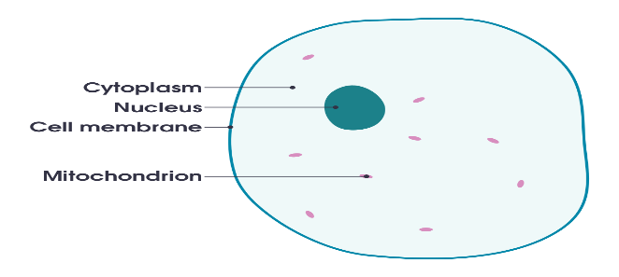  Plant Cell  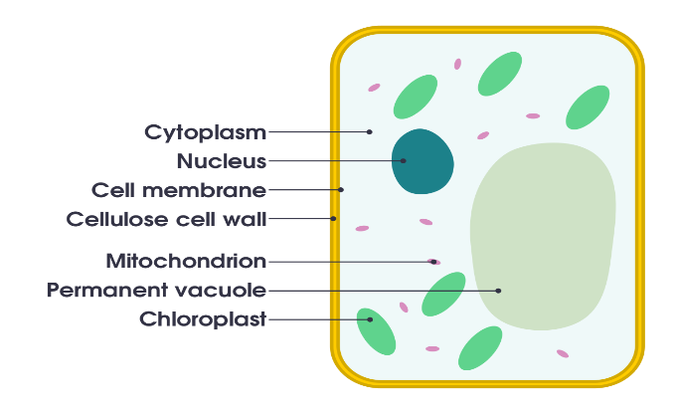 | Nucleus – Contains the DNA and controls the cell  Cell Membrane – Controls what goes in and out of the cell  Cytoplasm - Jelly like, all chemical reactions occur in here.  Mitochondria – Respiration occurs inside to release energy for the cell to use.  Cell Wall – Protects the cell and gives it structure  Chloroplasts – Carry out photosynthesis to make food for the plant.  Vacuole – Filled with cell sap and gives the cell shape.  Animal Cells contain a nucleus, cell membrane, cytoplasm and mitochondria.  Plant cells contain a nucleus, cell membrane, cytoplasm and mitochondria PLUS a cell wall, chloroplasts and a vacuole.
Lesson 4  Specialised Cells | Lesson 5  Movement of Substances | Lesson 6  Unicellular Organisms
Cells are designed to carry out the job they perform.  Egg cell (ovum)  Job: Reproduction to be fertilised by sperm  Features: Nucleus contains half the genetic info to create a baby and contains lots of energy to allow egg to develop if it is fertilised.  Sperm cell  Job: Reproduction to fertilise the egg cell  Features: Contains half the genetic info to create a baby and has a tail to swim to meet the egg  Neurone (nerve cell)  Job: Help nerve impulses move around the body  Features: Long and thin, can send electrical impulses large distances around the body  Plant Palisade cell  Job: Help the plant photosynthesis and make food  Features: Lots of chloroplasts to trap light energy for photosynthesis  Plant Root cell  Job: Help the plant take in water through the roots  Features: large surface area so they can absorb more water from the soil. | Diffusion is the movement of particles from an area of high concentration to an area of low concentration. ​  This happens in liquids and gases but not solids because the particles can only vibrate in a solid, but can’t move from place to place  Substances that move in and out of cells by diffusion include  - Oxygen into cells for respiration  - Glucose into cells for respiration  - Carbon dioxide out of cells from respiration and into leaf cells for photosynthesis  - Water into root hair cells  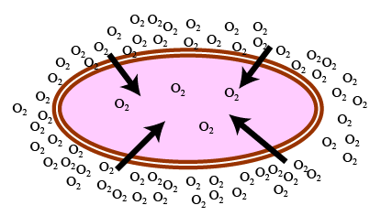  Particles diffuse faster at higher temperatures because the particles have more kinetic energy so move faster. | Unicellular organisms are made up of only one cell  e.g. Amoeba and Euglena  Multicellular organisms are made up of more than one cell. All species of animals, land plants and most fungi and algae.  Amoeba  - Have no fixed shape  - Found in fresh water, salt water, wet soil and inside animals  - Moves by changing shape  - An amoeba reproduces by splitting into two cells  - This is called binary fission  Euglena  - Euglena are found in freshwater  - The eyespot detects light and move using their flagellum to ‘swim’ towards the light.  - Euglena have chloroplasts and make their own food by photosynthesis  - Euglena also reproduce asexually by binary fission

Lesson 7  Levels of Organisation | Lesson 8  The Skeleton | Lesson 9  Movement – Joints
Tissues are a group of cells with similar structures, working together to perform a shared function.  eg muscle tissue is made up of lots of muscle cells.  Organs are made up of a group of tissues, working together to perform specific functions.  eg the Heart is made up of muscle, connective, nervous and fat tissues  Organ Systems are made up of a group of organs with related functions, working together to perform body functions.  eg the Digestive system which is made up of many organs including the mouth, stomach, small and large intestines.  Circulatory System- transports blood around the body  Nervous System- allows us to sense and react to our surroundings  Reproductive System- used to produce young  Respiratory System- for gas exchange in and out of the body | 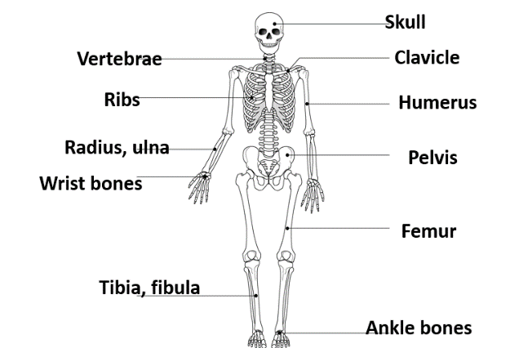  Bones are living tissue supplied by blood. They are growing all of the time. They can repair themselves when damaged. Calcium and other materials make bones strong.  Functions of the skeleton:  - Protection – skull protects the brain, rib cage protects the heart and lungs, vertebrae protect the spinal cord.  - Support – the skeleton provides a framework for muscles and organs to connect to.  - Movement – the skeleton has joints with muscles, ligaments and tendons allowing movement.  - Blood production – long bones contain bone marrow which makes blood cells | Joint Where two or more bones join together.  A Synovial joint  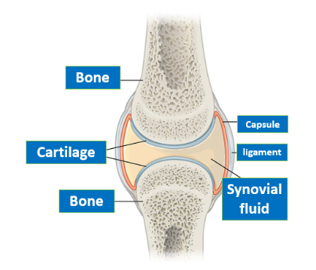  - Cartilage – soft tissue at the end of a bone  - Synovial fluid –fluid found in the joint which stops bone rubbing against bone  - Ligament – joins bone to bone  - Tendon – joins muscle to bone

Lesson 9  Movement – Joints (continued) | Lesson 10  Movement – Muscles
Types of joint  - Pivot – the ends of the bones are covered in cartilage, allows 360° movement  - Hinge – works like a lever and allows 180° movement  - Fixed – forms between two bits of bone that don’t move  - Ball and socket – an example is the hip joint, allows 360° movement | Muscles  - Are a type of tissue which contains specialised cells which contract  - Have lots of mitochondria for respiration to produce energy.  - Have a good blood supply.  Three main types of muscle  - Cardiac – found in the heart  - Smooth – attached to bone, the main type of muscle  - Skeletal – used for involuntary movements like in your gut.  Major muscle groups  Bicep: Flex the arm (bend towards the body)  Triceps: Extends the arm (straightens away from body)  Quadriceps: Extends the lower leg  Abdominals: Move the torso and helps with breathing | Antagonistic pairs  Muscles only pull. Two muscles that work at a joint to move are called antagonistic pairs.  Example – bicep & triceps  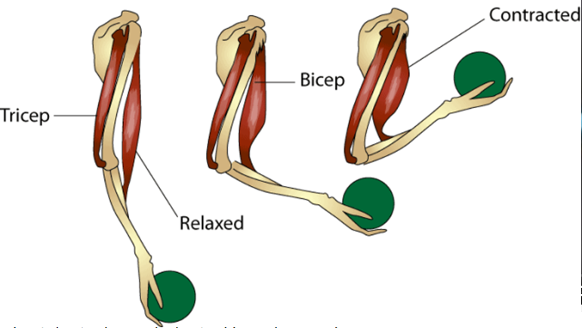  Homologous Structures:  - The chicken wing and the human arm are examples of homologous structures.  - This means they have a similar underlying structure but have different functions.  