
Spring Edition
This edition of our newsletter will cover some of the work that the Child Centred policing teams have been doing as well as highlight upcoming projects.
As always if you have a general enquiry, please contact childcentredpolicing@kent.police.uk

News

Safer Knife Replacement Scheme (SKRS)
The VRU is offering a free scheme to replace pointed kitchen knives with safer alternatives in homes across Kent and Medway. The aim is to reduce the risk of serious injury where kitchen knives are a factor.
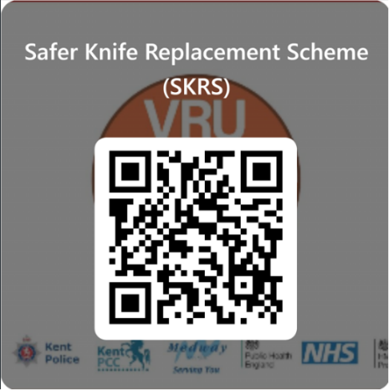
Officers can offer the scheme when:
- A young person is linked to weapon-related offending
- There are concerns around gangs, drug activity, or high-risk domestic abuse
How it works:
Agree disposal with the family → scan the QR code → place old knives in the secure tube → provide the replacement safety knives. No training required.
This voluntary scheme supports existing safeguarding measures and helps make homes safer.
Several schools have taken in their home economic classes have made the change to the safer knives.
For packs or more information:
📧 vru.programme.delivery@kent.police.uk

Financially Motivated Extortion (“Sextortion”) – Key Information for Schools
Kent Police are seeing a rise in financially motivated extortion targeting young people online. Most victims are boys aged around 14, with suspects commonly operating from overseas locations. Offenders typically contact victims on platforms like TikTok, Snapchat and Instagram, persuade them to share an intimate image, and then threaten to release it unless money is paid.

Schools are encouraged to raise awareness and direct students to trusted resources. The children Society provides accessible guidance for families, and Pol-Ed Kent offers free educational materials for all schools, funded by Kent Police and the VRU.
For support or to access Pol-Ed resources, please visit the Pol-Ed Kent platform or contact the relevant policing team - childcentredpolicing@kent.police.uk


Recent Projects

Staying Safe this summer – Knives, Catapults and E-scooters

Across Kent, officers continue to see young people placing themselves at risk through the misuse of catapults, e-scooters and knives.

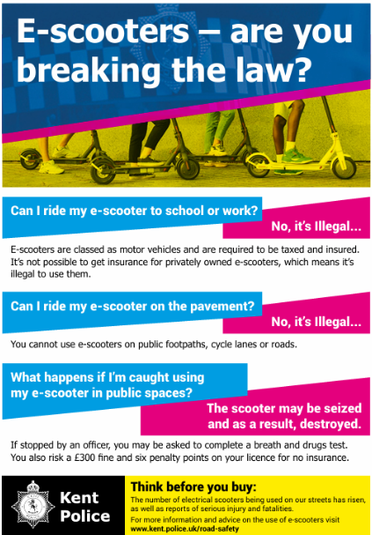
Catapults are classed as offensive weapons, and carrying one without a reasonable excuse can lead to serious penalties—including imprisonment—and misuse can result in even harsher consequences. Privately owned e-scooters also remain illegal to use on roads, pavements or cycle lanes, with riders facing fines, points on their licence and potential seizure of the scooter.
Schools and officers are also reminded of the key actions required when a child is found with a knife. This includes completing an immediate risk assessment, submitting a Youth Justice Notification within 24 hours, and considering outcomes such as Youth Conditional Cautions or Deferred Outcomes unless exceptional circumstances apply.
Together, these measures help reduce harm, promote safer choices, and protect young people across our communities.

A Reminder for All Students: Staying Safe Online and Social Media Trends
We would like to remind students of the importance of not taking part in viral social media trends that may involve risky or illegal behaviour. Unfortunately, several young people across Kent have recently become involved in such trends, resulting in Police intervention.
Becoming involved in activities that lead to a criminal offence can have serious and lasting consequences, including the possibility of a criminal conviction that could impact a young person’s future opportunities. This can include something as simple as reposting content which may inadvertently mean they have committed a criminal offence themselves.
We all share a responsibility to keep one another safe. Please encourage students to speak up if they witness or feel pressured to take part in inappropriate behavior—only where it is safe to do so. They should always talk to a trusted adult and report any concerns to their school safeguarding team, the Police, or anonymously via Fearless at crimestoppers-uk.org/fearless.
Thank you for helping us support the safety and wellbeing of all young people.


Who to contact across the county

Dartford and Gravesham

PS Nikki Lee Nikki.Lee@kent.police.uk and PS Siobhan Rowe Siobhan.Rowe@kent.police.uk

Medway

DS Raj Dusanjh Raj.Dusanjh@kent.police.uk

Swale

PS Carli Deacon Carli.Deacon@kent.police.uk

Maidstone

PS Andrew Stringer Andrew.Stringer@kent.police.uk

Tonbridge & Malling, Tunbridge Wells and Sevenoaks

PS Ian Loader Ian.Loader@kent.police.uk

Ashford

PS Katie Reed Katie.Reed@kent.police.uk

Canterbury

PS John Woodward John.Woodward@kent.police.uk

Dover

PS Gavin Rolfe Gavin.Rolfe@kent.police.uk

Thanet

PS Sheena Maclean-Bell Sheena.Maclean-Bell@kent.police.uk

Folkestone and Hythe

PS Adam Plant Adam.Plant@kent.police.uk

