ARTIST OF THE MONTH May 2026
Artist of the month is a competition that runs in school. Each month we look at a different artist and their work, children can then respond to this artist by either creating a picture, taking a photograph, writing a story, doing some research or a different response that inspires them. Mrs Britten our Art and Design subject lead shares the artist of the month via the school art notice board. The artist of the month winner will be announced at the end of each month.
To enter you need to respond to the artist however you choose. Put your entry into the ‘Artist of the Month’ basket next to the art gallery display or email it to enquiries@williamgilbertend.derbyshire.sch.uk with the title 'Artist of the Month'. Please enter by Monday 1st June 2026
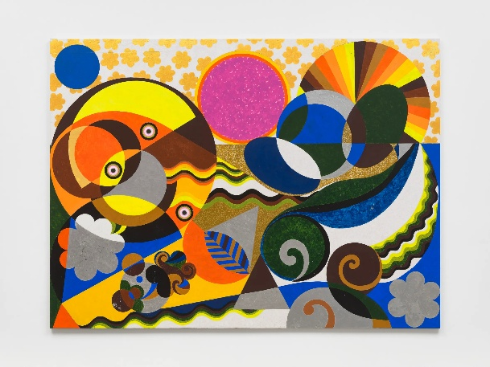
This month's artist is: Beatriz Milhazes
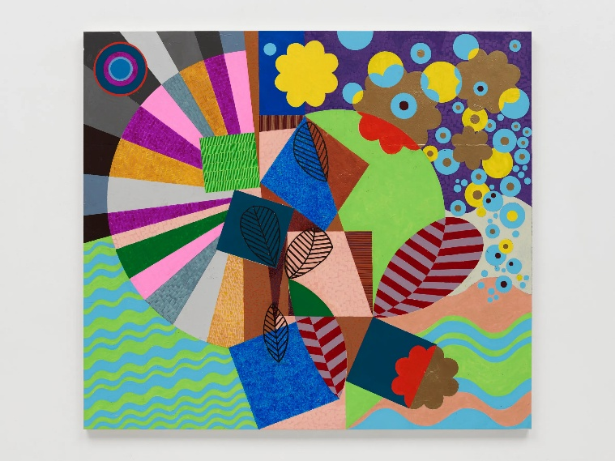

‘Swirling Water’ (2025)

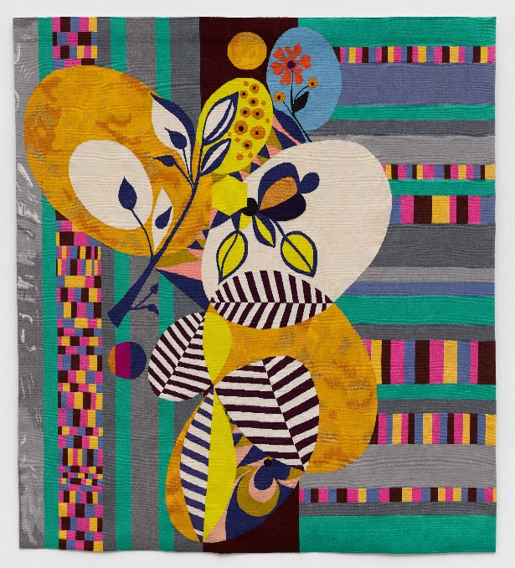
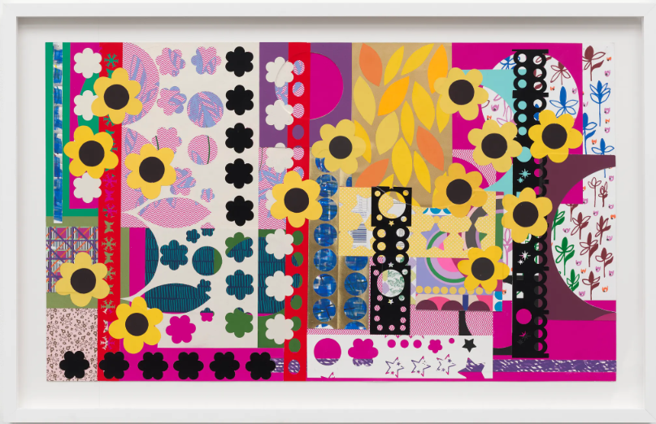
‘Cerimônias Femininas ’ (2022)

‘Histórias Tropicais I’ (2024) ‘Dance in Yellow’ (2020)

About the Artist – Beatriz Milhazes

Beatriz Milhazes is a Brazilian artist who was born in 1960 and lives in Rio de Janeiro. She is known for creating large, colourful paintings filled with patterns, shapes and bright colours.

Milhazes studied art at university and was inspired by Brazilian culture, music, festivals and decorations she saw around her growing up. Her artwork often includes circles, flowers, stripes and repeating patterns that overlap and dance across the page. Some of her designs are inspired by lace, carnival decorations, and even wrapping paper or wallpapers.

Instead of painting pictures that look realistic, Milhazes uses shapes and colour to create exciting, joyful artworks that make you want to look again and again. When you look closely at her paintings, you might notice that they are carefully layered. She often paints patterns separately, presses them onto the canvas, and then peels them away, leaving textured shapes behind. This makes her work feel lively and full of movement. Her paintings don’t tell one clear story – instead, they invite you to explore, imagine and decide what you see for yourself. Beatriz Milhazes’ art shows us that colour and pattern can be powerful. Her work reminds us that art can celebrate happiness, culture and creativity, and that experimenting with design can lead to exciting results.

Questions to Think About
- What shapes and patterns can you spot in Beatriz Milhazes’ artwork?
- How do the bright colours make you feel when you look at her paintings?
- Why do you think she repeats shapes and patterns again and again?
- Which part of the artwork do your eyes notice first, and why?

If you made your own artwork inspired by Milhazes, what colours and patterns would you choose?

Now It’s Your Turn!

This month, our Artist of the Month is Beatriz Milhazes, a Brazilian artist famous for her bold colours, joyful patterns and celebration of Brazilian culture. Her artwork is inspired by festivals, music, decorations, flowers and the exciting energy of Rio de Janeiro.
This year, Duffield Carnival 2026 is all about Celebrating the Nations of the World Cup, and our school is proudly celebrating Brazil and Rio. We would love to use all pupils’ artwork to decorate our carnival float, filling it with colour, pattern and celebration – just like Milhazes’ paintings.

Beatriz Milhazes’ art is full of circles, flowers, stripes and repeating patterns, often layered on top of each other. Her work feels joyful and lively, a bit like a carnival itself! Instead of drawing realistic pictures, she uses shapes, colour and design to create eye-catching artwork that makes people smile.

Your challenge is to create Brazil-inspired artwork using bold colours, patterns and shapes. Think about carnival decorations, tropical flowers, music, movement and celebration. You might create flowers, patterns, flags, or abstract designs that feel energetic and fun. Your artwork will help turn our carnival float into a bright celebration of Brazil!
Be brave with colour, experiment with patterns and enjoy creating something joyful — just like Beatriz Milhazes.

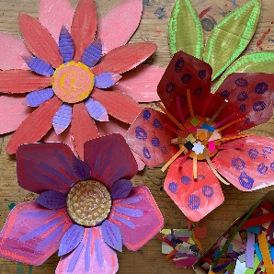
Some Ideas to Get You Started
EYFS
Ideas:
- Cardboard Carnival Flowers: Cut large flower shapes from cardboard, paint them in bright colours and add simple patterns (like the examples shown).
- Painted Circles & Dots: Use sponges or fingers to print overlapping circles inspired by Milhazes’ designs.

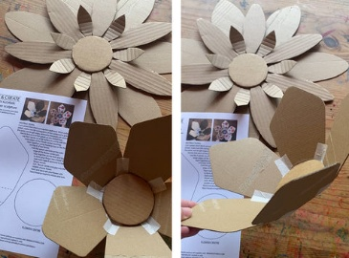
- Pattern Play: Decorate large flower or circle shapes with stripes, dots and zigzags.

KS1
Ideas:
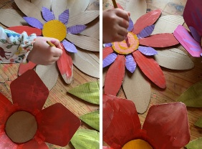
- Brazilian Flower Designs: Draw or cut flowers and decorate them with repeated patterns and bright colours.
- Circle Overlap Art: Create artwork using overlapping circles in different sizes, like Milhazes’ paintings.
- Mixed Media Flowers: Paint a flower shape, then add paper patterns or printed details on top.
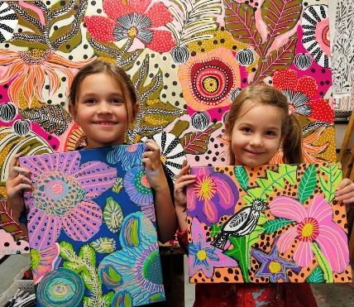
KS2
Ideas:
- Milhazes-Style Pattern Panels: Build complex designs using repeated shapes, symmetry and overlapping forms.
- Large-Scale Cardboard Flowers: Create bold flowers using cardboard, paint and collage for the carnival float.
- Layered Colour & Texture: Experiment with printing, painting and collage to create depth and interest.

Remember:
There’s no right or wrong way — Beatriz Milhazes shows us that art can be joyful, decorative and full of energy. Your artwork will help transform our carnival float into a celebration of Brazil, creativity and community.
