
Attendance at William Gilbert Endowed C of E Primary School and Nursery
We know how well pupils do in school is linked to good attendance.
Momments Matter Attendance Counts
 | Everyday | If your child is ill | If your child’s attendance is less than 90% | If we have serious concerns about attendance | Taking children on holiday / leave
Home Actions   | Bring your child to school every day.  8:40 – 8:55am | Ring school and let them know why.  (01332) 840 395  Keep them updated. | Let us know why your child’s attendance is low.  You can see your child’s daily attendance figures on your WeDuc app.  Let us know if you need support.  Attend the meeting. | Attend meetings.  Accept support offered.  Bring medical evidence if requested. | Complete a leave of absence form from the school office.  NB If you do not complete a form and the school suspect you are on holiday – the burden of proof falls to you as parent to prove that your child was ill and not on holiday.
School Actions   | Create a welcoming environment for your child. | If we do not hear from you, we will ring and may do a home visit.  If your child’s attendance drops below 95%, we will send a letter to let you know. | We will send a letter to let you know.  We will arrange a meeting and make an agreement. | We will arrange a meeting.  We will offer support. | The school will only authorise this in exceptional circumstances.  The school may refer this to the Local Authority to process a penalty notice (a fine).
 | 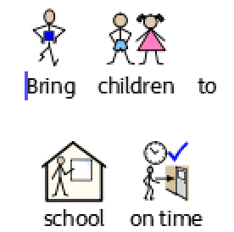 |  | 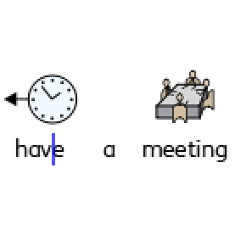 |  | 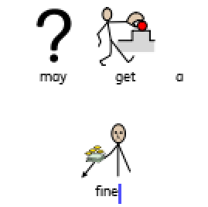
Ring the School Office: 01332 840 395 or email enquiries@williamgilbertend.derbyshire.sch.uk

