Sight Word Rocket – Set 8
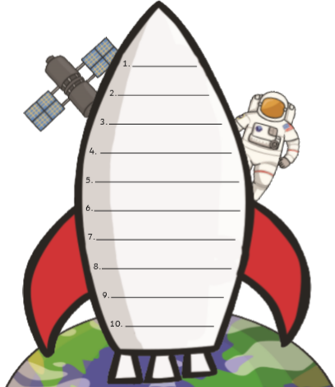
Can you practise reading and writing these sight words?
little
Mr
put
friend
ask
once
one
today
Mrs
love

