Lyrics for Christmas

GLEE
CLUB
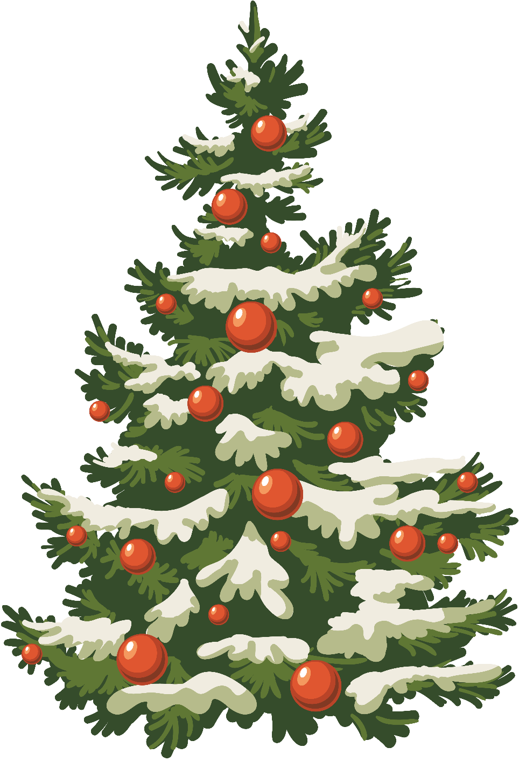

Feliz Navidad 2:45

Intro x1

(Shakers) Feliz Navidad, Feliz Navidad, Feliz Navidad, Prospero ano y felizidad
Feliz Navidad, Feliz Navidad, Feliz Navidad, Prospero ano y felizidad

I wanna wish you a Merry Christmas, I wanna wish you a Merry Christmas,
I wanna wish you a Merry Christmas from the bottom of my heart.
I wanna wish you a Merry Christmas, I wanna wish you a Merry Christmas,
I wanna wish you a Merry Christmas from the bottom of my heart.

Break (Shakers) x1

(Shakers) Feliz Navidad, Feliz Navided, Feliz Navidad, Prospero ano y felizidad
Feliz Navidad, Feliz Navided, Feliz Navidad, Prospero ano y felizidad

I wanna wish you a Merry (harmony) Christmas,
I wanna wish you a Merry (harmony) Christmas,
I wanna wish you a Merry (harmony) Christmas
from the bottom of my heart.
I wanna wish you a Merry (harmony) Christmas,
I wanna wish you a Merry (harmony) Christmas,
I wanna wish you a Merry (harmony) Christmas
from the bottom of my heart.

(Shakers) Feliz Navidad, Feliz Navided, Feliz Navidad, Prospero ano y felizidad

(Shake Shake Shake)

I Wish It Could Be Christmas Every Day 4:14

(Slow – jingle bells)
When the snowman brings the snow
Well he just might like to know
He's put a great big smile on somebody's face
If you jump into your bed
Quickly cover up your head
Don't you lock the doors
You know that sweet Santa Claus is on the way
Pick up the pace [Chorus]
Well I wish it could be Christmas every day
When the kids start singing and the band begins to play
Oh, I wish it could be Christmas every day
Let the bells (bells bells) ring out (bells bells) for Christmas (bells)
[Verse 2] (bells)
When we're skating in the park
If the storm cloud paints it dark
Then your rosy cheeks going to light my merry way
Now the frosticles appear
And they've frozen up my beard
So we'll lie by the fire
Till the sleep simply melts them all away
[Chorus]
Well I wish it could be Christmas every day
When the kids start singing and the band begins to play
Oh, I wish it could be Christmas every day
Let the bells (bells bells) ring out (bells bells) for Christmas

Rock Out!! (Instrumental Bridge)

When the snowman brings the snow
Well he just might like to know
He's put a great big smile on somebody's face
If you jump into your bed
Quickly cover up your head
Don't you lock the doors
You know that sweet Santa Claus is on the way

[Chorus]
Well I wish it could be Christmas every day
When the kids start singing and the band begins to play
Oh, I wish it could be Christmas every day
Let the bells (bells bells) ring out (bells bells) for Christmas

Well I wish it could be Christmas every day
When the kids start singing and the band begins to play
Oh, I wish it could be Christmas every day
Let the bells (bells bells) ring out (bells bells) for Christmas

Why don’t you give your love for Christmas!

Love Shone Down (Long Intro x2) 3:44

I had a dream that I was standing on a hillside
And all the lights of town
were shining far below
When up in the air beautiful voices
Sing a new song, let everyone know,

Oh and love shone down
over the hills and over the valleys,
Oh and love shone down over the world

Somebody spoke to me
I knew it was an angel
He said there’s something
that I think you ought to know.
Then he just smiled, said don’t be afraid now.
Sing a new song, let everyone know

Oh and love shone down
over the hills and over the valleys,
Oh and love shone down over the world

(Instrumental) (8 bars)

And then he told me all about the baby Jesus,
How to find him where exactly I should go.
Then he was joined by millions of others
Sing a new song, let everyone know

Oh and love shone down
over the hills and over the valleys,
Oh and love shone down over the world

(Instrumental) (4 bars)

(Solo) did I dream or was I really on that hillside
On that Christmas night so very long ago,
When he was born Jesus our Saviour
Sing a new song let everyone know

Oh and love shone down
over the hills and over the valleys,
Oh and love shone down over the world

Over the world

Santa’s Coming 3:30

Nights are getting shorter now, hot chocolate fills the air
and Christmas cheer does too
Picking out your Christmas tree, so lovely
The joy this time it brings to you

(Oh, do do do, oh, do do do) (Oh, do do do, oh, do do do)
(Oh, do do do, oh, do do do) Santa's coming to town
(Oh, da da da, oh, da da da) (Oh, da da da, oh, da da da)
(Oh, da da da, oh, da da da) Santa's coming to town

Sing it to the deer in the sky
Sing it as they jingle, jingle, jingle tonight
Sing it to the moon, set it free
You're the angel on the top of my tree
Sing it to the spirit above
Sing your heart out with all of your love

Santa's coming for us Santa's coming for us Santa's coming for us
Santa's coming for us Santa's coming for us Santa's coming for us
Oh, Santa's coming for us

Send your letters off to Santa, baby
Tell him all your secret wishes too
Send your letters off to Santa, baby
Hoping all your wildest dreams come true

(Oh, do do do, oh, do do do) (Oh, do do do, oh, do do do)
(Oh, do do do, oh, do do do) Santa's coming to town
(Oh, da da da, oh, da da da) (Oh, da da da, oh, da da da)
(Oh, da da da, oh, da da da) Santa's coming to town

Sing it to the deer in the sky
Sing it as they jingle, jingle, jingle tonight
Sing it to the moon, set it free
You're the angel on the top of my tree
Sing it to the spirit above
Sing your heart out with all of your love
Santa's coming for us Santa's coming for us Santa's coming for us
Santa's coming for us Santa's coming for us Santa's coming for us
Oh, Santa's coming for us

(Oh, do do do, oh, do do do) (Oh, do do do, oh, do do do)
(Oh, do do do, oh, do do do) Santa's coming to town
(Oh, da da da, oh, da da da) (Oh, da da da, oh, da da da)
(Oh, da da da, oh, da da da) Santa's coming to town

(Oh, do do do, oh, do do do) (Oh, do do do, oh, do do do)
(Oh, do do do, oh, do do do) Santa's coming to town

Sparkle and Shine 2:07

Ooh-ooh, ooh-ooh Ah Ooh, ooh, ooh

(Solo) Okay, everybody, clap your hands
I'm a superstar, and I'm coming out tonight

I've had a little makeover And I'm all dressed up tonight
A cheeky drink, a naughty wink We'll loosen up alright
Stand back and put your shades on 'Cause I'm about to shine
My blinding light will throw you 'Cause there's no starlight like mine

Ooh-oh, ooh-oh

Sparkle and shine Planets gather 'round
Sparkle and shine Let's all make a dazzling sound
Here's something you won't believe It's the first time ever Christmas Eve

I've got my light within me And it's coming out for you
I'm dizzy with self-confidence Hope you can feel it too
I'm lighting up the skies tonight So, come on, join the party
Make the moment last all night And keep the stars all starry

Ooh-oh, ooh-oh, Ooh-oh, ooh-oh

Sparkle and shine Planets gather 'round
Sparkle and shine Let's all make a dazzling sound

Here's something you won't believe It's the first time ever Christmas Eve

Last Christmas

Last Christmas I gave you my heart
But the very next day you gave it away
This year, to save me from tears
I'll give it to someone special

Last Christmas I gave you my heart
But the very next day you gave it away
This year, to save me from tears
I'll give it to someone special

Once bitten and twice shy
I keep my distance, but you still catch my eye
Tell me baby, do you recognize me?
Well, it's been a year, it doesn't surprise me

Happy Christmas, I wrapped it up and sent it
With a note saying "I love you", I meant it
Now I know what a fool I've been
But if you kissed me now, I know you'd fool me again

Last Christmas I gave you my heart
But the very next day you gave it away
This year, to save me from tears
I'll give it to someone special

Last Christmas I gave you my heart
But the very next day you gave it away
This year, to save me from tears
I'll give it to someone special

Sing 4:40

Some words they can’t be spoken only sung,
So hear a thousand voices shouting love.
There’s a place, there’s a time in this life
When you sing what you are feeling,
Find your feet, stand your ground,
Don’t you see right now the world is listening to what we say?

Sing it louder, sing it clearer, knowing everyone will hear you,
Make some noise, find your voice tonight.
Sing it stronger, sing together, make this moment last forever,
Old and young shouting love tonight.

To sing we’ve had a lifetime to wait (wait, lifetime to wait)
And see a thousand faces celebrate (celebrate, faces celebrate)
You brought hope, you brought life,
Conquered fear, no it wasn’t always easy,
Stood your ground, kept your faith,
Don’t you see right now the world is listening to what we say?

Sing it louder, sing it clearer, knowing everyone will hear you,
Make some noise, find your voice tonight.
Sing it stronger, sing together, make this moment last forever,
Old and young shouting love tonight.

Some words they can’t be spoken only sung,
To hear a thousand voices shouting love and light and hope.

Just sing; just sing; just sing; just sing.

Sing it louder, sing it clearer, knowing everyone will hear you,
Sing it stronger, sing together, make this moment last forever, (sing)

Hear a thousand voices shouting love.

