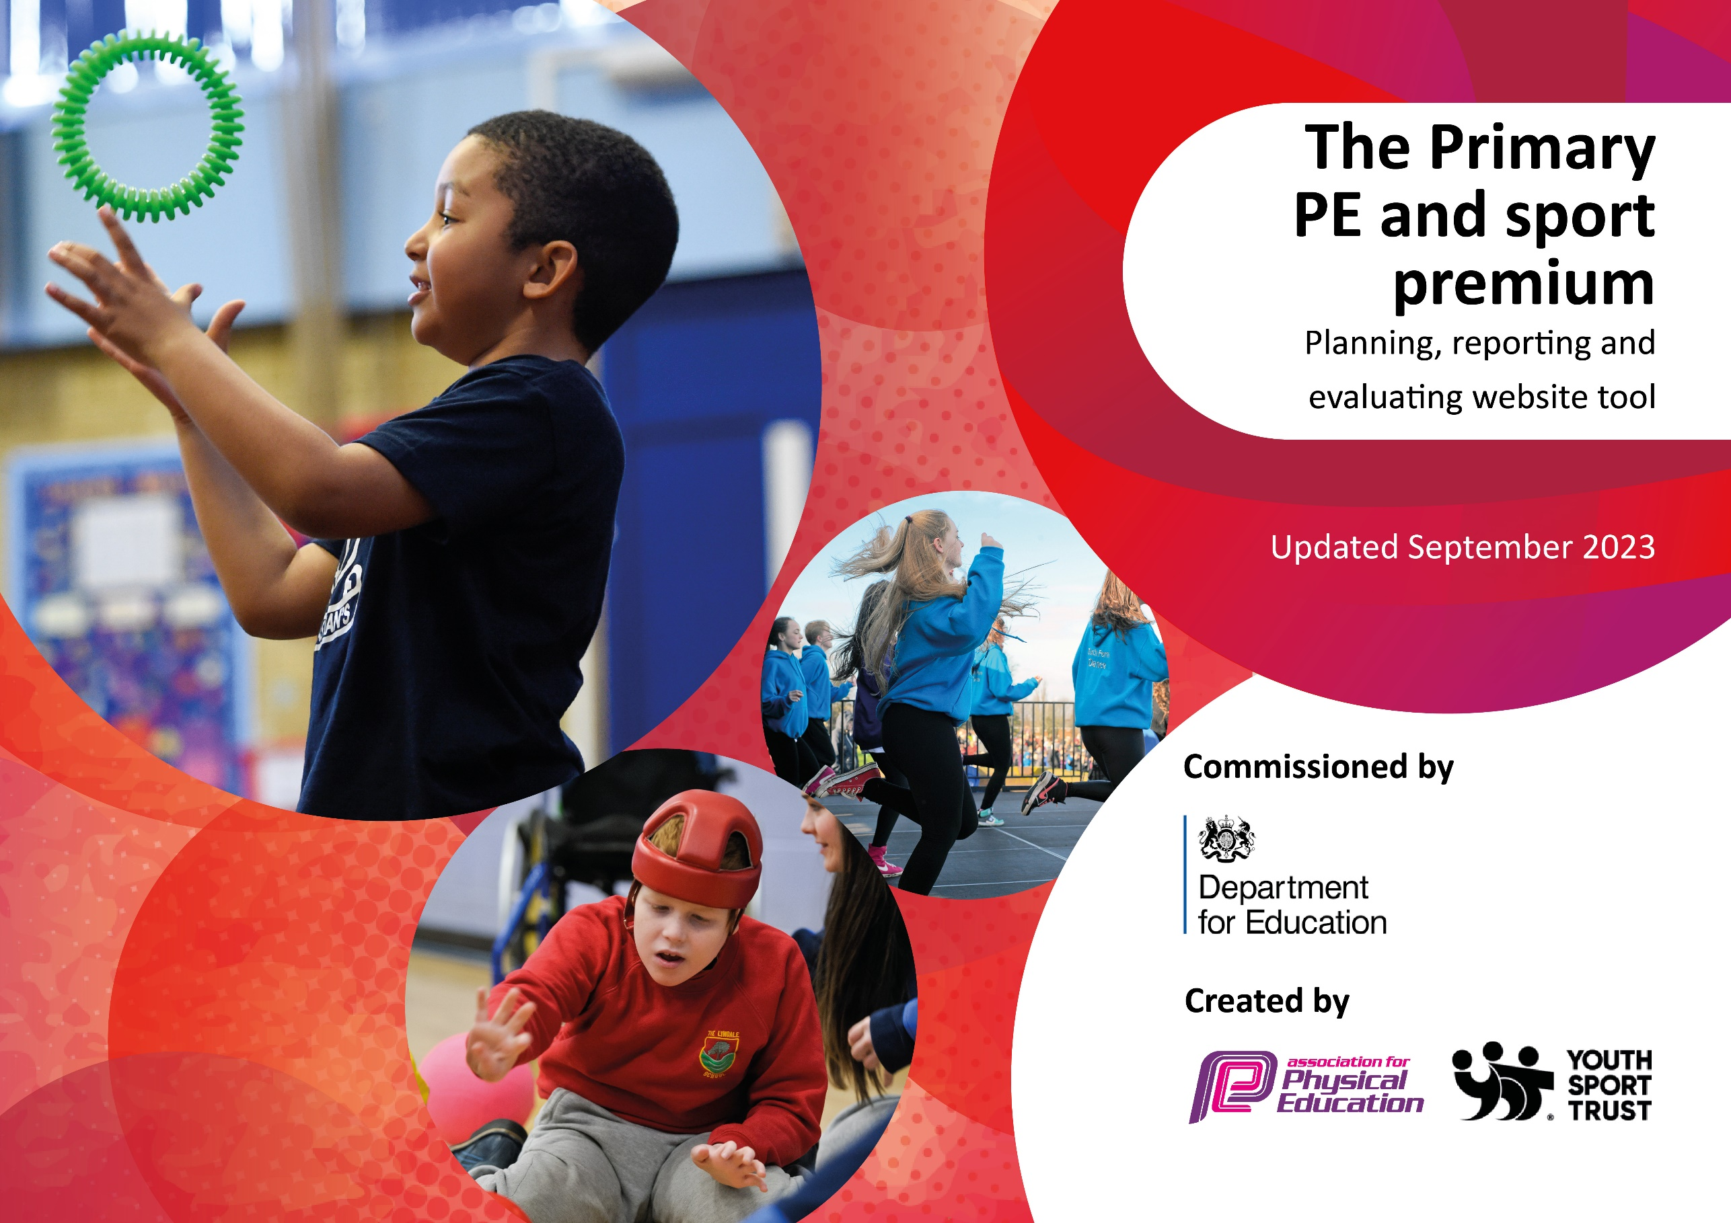

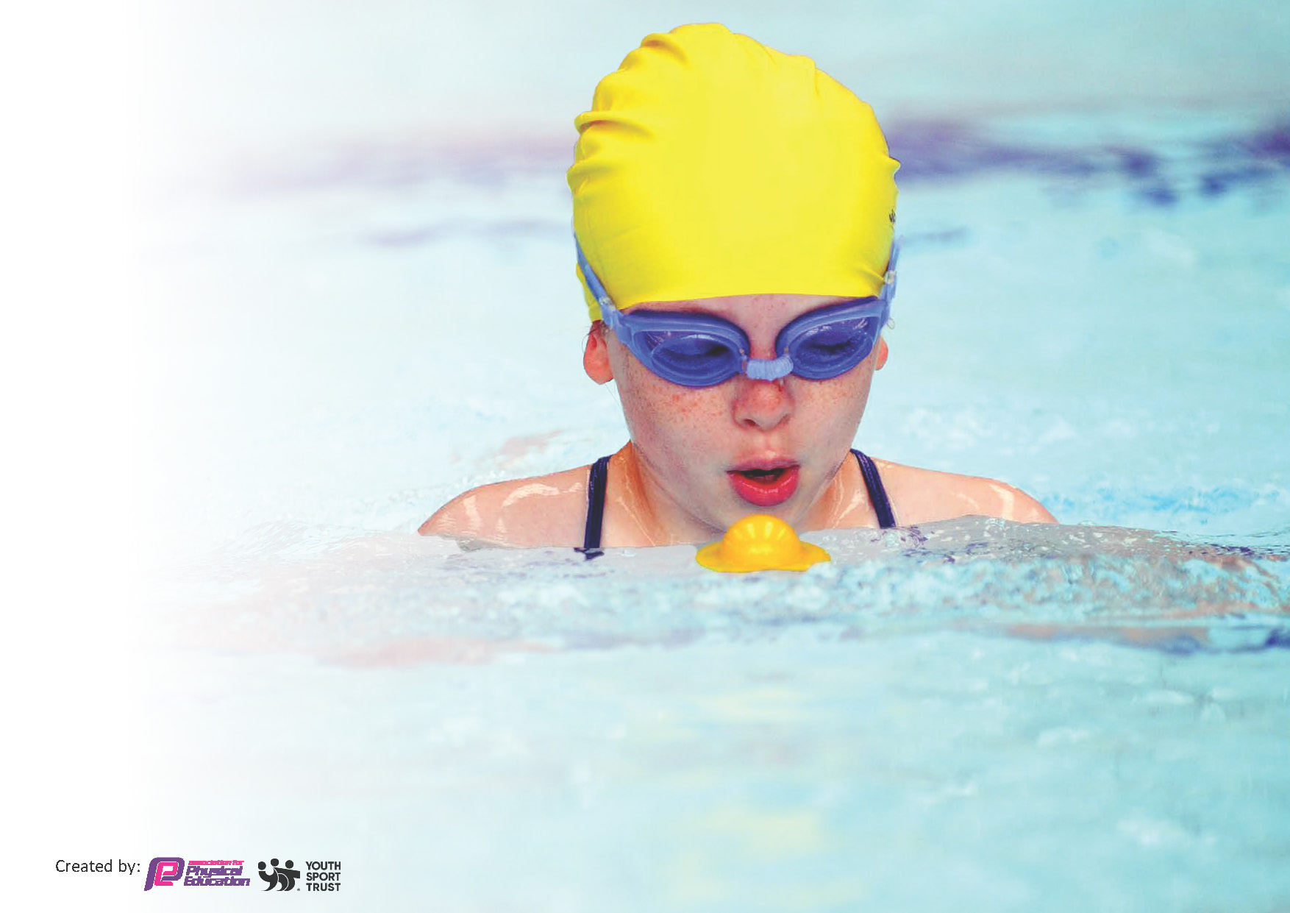
This template can be used for multiple purposes:
by:
- It enables schools to effectively plan their use of the Primary PE and sport premium
- It helps schools to meet the requirements (as set out in guidance) to publish information on their Primary PE and sport premium
- It will be an effective document to support Ofsted inspections enabling schools to evidence progress in Physical Education (PE) and evidence swimming attainment, which forms part of the PE National Curriculum. We would recommend schools consider
the Intent, Implementation and Impact of any spend, as examined within the Education Inspection Framework.

It is important that your grant is used effectively and based on school need.

Schools must use the funding to make additional and sustainable
improvements to the quality of the PE, School Sport and Physical Activity (PESSPA)
they offer. This means that you should use the Primary PE and sport premium to:

- Build capacity and capability within the school to ensure that improvements made now will benefit pupils joining the school in future years
- Develop or add to the PESSPA activities that your school already offers.

The Primary PE and sport premium should not be used to fund capital spend projects; the school’s core budget should fund these. Further detail on capital expenditure can be found in the updated Primary PE and sport premium guidance.

The Primary PE and sport premium guidance, outlines 5 key priorities that funding should be used towards. It is not

necessary that spending has to meet all the key priorities, you should select the priorities that you aim to use any funding towards.

Although completing this template is not a requirement for schools, schools are required to publish details of how they spend this funding. Schools must also outline what the impact this funding has had on pupils’ PE and sport participation and attainment and how any spending will be sustainable in the future. All funding must be spent by 31st July 2024.

The Department for Education has worked closely with the Association for Physical Education (afPE) and the Youth Sport Trust (YST) to develop this template and encourages schools to use it. This template is an effective way of meeting the reporting requirements of the Primary PE and sport premium.
Review of last year’s spend and key achievements (2022/2023)

We recommend you start by reflecting on the impact of current provision and reviewing your previous spend.

Activity/Action | Impact | Comments
Equipment and Kit  To be purchased to allow teachers and staff to provide best possible lessons and learning within PE as well as continuing with the best possible provision of equipment for the children. Equipment has also been purchased to fit in with new SoW.  School Games Kite mark (SSPAN)  (Also linked to Key indicator 2, 3, 4  & 5)  Secure gold mark standard, while moving towards keeping the the Gold Standard.  Provides:  - Competition entry fees  - Reduced training costs  - Festivals  - Conferences  - Links with other schools  - Affiliations to competitions and access to coaching • Increase pupils’ participation in the School Games  Provide existing staff with training or resources to help them teach PE and sport more effectively  Continued and monitored  Implementation of a Whole School  Scheme of Work - Complete PE  Ensure all staff are familiar and comfortable with the use and employment of the lesson plans -Staff meeting to be held to explain and explore the new scheme being used by complete PE.  -Staff training to apply and the use SoW correctly and effectively.  Year 6 Swimming Boosters  Transport  Transport is essential to enable our children to experience competition further afield.  MUGA – Multi Use Games Area | Sports kits to be ordered to raise the profile of sport and equipment to keep kit up to date and tidy.  - Maintains high standard and good representation of the school when participating in competitions.  - Staff wearing sports kit encourages and demonstrates the correct clothing to have when participating in sport. While ensuring staff feel comfortable when delivering PE.  Maintain links with other schools and staff with the City Sports Partnership. Learning from other schools best practice as highlighted by City Sports staff. Attend conferences/meetings with the City Sports Partnership to ensure that St John the Baptist is up to speed with current developments in sporting education in Leicester.  A few virtual competitions were entered this year to keep the competitive nature of sport going throughout school and within cohorts.  Take up of virtual events and through home learning was high.  lead staff development plan (in consultation with all staff through audit) to include engagement with relevant high quality, external provided training, supporting resources and teaching aids.  Sport based CPD based on a 2 year rolling system to ensure maximum coverage of all areas of PE. Offering more of a variety in sports.  -Positive relationships established with internal staff and high quality child centered external coaches providing a range of enrichment, extension and enabling opportunities accessed by the majority of pupils.  15% more have now passed the swimming requirements due to top up boosters.  Transport is essential to enable our children to experience competition further afield. Our school team and athletes play and compete in the Leicester City league and Inspire Together Competition calendar and often need to play away matches. We do however  walk to as many local fixtures/festivals as possible. Competition provides children with a purpose for taking part in sport – learn social, communication, teamwork and leadership skills. Meet other similar aged children from other local schools – helpful with transition to secondary school. Children are exposed to and become interested in a variety of different sports. This promotes lifelong active lifestyle. | Cost of purchases was £8,500  Cost - £2000  £150 yearly subscription  £7,000  £2,350  £14,000

Key priorities and Planning
This planning template will allow schools to accurately plan their spending.

Action – what are you planning to do | Who does this action impact? | Key indicator to meet | Impacts and how sustainability will be achieved? | Cost linked to the action
Take part in Inspire Together competitions  Swimming Boosters  Complete PE  PE equipment  Minibus | Completed by CF June 2024  Completed by CF June 2024  Completed by CF June 2024  To be completed by JM/DS throughout the year  To be completed by MG | Key Indicator 5 – Increased participation in competitive sport.  Key Indicator 2 – The profile of PESSPA being raised across the school as a tool for whole school improvement  Key Indicator 3: Increased confidence, knowledge and skill of all staff in teaching PE and Sport  Key Indicator 5 – Increased participation in competitive sport.  Key Indicator 5 – Increased participation in competitive sport. | Give children an opportunity to take in competitive sport against other schools with the opportunity to progress to county and beyond.  An opportunity to mix with other groups.  To create a positive experience in competition  To facilitate all children being able to swim 25m by the time they leave primary school  All staff grow in confidence in teaching PE. To set a high level of teaching standards so that the children progress in PE | £2,200  £7,000  £210 annually  £2000  £6000

e.g. CPD for teachers. | Primary generalist teachers. | Key Indicator 1: Increased confidence, knowledge, and skills of all staff in teaching PE and sport.  Key indicator 5: Increased participation in competitive sport. | Primary teachers more confident to deliver effective PE supporting pupils to undertake extra activities inside and outside of school, including teaching water safety and swimming and as a result improved % of pupil’s attainment in PE. | £5000 for 5 teachers to undertake CPD.

Key achievements 2023-2024
This template will be completed at the end of the academic year and will showcase the key achievements schools have made with their Primary PE and sport premium spending.

Activity/Action | Impact | Comments
Equipment and Kit To be purchased to allow teachers and staff to provide best possible lessons and learning within PE as well as continuing with the best possible provision of equipment for the children. Equipment has also been purchased to fit in with new SoW.  School Games Kite mark (SSPAN)  (Also linked to Key indicator 2, 3, 4  & 5)  Secure gold mark standard, while moving towards keeping the the Gold Standard.  Provides:  - Competition entry fees  - Reduced training costs  - Festivals  - Conferences  - Links with other schools  - Affiliations to competitions and access to coaching • Increase pupils’ participation in the School Games  Provide existing staff with training or resources to help them teach PE and sport more effectively  Continued and monitored  Implementation of a Whole School  Scheme of Work - Complete PE  Ensure all staff are familiar and comfortable with the use and employment of the lesson plans -Staff meeting to be held to explain and explore the new scheme being used by complete PE.  -Staff training to apply and the use SoW correctly and effectively.  Year 6 Swimming Boosters  Transport  Transport is essential to enable our children to experience competition further afield. | Sports kits to be ordered to raise the profile of sport and equipment to keep kit up to date and tidy.  - Maintains high standard and good representation of the school when participating in competitions.  - Staff wearing sports kit encourages and demonstrates the correct clothing to have when participating in sport. While ensuring staff feel comfortable when delivering PE.  Maintain links with other schools and staff with the City Sports Partnership. Learning from other schools best practice as highlighted by City Sports staff. Attend conferences/meetings with the City Sports Partnership to ensure that St John the Baptist is up to speed with current developments in sporting education in Leicester.  A few virtual competitions were entered this year to keep the competitive nature of sport going throughout school and within cohorts.  Take up of virtual events and through home learning was high.  lead staff development plan (in consultation with all staff through audit) to include engagement with relevant high quality, external provided training, supporting resources and teaching aids.  Sport based CPD based on a 2 year rolling system to ensure maximum coverage of all areas of PE. Offering more of a variety in sports.  -Positive relationships established with internal staff and high quality child centered external coaches providing a range of enrichment, extension and enabling opportunities accessed by the majority of pupils.  15% more have now passed the swimming requirements due to top up boosters.  Transport is essential to enable our children to experience competition further afield. Our school team and athletes play and compete in the Leicester City league and Inspire Together Competition calendar and often need to play away matches. We do however  walk to as many local fixtures/festivals as possible. Competition provides children with a purpose for taking part in sport – learn social, communication, teamwork and leadership skills. Meet other similar aged children from other local schools – helpful with transition to secondary school. Children are exposed to and become interested in a variety of different sports. This promotes lifelong active lifestyle. | Cost of purchases was £4,455.73  Cost - £2200  £210 yearly subscription  £7,000  £1,950

Swimming Data
Meeting National Curriculum requirements for swimming and water safety.
Priority should always be given to ensuring that pupils can perform safe self-rescue even if they do not fully meet the first two requirements of the National Curriculum programme of study

Question | Stats: | Further context  Relative to local challenges
What percentage of your current Year 6 cohort can swim competently, confidently and proficiently over a distance of at least 25 metres? | 86% | This year St Johns have had the opportunity to have a mobile pool bought into the school for three weeks, allowing the year 6 booster sessions to happen multiple times a week, meaning more children have been able to pass the 25m swim test. Our 14% of students who have not passed are due to various reasons, some parents did not want children to swim, some children were not part of the school in year 5 and therefore this was their first year ever getting into a pool and some children were not able to complete the test due to SEN needs.
What percentage of your current Year 6 cohort can use a range of strokes effectively [for example, front crawl, backstroke, and breaststroke]? | 72% | Our swimming sessions ran in three levels of ability groups for all of year 6, all of our top group were able to effectively use a range of strokes and the majority of our middle level group were able to do the same. Our lower-level groups worked on the basics during their first sessions, and some were able to demonstrate their use of strokes by the end of the lesson blocks. All year 6 children made progress throughout the sessions.

What percentage of your current Year 6 cohort are able to perform safe self-rescue in different water-based situations? | 94% | The majority of our year 6 children are able to perform safe self-rescue in different water related situations. This is covered in the first sessions of every block to ensure safety for all swimmers. The five children unable to demonstrate safe self-rescue were all due to SEN needs and were accompanied by an additional adult in the pool for safety reasons.
If your schools swimming data is below national expectation, you can choose to use the Primary PE and sport premium to provide additional top-up sessions for those pupils that did not meet National Curriculum  requirements after the completion of core lessons. Have you done this? | Yes | We have used the sports premium budget to offer our 30 lowest ability students additional booster sessions, out of the 30 selected, 16 have now passed the 25m swim test.
Have you provided CPD to improve the knowledge and confidence of staff to be able to teach swimming and water safety? | Yes/No | A massive benefit of having the mobile pool this year was the opportunity staff members got to see the pool in action, listen to the delivery of a lesson from a qualified instructor. Some members of staff also had the opportunity to enter the pool and perform wet and dry tests and then assist in the delivery of lessons.

Signed off by:

Head Teacher: | Trudie Colotto
Subject Leader or the individual responsible for the Primary PE and sport premium: | Courtney Foran and Lara Colotto
Governor: | Rachel Bhanu
Date: | 03/07/2024

