St Chad’s C.E. Primary and Nursery School
Forgiveness
Reflection areas from the Vision Group (Display on reflection board)
Look at the Lord’s Prayer
And forgive us our sins, as we also have forgiven those who sin against us. Matthew 6:12 (The Lord’s Prayer) ¬ How important do you think forgiveness is to God? ¬ Why do you think He included it in the Lord’s Prayer? What does that teach Christians about the importance of saying sorry and forgiving others?

Watch the RE Quest views on Forgiveness and look at the linked questions
https://request.org.uk/resource/issues/ultimate-questions/big-questions-why-should-i-forgive/

Why do you think Jesus said to forgive 70x7 times?
What does this look like in life?
Why do you think it says in the Bible about forgiving others?
Is it important to forgive people?
Is it easy to forgive people?
What would the world be like if no one forgave each other?

Create a class piece of forgiveness artwork
https://www.google.co.uk/search?q=forgiveness+artwork&source=lnms&sa=X&ved=0ahUKEwikzp-y6YXdAhXJC8AKHYWgBusQ_AUICigB&biw=1158&bih=802&udm=2

Share Hungry Caterpillar story-show images of caterpillar to chrysalis to butterfly on large paper. How can we change from what we are now to something better?

Week Beginning |  | Value – Forgiveness | Leader
Week 1 24/2/25  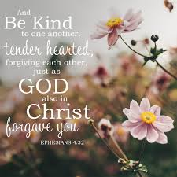 | Monday | Composer Launch | JH  EB and HS
 | Tuesday | KS2 Jacob and Esau  KS1 Reflection area | Rev Callum  PA and LE
 | Wednesday | Broken things  https://www.assemblies.org.uk/pri/2259/forgiveness | Year 6 and CHa  KA and JM
 | Thursday | Godly play KS1  KS2 Reflection area | CS  All KS1 staff
 | Friday | Celebration Worship  Prayers Reception | CS  All Staff
Week 2 3/3/25   | Monday | 9.05 Singing worship | JH  KH and NH
 | Tuesday | KS1 Unforgiving Servant  KS2 Reflection areas | Rev C  DW and FD
 | Wednesday | Making Mistakes  https://www.assemblies.org.uk/pri/4307/this-makes-no-sense | Year 5 and JM  JH and HP
 | Thursday | KS2 Window on the World  KS1 Reflection areas | CS  KS2 Teachers
 | Friday | Celebration Worship  Prayers Year 1 | CS  All staff
Week 3 10/3/25  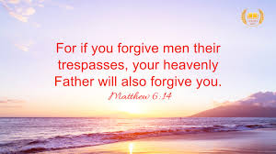 | Monday | Singing Worship | JH  EC and EB
 | Tuesday | KS2 Prodigal Son  KS1 Reflection areas | Rev C  CHa and NH
 | Wednesday | Why forgive?  https://www.assemblies.org.uk/pri/3167/to-forgive-or-not | PA and Year 4  KA and JM
 | Thursday | KS1 Godly Play:  KS2: Reflection areas | CS  KS1 teachers
 | Friday | Celebration Worship  Prayers Year 2 | CS
Week 4 17/3/25  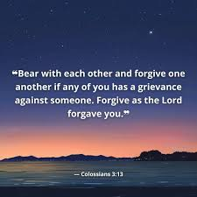 | Monday | Sing and Praise Worship | JH  DW and HS
 | Tuesday | KS1 Jesus forgives Peter  KS2 Reflection areas | Rev C  FD and KH
 | Wednesday | About Turn  https://www.assemblies.org.uk/pri/3851/pause-for-thought-aboutturn | Year 3 and EC  JH and HP
 | Thursday | Wizard of Oz at 9.30am | All staff
 | Friday | Celebration Worship  Prayers Year 3 | CS  All Staff
Week 5 24/3/25  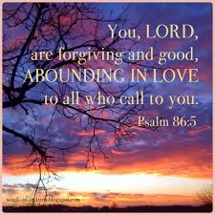 | Monday | Sing and Praise Worship | JH  PA and LE
 | Tuesday | KS2 Jonah  KS1 Reflection areas | Rev C  CHa and KA
 | Wednesday | Sydney opera House  https://www.assemblies.org.uk/pri/3684/pause-for-thought-letting-things-go | Year 2 and HS  KH and JM
 | Thursday | KS1 Godly Play:  KS2 Reflection areas | CS  KS1 teachers
 | Friday | Celebration Worship  Prayers Year 4 | CS  All staff
Week 6 31/3/25  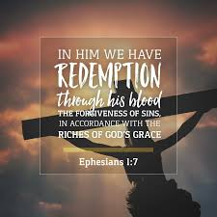 | Monday | Sing and Praise Worship Easter songs | JH  CHa and HS
 | Tuesday | Easter Pause Day launch  The meaning of Easter  https://www.assemblies.org.uk/pri/3086/taking-the-blame | FD  DW and EC
 | Wednesday | Class Easter service prep
 | Thursday | Whole School Easter Service Practise | JH, FD
 | Friday | Privilege Cards  Prayers Year 5  1.30 Easter Service at Church | CS  All staff
Songs | You Forgive Me https://www.youtube.com/watch?v=LO-2fm7IKcU  10, 000 reasons https://www.youtube.com/watch?v=DXDGE_lRI0E  Forgive one another https://youtu.be/HPPYg7mhEHc  Easter Jubilation Out of the Ark

