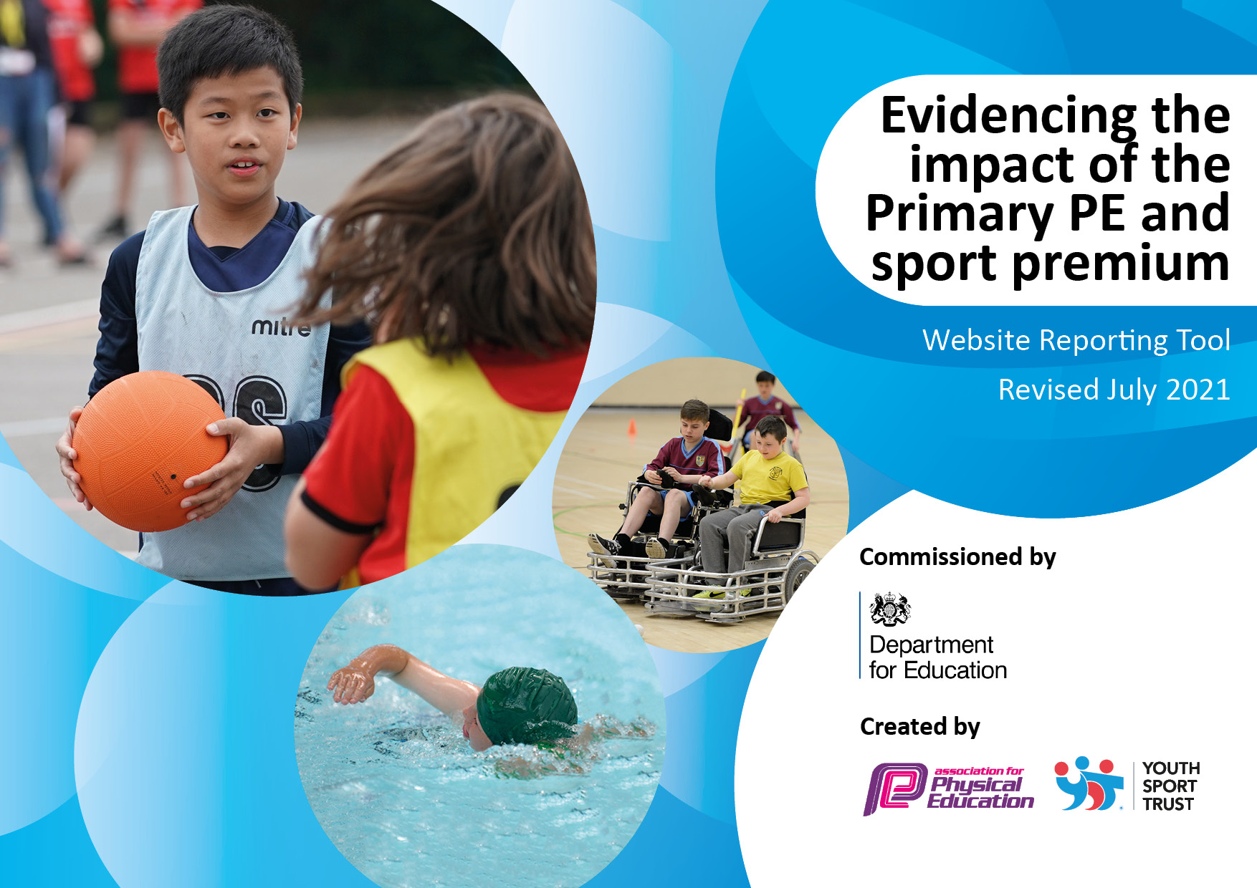

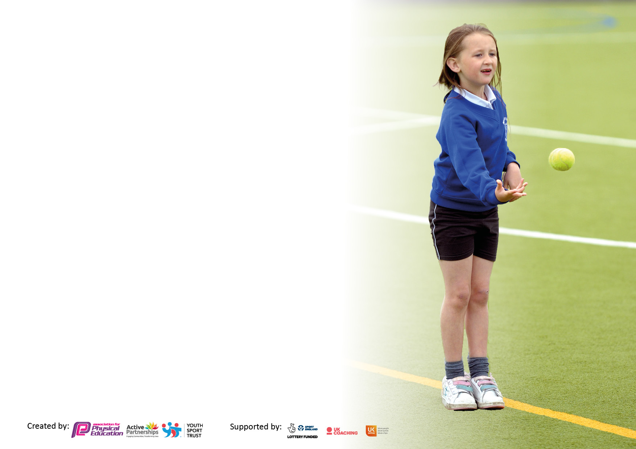

It is important that your grant is used effectively and based on school need. The [Education Inspection Framework](https://assets.publishing.service.gov.uk/government/uploads/system/uploads/attachment_data/file/843108/School_inspection_handbook_-_section_5.pdf) makes clear there will be a focus on **‘whether leaders and those responsible for governors all understand their respective roles and perform these in a way that enhances the effectiveness of the school’**.

Under the [Quality of Education](https://assets.publishing.service.gov.uk/government/uploads/system/uploads/attachment_data/file/843108/School_inspection_handbook_-_section_5.pdf) Ofsted inspectors consider:

**Intent** - Curriculum design, coverage and appropriateness

**Implementation** - Curriculum delivery, Teaching (pedagogy) and Assessment

**Impact** - Attainment and progress

To assist schools with common transferable language this template has been developed to utilise the same three headings which should make your plans easily transferable between working documents.

Schools must use the funding to make **additional and sustainable** improvements to the quality of Physical Education, School Sport and Physical Activity (PESSPA) they offer. This means that you should use the Primary PE and sport premium to:

* Develop or add to the PESSPA activities that your school already offer
* Build capacity and capability within the school to ensure that improvements made now will benefit pupils joining the school in future years
* The Primary PE and sport premium should not be used to fund capital spend projects; the school’s budget should fund these.

Pleasevisit[gov.uk](https://www.gov.uk/guidance/pe-and-sport-premium-for-primary-schools)fortherevisedDfEguidanceincludingthe5keyindicatorsacrosswhichschoolsshoulddemonstrate animprovement.Thisdocumentwillhelpyoutoreviewyourprovisionandtoreportyourspend.DfEencouragesschools to use this template as an effective way of meeting the reporting requirements of the Primary PE and sport premium.

We recommend you start by reflecting on the impact of current provision and reviewing the previous spend.

Schools are required to [publish details](https://www.gov.uk/guidance/what-maintained-schools-must-publish-online#pe-and-sport-premium-for-primary-schools) of how they spend this funding, including any under-spend from 2019/2020, as well as on the impact it has on pupils’ PE and sport participation and attainment. **All funding must be spent by 31st July 2023.**

We recommend regularly updating the table and publishing it on your website throughout the year. This evidences your ongoing self-evaluation of how you are using the funding to secure maximum, sustainable impact. Final copy must be posted on your website by the end of the academic year and no later than the 31st July 2023. To see an example of how to complete the table please click [HERE](http://www.afpe.org.uk/physical-education/wp-content/uploads/afPE-Example-Template-Indicator-2018-Final.pdf).



**Details with regard to funding**

Please complete the table below.

|  |  |
| --- | --- |
| Total amount allocated for 2022/23 | £19, 640 |
| Total amount of funding for 2022/23. To be spent and reported on by 31st July 2023. | £19, 640 |

**Swimming Data**

Please report on your Swimming Data below.

|  |  |
| --- | --- |
| Meeting national curriculum requirements for swimming and water safety.  N.B. Complete this section to your best ability. For example you might have practised safe self-rescue techniques on dry land which you can then transfer to the pool when school swimming restarts.  **Due to exceptional circumstances priority should be given to ensuring that pupils can perform safe self rescue even if they do not fully meet the first two requirements of the NC programme of study.** |  |
| What percentage of your current Year 6 cohort swim competently, confidently and proficiently over a distance of at least 25 metres?  **N.B.** Even though your pupils may swim in another year please report on their attainment on leaving primary school at the end of the summer term 2020.  Please see note above | 87% |
| What percentage of your current Year 6 cohort use a range of strokes effectively [for example, front crawl, backstroke and breaststroke]?  Please see note above | 87% |
| **What percentage of your current Year 6 cohort perform safe self-rescue in different water-based situations?** | 89% |
| Schools can choose to use the Primary PE and sport premium to provide additional provision for swimming but this must be for activity **over and above** the national curriculum requirements. Have you used it in this way? | Yes |

**Action Plan and Budget Tracking**

Capture your intended annual spend against the 5 key indicators. Clarify the success criteria and evidence of impact that you intend to measure to evaluate for pupils today and for the future.

|  |  |  |  |  |
| --- | --- | --- | --- | --- |
| **Academic Year:** 2022/23 | **Total fund allocated: £19,210** | **Date Updated: 08/07/2022** | |  |
| **Key indicator 1:** The engagement of all pupils in regular physical activity – Chief Medical Officers guidelines recommend that primary school pupils undertake at least 30 minutes of physical activity a day in school | | | | Percentage of total allocation: |
| 14.3%= £2820 |
| **Intent** | **Implementation** | | **Impact** |  |
| Your school focus should be clear what you want the pupils to know and be able to do and about  what they need to learn and to  consolidate through practice: | Make sure your actions to achieve are linked to your intentions: | Funding allocated: | Evidence of impact: what do pupils now know and what can they now do? What has changed?: | Sustainability and suggested next steps: |
| -Reintroduce the Golden KM to get all pupils undertaking at least 15 minutes of additional activity per day.  -Launch Real PE Home platform to support children and families to access physical activity at home.  -Support families to ensure all children have access to appropriate pe kit for part taking in physical activity and sport within school.  -Support pupils who have not yet achieved the requirement to swim 25m and perform a self-rescue at the end of their year 4 core swimming lesson programme. | * Identify course route and number of laps * Ensure all children have a login for real PE at home * Introduce to parents through newsletter * Support families and teachers to access.   - to have clean PE kit available for children who frequently attend school without suitable clothing for physical activity and sport.  - Provide pupils with additional opportunities to learn a self-rescue both on land and within water.  - renegotiate additional pool time with leisure centre to provide additional swimming lessons with highly trained coaches for target children in years 5 and 6. | £50  £230  £200  £2,340 | -All pupils involved in 15 minutes additional activity per day.  - All families have opportunity to access free physical activity games and ideas to enhance physical activity beyond the school day.  - All pupil able to actively and safely participate in PE, school sport and physical activity in appropriate clothing.    - increase the number of pupils achieving the national swimming requirements by the end of year 6.  -Reduce the gap in swimming attainment for disadvantaged pupils. | -Ensure golden KM is firmly embedded in school day.    - continue to work closely with families to embed Real PE Home in the school community and increase number of families utilising the platform.  -Continue to ensure all children, particularly PP children have access to the correct PE kit.  - continue to work closely to provide swimming teachers with knowledge of pupil’s current experience prior to swimming lessons to support assessment and grouping at the beginning of year 4 and identifying pupils who would benefit from additional lessons through assessment at the end of year 4. |

|  |  |  |  |  |
| --- | --- | --- | --- | --- |
| **Key indicator 2:** The profile of PESSPA being raised across the school as a tool for whole school improvement | | | | Percentage of total allocation: |
| 5.1%= £1010 |
| **Intent** | **Implementation** | | **Impact** |  |
| Your school focus should be clear what you want the pupils to know and be able to do and about  what they need to learn and to  consolidate through practice: | Make sure your actions to achieve are linked to your intentions: | Funding allocated: | Evidence of impact: what do pupils now know and what can they now do? What has changed?: | Sustainability and suggested next steps: |
| -Train and equip upper KS2 pupils to become play leaders to raise activity levels and opportunities for sport and physical activity during lunch times.  - provide access to Real PE games and play activities to support playleaders in running and facilitating physical activities at lunch times.  -Extra display and notice boards in the hall and around the communal corridors to raise the profile of PE and sport to all pupils, visitors and parents. | - provide training with PE coordinator for playground leaders to develop their leadership skills and knowledge of games and activities.  Support playleaders by timetabling leaders to organise 1x activity each day on a rota.  - buy equipment to support playleaders to undertake their role.  - Playleaders to have access to Real PE resources, games and activities to develop physical activity and fundamental movement skills during lunch times.  -Buy notice boards and arrange to have them fitted and fixed into place.  -achievements celebrated- (match results, notable pupils’ achievements within lessons and outside of school). | £750  £160  £100 | - increase the number of children participating in physical activity at lunch times.  -develop pupils’ knowledge of playground games and activities.  -reduce the number of incidents of social conflict during lunchtime by facilitating cooperative play.  -All pupils have access to additional daily physical activity opportunities each day.  The notice boards are regularly updated with information about matches/ clubs and results so pupils’ are inspired and wanted to get involved in sport and activity both inside and outside school. | - work closely with lunchtime school staff and DSSP to further support playleaders.  -closely monitor number of pupils accessing playleader run activities.  - continue to raise the profile of Real PE platform and physical activity within school. |

|  |  |  |  |  |
| --- | --- | --- | --- | --- |
| **Key indicator 3:** Increased confidence, knowledge and skills of all staff in teaching PE and sport | | | | Percentage of total allocation: |
| 48.6% =£9560 |
| **Intent** | **Implementation** | | **Impact** |  |
| Your school focus should be clear | Make sure your actions to | Funding | Evidence of impact: what do | Sustainability and suggested |
| what you want the pupils to know | achieve are linked to your | allocated: | pupils now know and what | next steps: |
| and be able to do and about | intentions: |  | can they now do? What has |  |
| what they need to learn and to |  |  | changed?: |  |
| consolidate through practice: |  |  |  |  |
| In order to improve the progress and achievement of all pupils the focus is on up-skilling staff:  - provide refresher training for Real PE to all teaching staff new and existing.  - Join the Dartmoor Schools Sports Partnership to ensure all staff have access to high quality team teaching, professional development and training opportunities with highly experienced PE teachers and sports coaches.  -allocate and fund time to release subject leader half day 1x weekly to undertake teaching mentoring and team-teaching programme to support implementation of curriculum.  - provide subject leader and teaching staff with access to the Association for Physical Education.  -identify and stock additional equipment to further develop the provision of curricular PE | ­- Baseline assess pupils so that impact can be measured over time.  -ensure all staff have access to the Real PE teaching platform and assessment platform.  Set up assessment wheels for new classes.  -book and undertake two CPD twilight sessions in Autumn term 2022 with the Real PE coaches:  1x refresher training on teach a high-quality lesson and utilising the platform to support and enhance teaching in lessons.  1x Real PE assessment platform training.  -organise membership meeting with Dartmoor Schools Sports Partnership.  -identify staff members areas for development through survey.  -Arrange 3x CPD for focused activities/ areas of development for staff members.  Arrange 3x PE impact days.  -subject leader to partake in PE lead update meetings  -Subject leader to devise a mentoring, team-teaching and quality assurance time table to support all staff in implementing the PE curriculum.  -Subject leader to undertake team teaching, lesson observations, feedback to support staff development of subject knowledge and confidence.  -Subject leader to conduct quality assurance to monitor the implementation and impact of the PE curriculum.  -continue to renew association subscription and provide staff with access.  -subject leader to attend webinars and read recent research.  -signpost teachers to useful webinars for CPD- 2x yearly.  -Provide subject leader and staff with copies of the associations publication of Physical Education matters and Physical Education and Sport Pedagogy journal to support staff development.  -conduct yearly audit of equipment to identify safety concerns and gaps within resources for teaching curriculum | £1000  £1730  £6200  £180  £900 | -All teaching staff have knowledge and confidence to deliver high-quality Real PE lessons to support the development of fundamental movement skills and multi-ability cogs for all children.  - All staff are consistently utilising high- quality assessment for learning methods within lessons as well as conducting summative assessment both prior teaching and once half termly.  -support for subject leader in leading and developing PE and school sport across the school.  - CPD delivered to staff  -Subject leader attended conference run by DSSP  -quality assurance of pe lessons, raising the quality of teaching across the school and identifying strengths and areas of improvement in curriculum pe.  -Subject leader has undertaken pupil voice to further develop the curriculum, physical activity and school sport on offer to pupils in the school.  - targeted CPD in planning and team- teaching lessons with specifically identified staff members has raised confidence and subject knowledge of teachers.  -Teachers have had access to webinars and up to date information via updates sent from subject leader, webinars sign posted to specific staff members to raise subject knowledge and access to the real pe association has kept teachers informed with up to date research and pedagogy.  -increased access to a range of equipment and resources for adapting pe lessons to suit all pupils needs.  Increased access to quantity and quality equipment to ensure pupils are maximising the time spend physically moving and engaging in PE lessons and school sports clubs. | -Should PE and Sport funding be discontinued, staff are upskilled and confident in delivering high-quality PE and physical activity both within and outside the school curriculum.  -closely work with SLT to monitor impact on pupil’s progress and attainment over time.  -utilise impact days to support further staff development by identifying areas of CPD for staff members.  -Subject leader to reduce time monitoring curriculum and increase time team teaching, planning and assessing with teachers.  -continue to engage staff with up to date research and pedagogy through signposting more webinars or articles  -Ensure equipment is well maintained and safe through the use of a sports leaders or active play leaders |
| **Key indicator 4:** Broader experience of a range of sports and activities offered to all pupils | | | | Percentage of total allocation: |
| 12.7% =£2500 |
| **Intent** | **Implementation** | | **Impact** |  |
| Your school focus should be clear | Make sure your actions to | Funding | Evidence of impact: what do | Sustainability and suggested |
| what you want the pupils to know | achieve are linked to your | allocated: | pupils now know and what | next steps: |
| and be able to do and about | intentions: |  | can they now do? What has |  |
| what they need to learn and to |  |  | changed?: |  |
| consolidate through practice: |  |  |  |  |
| -partner with outside local sports clubs and coaches to support and enhance the offer of extra-curricular school sports clubs.  - fund transport to facilitate pupils to attend clubs and fixtures at local schools. | -identify and partner with 2x local sports clubs to enhance extra-curricular offer for pupils.  -Identify and partner with local coaching company to facilitate additional sports and physical activity clubs to broaden offer for pupils.  -identify partnerships with other local schools to develop and enhance the range of sporting and physical activity opportunities on offer to all pupils. | £200  £2300 | - promotion of local football, tennis, rugby and swimming clubs has increased participation of pupils in clubs both in and outside school.  - increasing number and range of clubs being run in school being accessed by a variety of pupils.  - a wider range of sport and physical activity festivals and competitions being attended and more frequently  -Attending sessions in coastal water safety has increased knowledge and understanding for our disadvantaged pupils | -closely monitor the number and range of pupils accessing extra- curricular sports and physical activity both at lunch and after school.  -Increase range of opportunities for KS1 children to attend festivals in local area by building more partnerships with local schools. |

|  |  |  |  |  |
| --- | --- | --- | --- | --- |
| **Key indicator 5:** Increased participation in competitive sport | | | | Percentage of total allocation: |
| 19.1% = £3750 |
| **Intent** | **Implementation** | | **Impact** |  |
| Your school focus should be clear | Make sure your actions to | Funding | Evidence of impact: what do | Sustainability and suggested |
| what you want the pupils to know | achieve are linked to your | allocated: | pupils now know and what | next steps: |
| and be able to do and about | intentions: |  | can they now do? What has |  |
| what they need to learn and to |  |  | changed?: |  |
| consolidate through practice: |  |  |  |  |
| -join Dartmoor School Sports Partnership to enhance the opportunities for interschool competitions.  -fund transport to Inter-school competitions and events. | - Identify and attend local cluster events (festivals and tournaments):  1x KS1(year1/2)  1x LKS2 (year 3/4)  1x UK2 (year 5/6)  1x SEND  1x DSSP event  -identify events and book transport to facilitate pupils in attending inter-school competitions. | £1,750  £2000 | -pupils attended football tournament competitions, cross country running events, SEND swimming, swimming gala and multi-skills festivals  -boosted confidence and competence for pupils representing the school.  -all pupils have had opportunities to attended and represent school at various interschool competitions during school hours. | - ensure replacement/ rearranged events are located or attended for those events cancelled by staff absence, industrial action and weather.  -Ensure equal opportunities for all pupils to attend by supporting pupils in accessing the correct kit and transportation needed for after school events. |

|  |  |
| --- | --- |
| Signed off by | |
| Head Teacher: | Gareth Howells |
| Date: | 26.06.2023 |
| Subject Leader: | Katy Mott |
| Date: | 26.06.2023 |
| Governor: | Miranda Martyn |
| Date: | 26.06.2023 |