Online Safety Toolkit: Essential Resources for Parents

We understand that navigating the digital world with your children can be challenging. To help you support your children and address online safety concerns, we have compiled information on three key services designed to help remove harmful content and offer crucial support.

- CEOP: Child Exploitation and Online Protection Command

https://www.ceop.police.uk/ceop-reporting

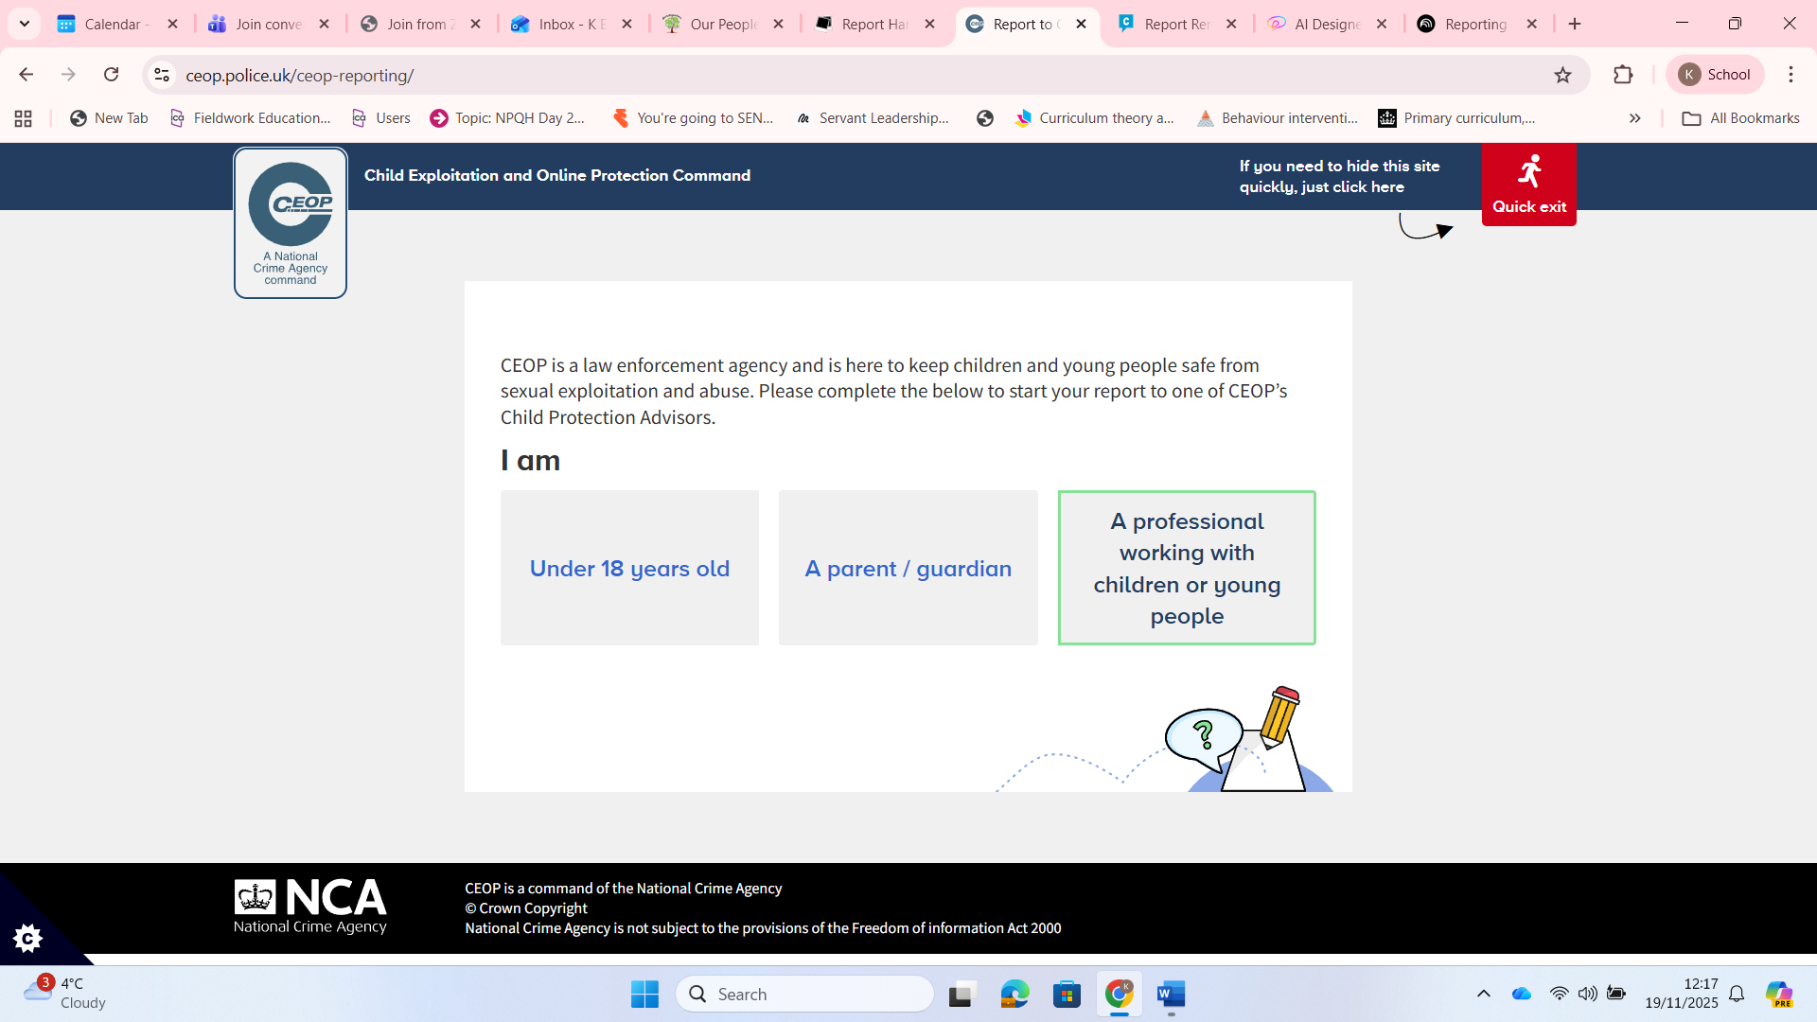

The Child Exploitation and Online Protection (CEOP) Command is dedicated to keeping children safe from sexual harm and grooming online.

What CEOP handles (and what it doesn't): CEOP helps with concerns related to sexual harm and grooming online. It is important to know that CEOP does not respond to reports about online bullying, fake accounts, or account hacking. If you have concerns about something sexual that has happened to your child or another child online, you can make a report as a parent/guardian.

What parents should know:

- If you have already reported your concern to the police (via 999 or 101) or children’s social care, you do not need to make a report to CEOP.
- For advice and further information on keeping your child safe online, you can visit the CEOP Education website for parents and carers.
- If you wish to discuss a concern or seek advice immediately, you can call the NSPCC helpline for parents and professionals at any time on 0808 800 5000.

- Report Harmful Content

https://reportharmfulcontent.com/?lang=en-gb

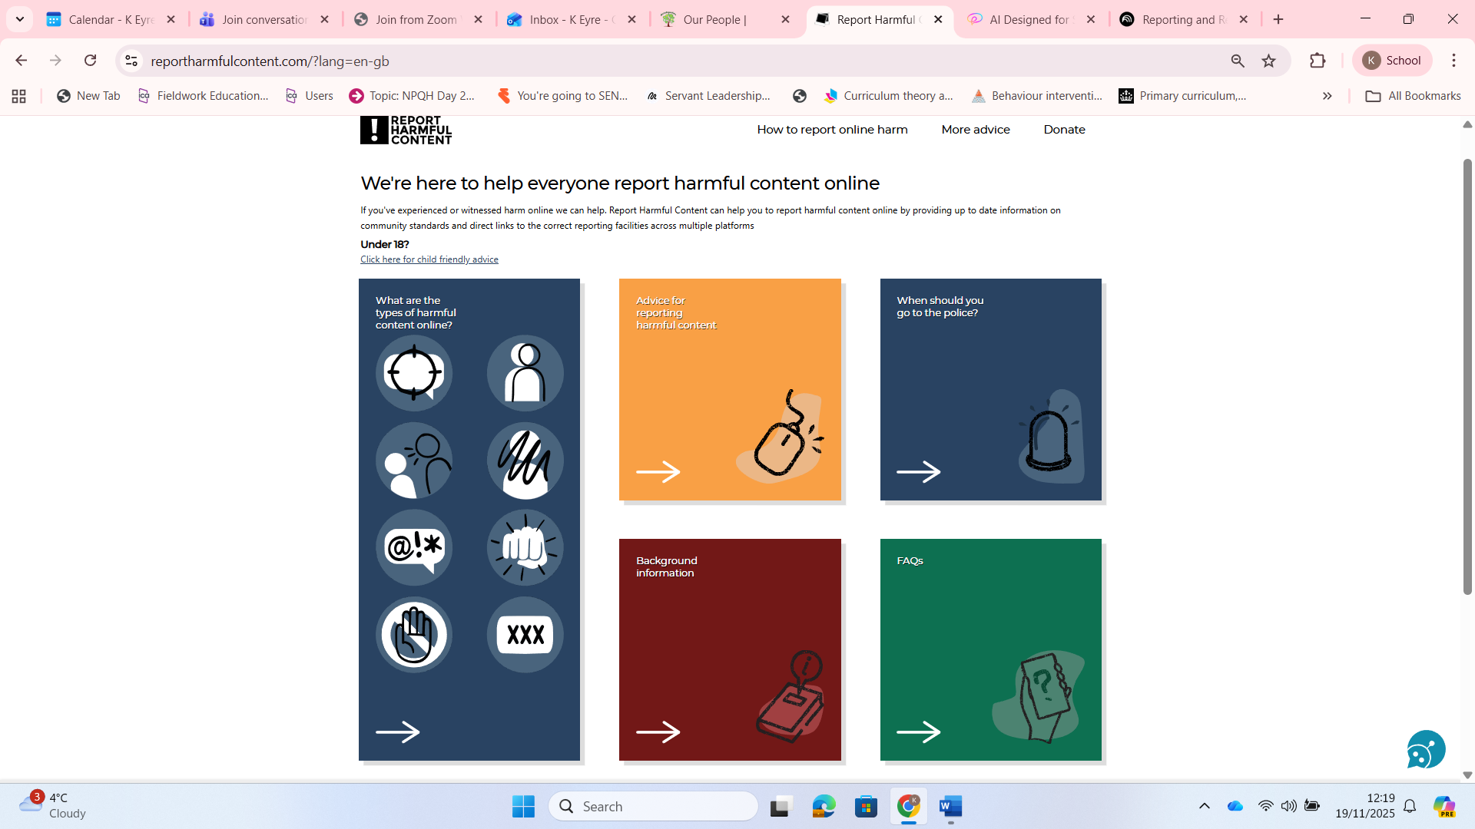

Report Harmful Content is a service dedicated to helping everyone report various types of harmful content online.

What they do: Report Harmful Content provides a vital service for individuals who have witnessed or experienced harm online. They help you report harmful content by offering up-to-date information on community standards and providing direct links to the correct reporting facilities across multiple platforms.

Key Reporting Information:

- If you or the person you are helping is in immediate danger, you should contact the police by dialling 999.
- For young people: If a child is under 18, there is a separate section on the website offering child-friendly advice.
- Important Exclusions: Report Harmful Content is unable to take reports about terrorism-related content (which should be reported to Action Counters Terrorism). They are also unable to take reports of sexual images of under 18s, which should be reported directly to the Internet Watch Foundation (IWF).

- Childline and the Report Remove Service

https://www.childline.org.uk/info-advice/bullying-abuse-safety/online-mobile-safety/report-remove

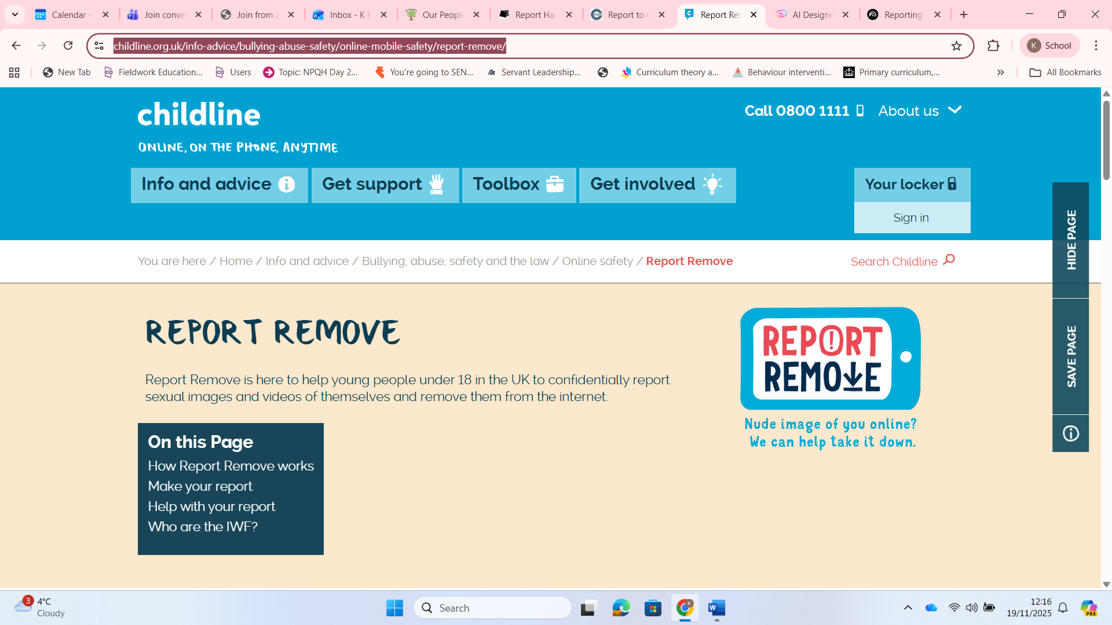

Childline is available for all young people, offering support whatever they are going through. Childline operates a specific service called Report Remove, which focuses on removing sexual images and videos of young people under 18 from the internet.

Report Remove Focus: Report Remove is specifically designed to help young people under 18 in the UK to confidently report sexual images and videos of themselves and remove them from the internet. This service is safe, easy, and free. Childline works alongside the Internet Watch Foundation (IWF) to achieve this.

Support for the Young Person:

- A young person making a report will create a Childline account to receive updates on their report. Updates are sent to their Childline locker.
- Young people can talk to a Childline counsellor if they want any extra support, or access support on the Childline website. Counsellors are always there to help and can be spoken to about anything they are going through.
- Confidentiality: Most of the time, nobody will know that the young person made a report. The image or video is shared with the IWF, and they will work with the police to get it removed. If the police already have the image, they might investigate, but the police are there to protect the young person, not get them into trouble.
- General Support and Contact: For immediate support or if your child needs someone to talk to, Childline can be reached 24 hours a day by calling them free on 0800 1111. Young people can also access 1-2-1 counsellor chat or use message boards to share experiences with other young people.

In Summary: Key Contacts for Immediate Help

Concern | Recommended Action/Contact | Details from Sources
Immediate Danger (Police) | Call 999 | Contact the police if in immediate danger.
General Online Harm (e.g., harassment, bullying, general misconduct) | Report Harmful Content | Provides links and advice for reporting harmful content across multiple platforms.
Sexual Harm / Grooming (Child) | CEOP | Dedicated to keeping children safe from sexual harm and grooming online.
Sexual Images / Videos of Under 18s | Childline Report Remove | Specifically for young people under 18 in the UK to report and remove these images.
Emotional Support / Talking to someone anonymously | Childline | Free phone line 0800 1111 available 24 hours a day.
Parent/Professional Advice | NSPCC Helpline | Call 0808 800 5000 for discussion or advice.

