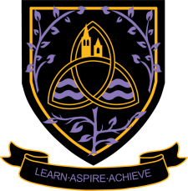
English Language
A Level 2024 - 2026
Wigston College

Examination Board
AQA
Entry Requirements:
GCSE Grade 5 in English Language or English Literature.
What will I be studying?
Component 1 [40%] Language, the individual and society
Component 2 [40%] Language diversity and change
Component 3 [20%] Language in action
How will I be studying?
This course will be taught in a group with access to two different teachers. You will be expected to make an active contribution to classroom debate and participate fully in creating a dialogue of learning. Your assignments will involve a range of tasks, with both analytical and creative elements. Students will be expected engage in wider reading, explore relevant cultural events and participate in practical workshops. There will be a stress upon independent learning as the course progresses, with students taking on greater ownership and control of their studies. The course is designed to enhance the students’ relationship with English language and the study of linguistics.
How will I be assessed?
Component 1 [40%] - Language, the individual and society: This is a 2hr and 30 minute written examination and externally marked.
Component 2 [40%] - Language diversity and change: This is a 2hr and 30 minute written examination and externally marked.
Component 3 [20%] - Language in action: an internally assessed and externally moderated folder of coursework.
Where Next?
English Language is recognised as a rigorous academic award and highly valued by higher education institutions. It develops your pragmatic approach to tasks and enhances your powers of communication, allowing you to fully understand how and why our language functions. It provides unique insight to appreciate how humans convey information, exploring both the production and reception elements of communication. It is an incredibly adaptive subject, offering development opportunities in business, advertising, the arts, speech therapy, to name but a few.

