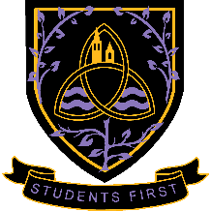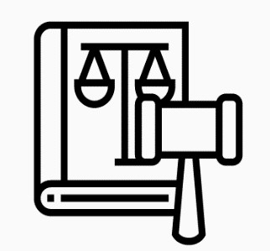

Wigston College

Law

A Level

2024

-

2026

Examination Board
AQA 603/1009/1
Entry Requirements
In addition to the standard College entry requirements (see our prospectus), a minimum of GCSE level 5s in English Language and English Literature are required.
What will I be studying?
Year 1: In the first year you will learn about the nature of law, including the sources of law and the differences between criminal and civil law. You will also explore the English legal system, for example the courts, how law is made and reformed, and how you can qualify as a lawyer. You will be introduced to two areas of law, criminal law and tort law, and will learn to apply legal principles and cases to hypothetical scenarios.
Year 2: In the second year you will focus on problem solving in criminal law, tort law and contract law. You will also explore the role of law in society, study the relationship between law and morality and consider whether the law always achieves justice.

How will I be studying?
Through discussion, group work, individual work, presentations, written projects, essay writing and conducting research.

How will I be assessed?

Paper 1: The nature of law and the English legal system (25 marks) and Criminal law (75 marks). 2 hour examination. A combination of multiple choice, short answer and extended writing questions.

Paper 2: The nature of law and the English legal system (25 marks) and Tort (75 marks). 2 hour examination. A combination of multiple choice, short answer and extended writing questions.

Paper 3: The nature of law and the English legal system (25 marks) and Contract Law (75 marks). 2 hour examination. A combination of multiple choice, short answer and extended writing questions.

Where Next?
A Level Law is not just for students who want to enter a career in law. It is a respected subject and is a welcome addition to many A Level programmes of study. A Level Law links well with science subjects, English Language and Literature, humanities, social science subjects and even Drama and Theatre Studies

