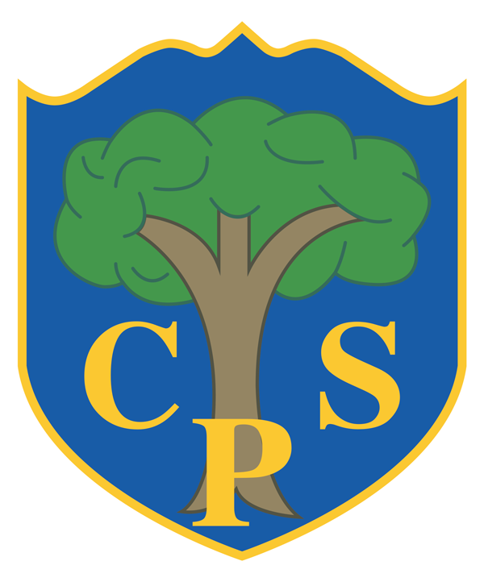
MUSIC Development Plan
COPPICE PRIMARY SCHOOL

Overview
Detail | Information
Academic year that this summary covers | 2025-2026
Date this summary was published | May 2026
Date this summary will be reviewed | June 2027
Name of the school music lead | Mr Dafydd Lampard
Name of local music hub | Severn Arts

This is a summary of how our school delivers music education to all our pupils across three areas – curriculum music, co-curricular provision and musical experiences – and what changes we are planning in future years. This information is to help pupils and parents or carers understand what our school offers and who we work with to support our pupils’ music education.

Part A: Curriculum Music
This is about what we teach in lesson time, how much time is spent teaching music and any music qualifications or awards that pupils can achieve.
At The Coppice Primary School, we believe that music is fundamental in enriching our lives. We inspire our children to develop a love and appreciation of music, while also providing them with an extensive range of practical opportunities that develop their independent musicianship, increasing their self-confidence, creativity and collaboration. As a result, our curriculum (inspired by the Model Music Curriculum) has been carefully and comprehensively mapped out across the children’s journey through primary school. Each of the content threads of the music National Curriculum have been thoughtfully sequenced, with content delivered in small, manageable steps that allow the children to progressively build clarity and autonomy over their musicianship, whether with instrumentation, composition, singing or listening.
Music is taught in class by class teachers during a designated 45 minute slot every Wednesday at 14:30. Units are sequenced half-termly and alternate between a listening/appraisal focus and an instrument focus (see Curriculum Roadmap and Curriculum Overview for more detail on the specific units and their sequencing across the school).
Our music curriculum is delivered predominantly through Charanga and BBC Ten Pieces for the majority of the taught curriculum, with Sing Up, guidance from the Model Music Curriculum (MMC) and staff expertise used for singing and listening.
Instrumentation, Composition and Performance
The music National Curriculum (2013) states that children “have the opportunity to learn a musical instrument”, “understand and explore how music is created, produced and communicated, including through the inter-related dimensions” and “perform music across a range of historical periods”.
At The Coppice, this is achieved through the use of Charanga, which provides a classroom-based, participatory and inclusive approach to music learning. Within each unit, the children have the opportunity to explore sounds, listen actively, compose and perform.
Charanga builds experience and develops understanding of the dimensions of music throughout the scheme: pitch, duration, dynamics, tempo, timbre, texture, structure and appropriate musical notations. Each unit focuses on one process, such as performance or composition, or one dimension, such as pitch, but the learning progresses within the context of all the inter-related processes and dimensions of music. A wide variety of notations, including picture, graphic, rhythm and staff notation are integrated, wherever appropriate, with practical music-making activities throughout the scheme. Notations are used progressively to promote understanding and use of the representation of sound in symbols by all children.
Instrumentation begins in Nursery, with the use of tuned and untuned percussion in free-play. Whole-class singing remains the primary focus within the EYFS (see below for more information).
In KS1, the instrument focus is boomwhackers. The children have repeated exposure to these tuned percussive instruments throughout Years 1 and 2 and use them to perform collaboratively, in groups and as a class. In lower KS2, the children move onto glockenspiels, providing them increased independence over their musicianship, before progressing onto recorders in upper KS2.
While Charana is our primary source for instrumentation, we have also curated a set of three units per year group from BBC Ten Pieces – a major educational initiative launched by BBC Music and BBC Learning that introduces children to classical music. Each unit focuses on a particular performer and piece of music and consists of a series of lessons that get the children to listen to and appraise the music, before giving them the opportunity to use a wide variety of instruments (including body percussion) to compose and perform their own pieces, individually and in groups.
Listening and Appraisal
Our school has a very strong culture of music listening. With guidance taken from the MMC, as well as relying on the extensive knowledge of specialist staff members, we have created our own two-year rolling music listening curriculum. It is broken into weekly categories that explore a variety of different musical themes, such as genre, time period, musical elements, important dates, geographic location, cultures and traditions.
It is delivered in class each morning during the fifteen minute registration period in the form of the ‘morning music’. The music team creates morning slides for each year group that feature that week’s thematic focus and playlist of four songs, along with a brief contextual description of the song/artist. The children listen to the playlist each morning, focusing on one song a day, and vote for their favourite piece on Friday.
Additionally, the aforementioned BBC Ten Pieces units also integrate in-depth appraisal of the pieces, giving the children the opportunity to explore the history and cultural significance of a particular piece in depth.
Singing
Singing is our greatest strength within the music curriculum. We foster a whole-school approach to singing under the ‘growth-mindset’ that every child can sing when given the encouragement, practice and opportunity to thrive.
Weekly singing assemblies are a key aspect of our timetable and take place every Wednesday afternoon in the main hall. Being a three-form-entry school, Years 1 to 6 are split into three separate singing groups (with one class per year in each group) that rotate on a three-weekly rota. Each rota has a particular assembly/singing theme and a song is chosen that each class has 3 weeks to practice in class before their assembly. Daily singing is an expectation in our music curriculum and all class teachers are highly encouraging to the children and are essential in reinforcing this amazing culture of singing. On top of the assembly song, class teachers use Sing Up to sing a variety of other songs suitable to the children’s voices.
The assemblies themselves consist of an introductory piece that the children listen to and watch as they enter, followed by a comprehensive warmup that helps to educate the children on how to maintain a healthy voice. The main body of the assembly is spent singing a collection of songs that the children have learned, before finishing with a performance of that week’s chosen assembly song.

Part B: Extracurricular Music
This is about opportunities for pupils to sing and play music, outside of lesson time, including choirs, ensembles and bands, and how pupils can make progress in music beyond the core curriculum.
At The Coppice, we offer a range of extracurricular musical opportunities that enable all pupils to develop their skills and confidence, and we celebrate their ongoing achievements with our wider school community.
Peripatetic Music Lessons
We offer a wide range of peripatetic music lessons delivered by specialist teachers. Children have the opportunity to learn a variety of instruments, including guitar, violin, piano, flute, trumpet and percussion. These lessons support pupils in developing not just their musical talents, but also a lifelong love of music.
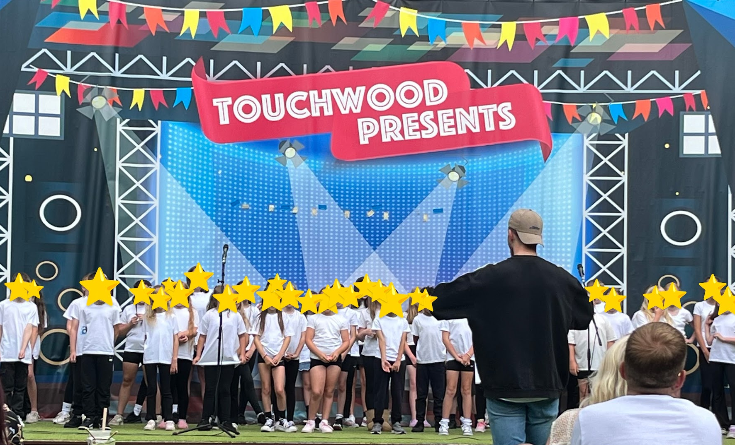
School Choir
Led by Mr Lampard, our choir is open to Years 4-6 and has a capacity of around 70 children that rehearse every Friday. It requires no audition to enter, making it accessible to all children, regardless of experience or ability. The children are exposed to more in-depth singing tuition and a vast array of performance opportunities. The club is active throughout the entire academic year and has two main performance phases: Young Voice (September-January) and The Coppice Choir Concert (January-July).
- Young Voices (September-January):
Since 2014, our school has proudly participated in the Young Voices concerts, allowing our choir to perform as part of one of the world's largest children’s choirs. Our pupils consistently demonstrate exceptional enthusiasm, dedication, and commitment to learning the repertoire. This experience not only develops their musical skills but also builds confidence and creates lasting memories.
- Coppice Choir Concerts (January-July):
During the second half of the academic year, we focus on our own repertoire of songs that we perform in our own concert in the summer within our wider community. The children have performed in one-off events at a range of locations, from St Philip’s Cathedral to Touchwood Shopping Centre; from Birmingham Town Hall to Hickory’s Smokehouse! These songs open up the opportunity for solo and group performances, as well as the progression to harmonies. The children are always very keen to involve themselves in these performances and always represent themselves and the school with pride.
On top of our main performances, we actively seek opportunities for the children to participate in local music events throughout the year, including annual festive performances at the local sheltered housing association and a community Christmas gathering at the Christian Life Centre on nearby Simms Lane.

Coppice Winter and Summer Music Concerts
Our Music Concerts are a highlight of the school year, bringing together all our young musicians to perform for an audience. These concerts showcase the breadth of musical talent within the school, featuring both singers and instrumentalists. Pupils at all stages of their musical journey are celebrated, from those who are just beginning to learn an instrument to those who have been developing their skills for several years. These performances provide a valuable opportunity for children to build confidence, take pride in their achievements and share their progress with the wider school community.

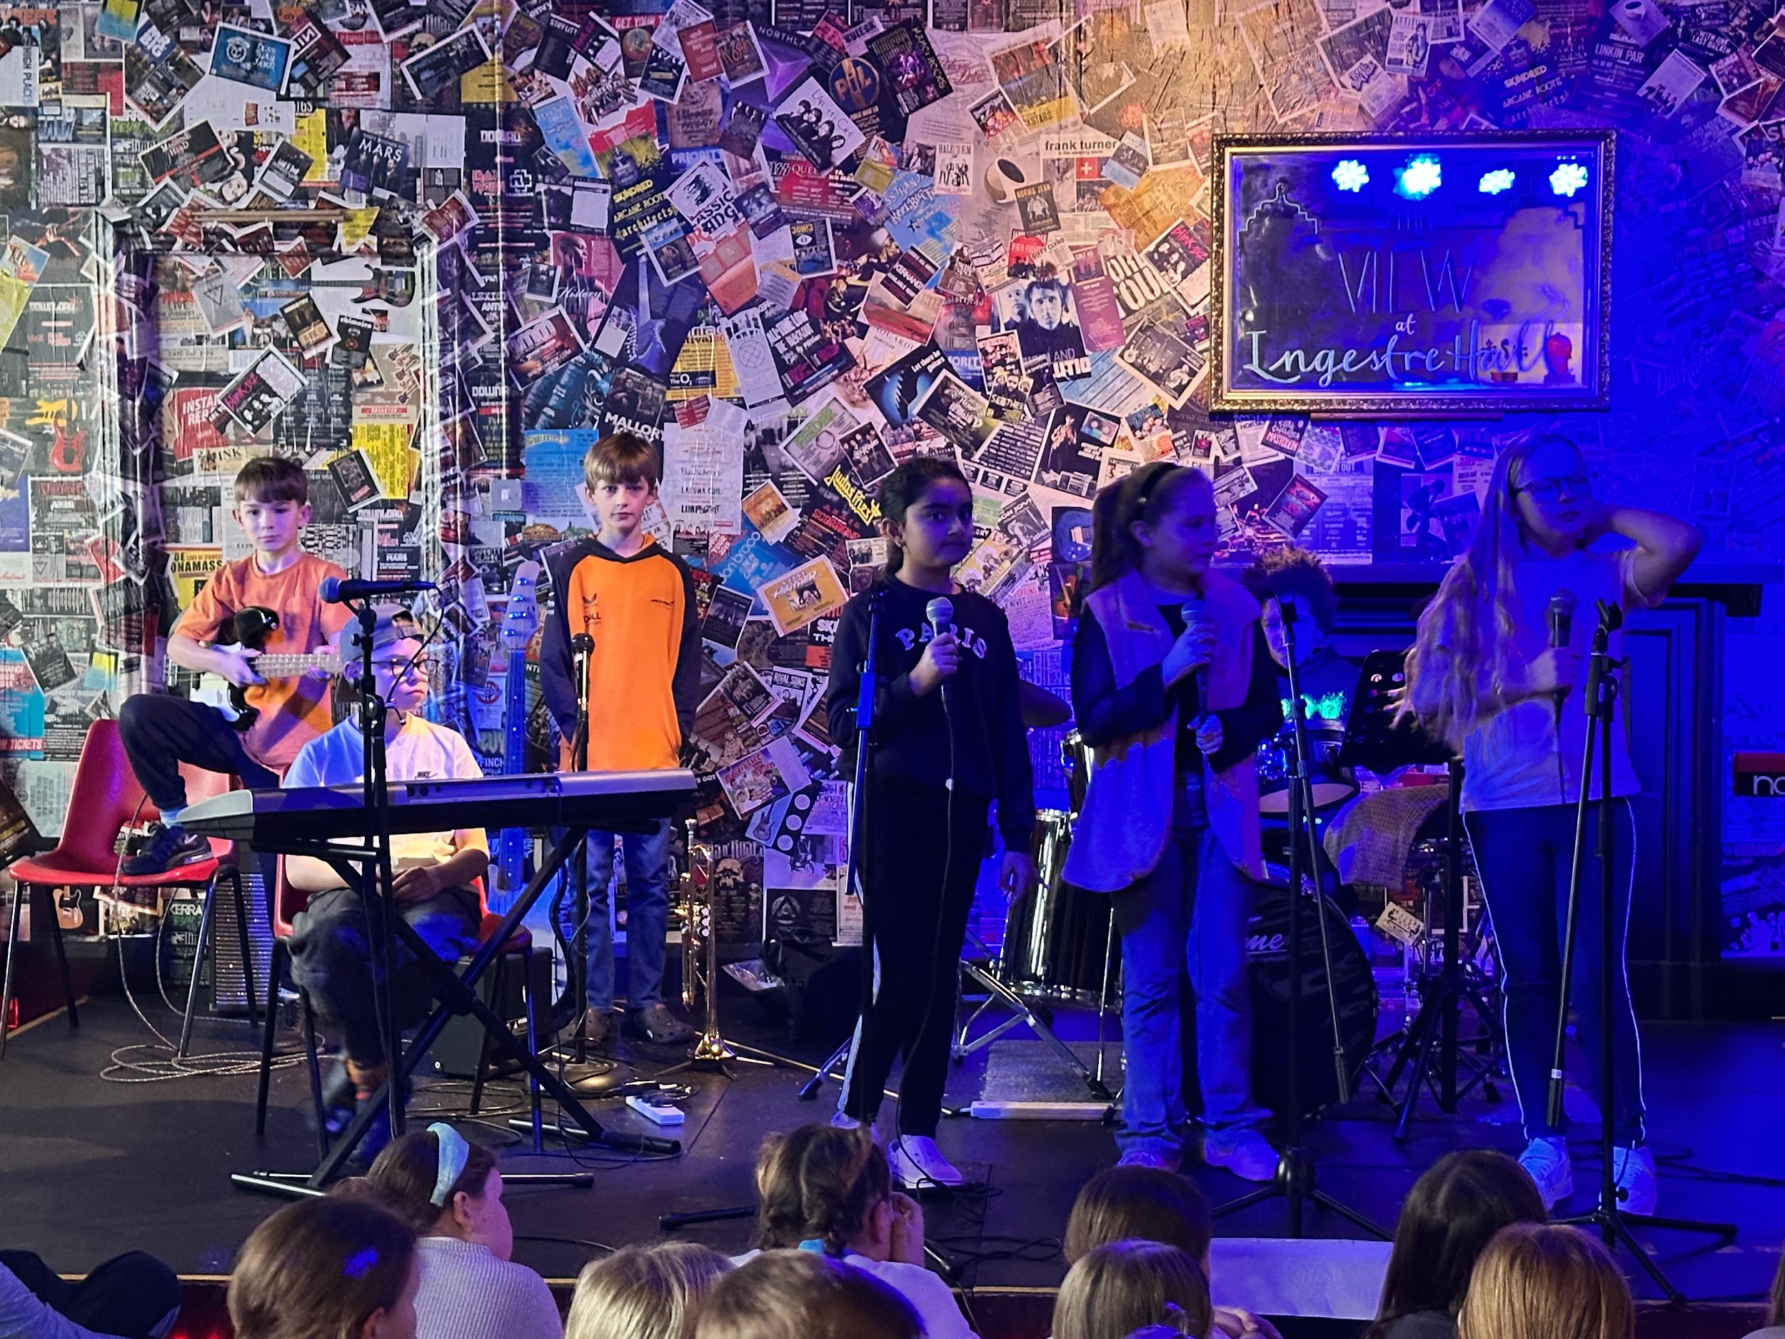
Year 5 Arts Residential: Ingestre Hall
Every Year 5 child has the opportunity to attend a residential arts experience at Ingestre Hall in Stafford. During this immersive week, children select a specialist art form, such as music. Over two days, the children work intensively on a group project, where they write lyrics, compose music and record their track. The week culminates in a showcase where children present their creations to their peers.

Part C: Musical Experiences
This is about opportunities for pupils to sing and play music, outside of lesson time, including choirs, ensembles and bands, and how pupils can make progress in music beyond the core curriculum.
- Daily in-class singing
- Weekly singing assemblies
- Class assemblies
- Y6 leavers assembly
- Winter and summer music concerts for peripatetic lessons
- Young Voices Concert
- School choir: various community performance throughout the academic year
- Y5 arts residential
- Class Christmas singing - each class learns and records themselves performing 3 Christmas songs that are then shared with parents.

In The Future
This is about what the school is planning for subsequent years.
- Introduce a method of assessment for singing and instrumentation that allows teachers to track children’s performance and confidence throughout the year and across key stages.
- Increase class teachers’ confidence with teaching singing at depth in class by providing them with singing-based CPD.

Further Information
The Department for Education publishes a guide for parents and young people on how they can get involved in music in and out of school, and where they can go for support beyond the school.
Severn Arts music hub – www.severnarts.org.uk

