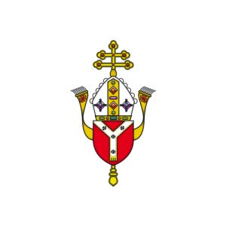
Botwell House Catholic Primary School
‘Love one another as I have loved you’
with Care, Courtesy & Concern
Headteacher: Mr K. Oakley

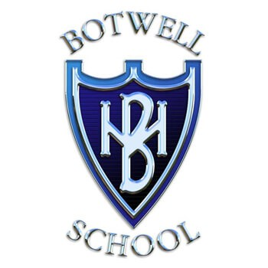
Tel: 0208 573 2229 Web: botwellhouseschool.co.uk
Twitter: @teambotwell Email: office@botwellhouse.school

Address: Botwell Lane, Hayes, Middlesex, UB3 2AB

Dear Parent / Carer 19th May 2026
Next half term we will once again be offering the following Clubs, which all start the week beginning 1st June and finish the week beginning 6th July 2026.
Mr Webb’s Sports Clubs – 3.15pm to 4.15pm

 | Tuesday | Wednesday | Thursday | Friday
Year 1 & 2 |  | Football
Year 3 & 4 | Multi Sports |  | Football
Year 5 & 6 |  |  |  | Football
The cost of the football club £5 per session (£30 in total).
The cost of the multi sports club £3 per session (£18 in total)
Please be aware that this club is being run by an external company – PSD – Mr Webb
Teacher-led Clubs – 3.15pm to 4pm
 | Year 1&2 | Year 3&4 | Year 5&6
Wednesday | Gardening | Art & Design | Running Club
The cost of these clubs is £3 per session (£18 in total).

Book by logging in to the teacher2parents app from 6pm tonight! Please remember to tick the consent box. Places are limited so book quickly, as spaces are allocated on a first come basis.
Unfortunately, we can not give any refunds.
Yours sincerely,
C.Bedford
Miss Bedford
PE Lead

