|  |  |
| --- | --- |
| **St Marys - Religious Education Knowledge Organiser** | |
| **Year 1** | **Topic 1.3 FAMILIES AND CELEBRATIONS** |

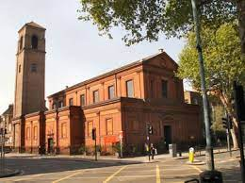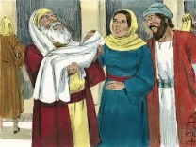

Key People and places

People: Simeon, Anna, Our parish priest

Place: Our local Parish Church: Our Lady of Grace and St Edwards

Key Scripture

Luke 2: 22-38 (Jesus is presented in the Temple)

Key Prayers

Sign of the Cross Our Father

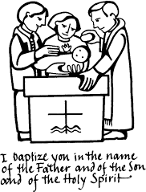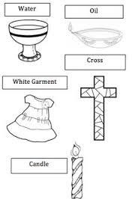

What will I know at the end of the unit?

* Recognise the stories of Jesus’ early life and that they are in the Bible.
* Begin to retell (sequence) in any form, the story of the Presentation.
* Talk about, ask questions and say what the stories of the Presentation and Finding in the Temple tell us about Jesus.
* Suggest an answer to questions like, ‘Why is my family important?’ and ‘Why is it good to belong?’
* Recognise that Baptism is a sign of belonging to God’s family.
* Talk about their experience of family celebrations and celebrations in a church.
* Name at least two signs used in Baptism.
* Say how at least one sign of Baptism is used.

|  |  |  |
| --- | --- | --- |
|  |  |  |
|  | What should I already know? |  |
|  | * What a celebration is * Why we celebrate * What a church building looks like and may have inside * That we have celebrations in church |  |

|  |  |
| --- | --- |
|  | |
| Key Vocabulary | |
| Baptism | The sacrament that allows us to join the family of the Church |
| Baptismal candle | The candle lit during Baptism which helps us understand that  when Baptised we are now “the light of the world” Mt 5 14 |
| belong | Acceptance as a member or part of a group |
| Church | All the people who love and believe in Jesus; the building  where we go to praise God |
| Font | The place in Church used to hold the water where the child is  Baptised |
| heaven | Where God lives and where we hope to be with Him one day |
| oil | A scared blessed oil used to bless the baby |
| white garment | The clothes worn by the child being baptised. White is a  symbol of purity |
| Sacrament | Sacred signs instituted by God. Meeting points with God. |
| sign | Something that shows meaning |
| Sunday | The “Day of the Lord” for Christians. |
| symbol | Something that represents something else |

|  |  |
| --- | --- |
| We will be looking at the signs and symbols of Baptism in this topic. |  |