Sight Word Rocket – Set 4
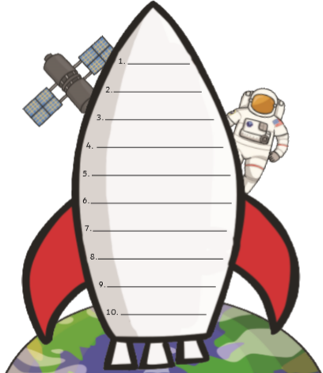
Can you practise reading and writing these sight words?
yes
this
some
they
went
her
said
like
all
are

