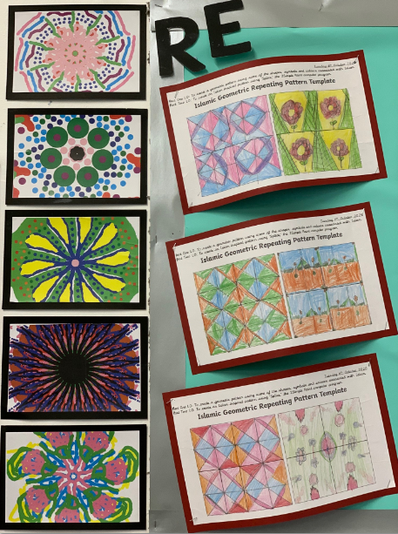
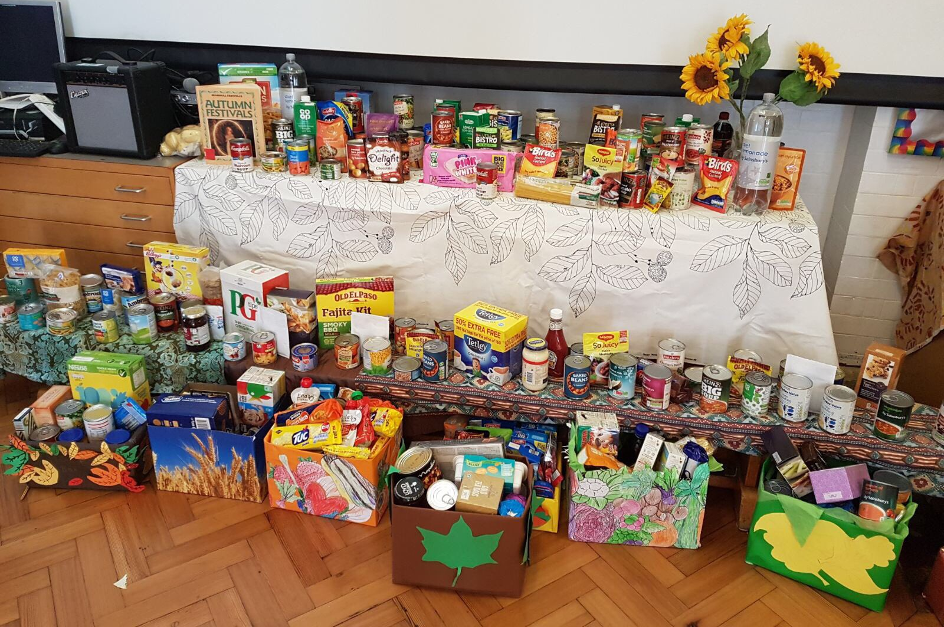
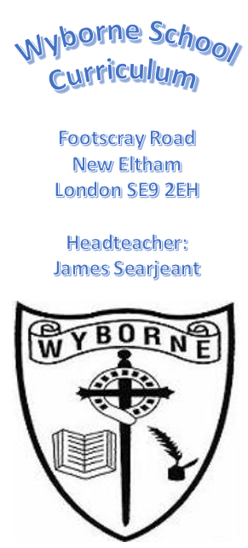

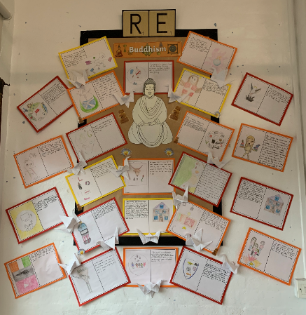
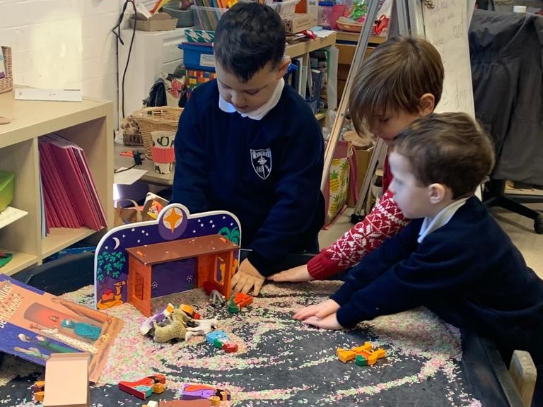
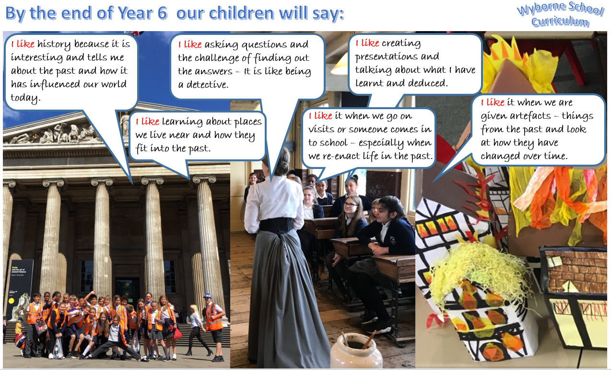
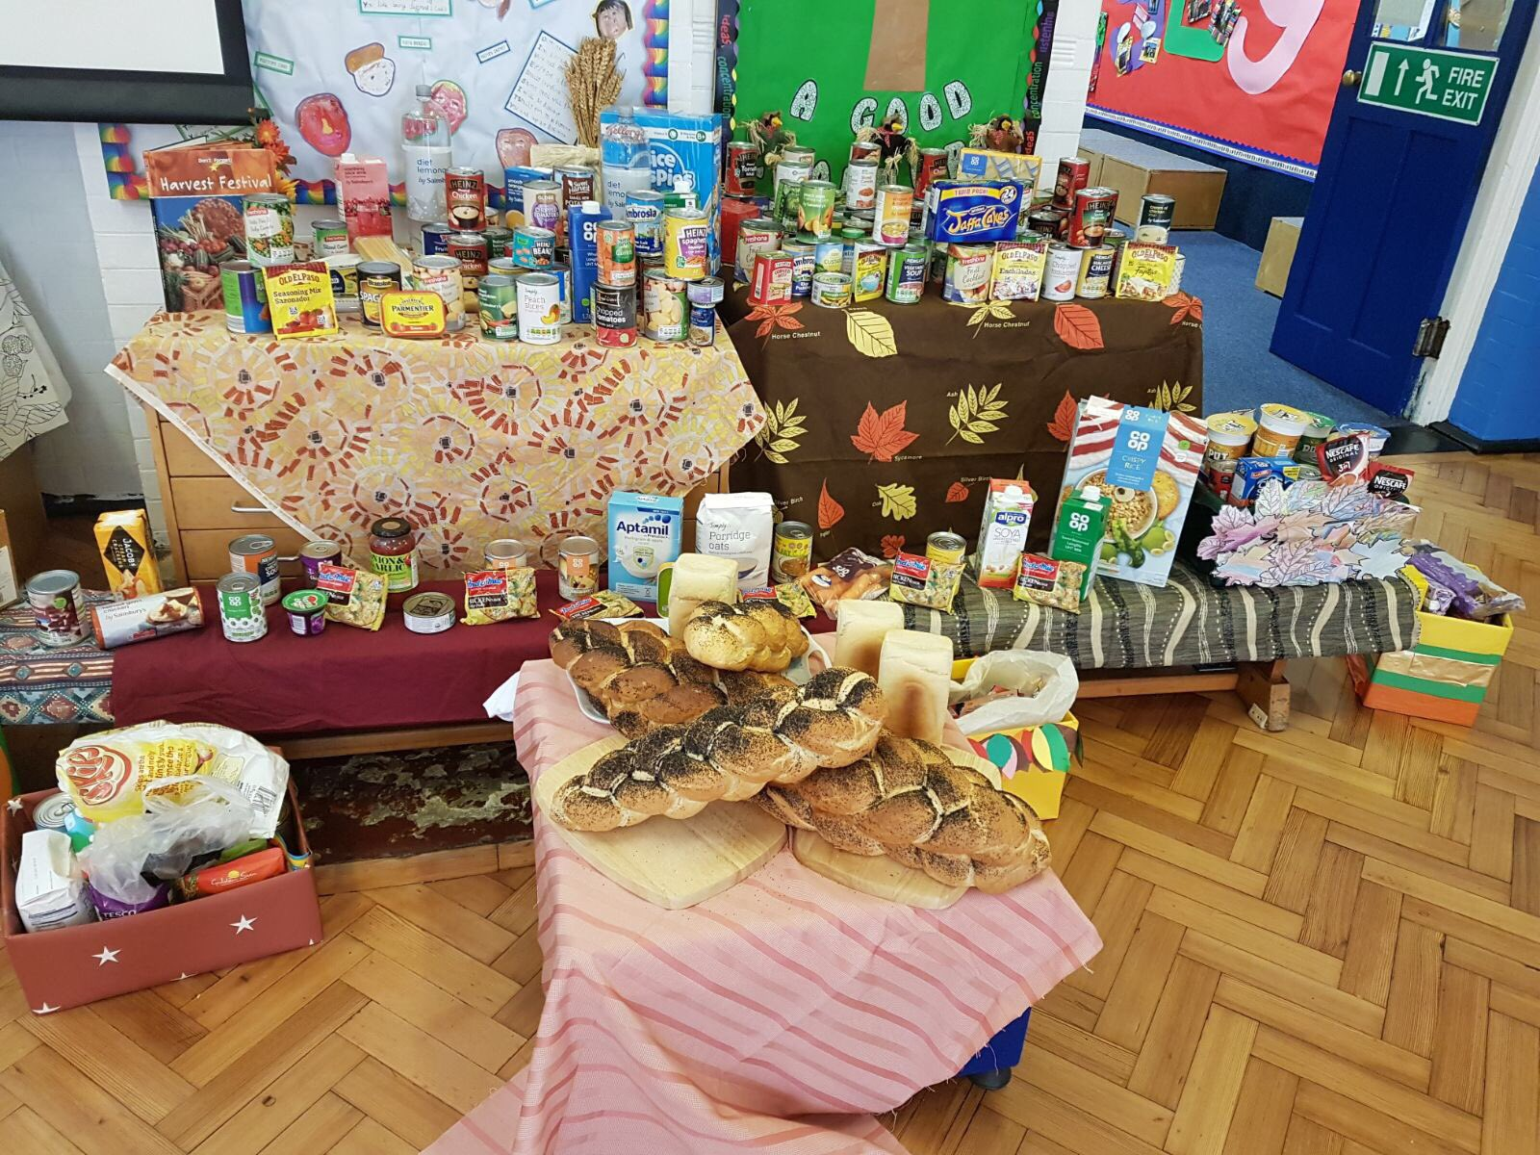
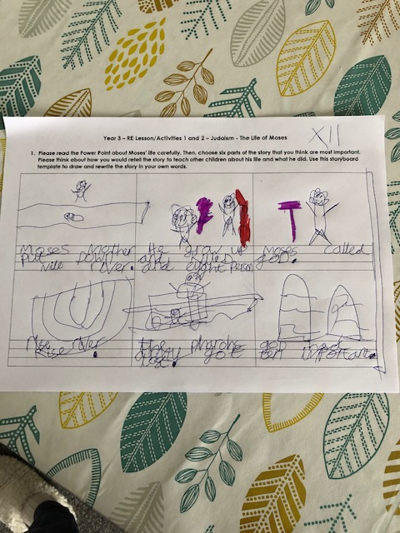
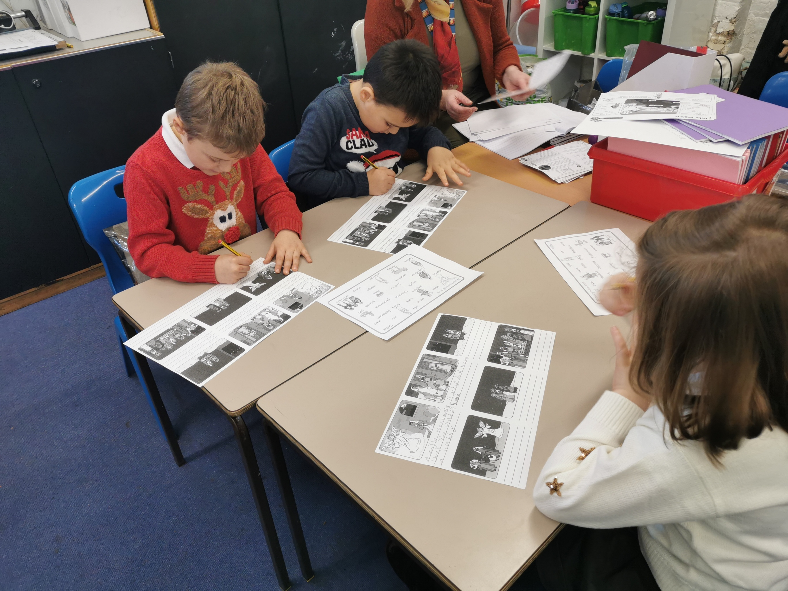
I like learning about the stories of people in different religious texts.
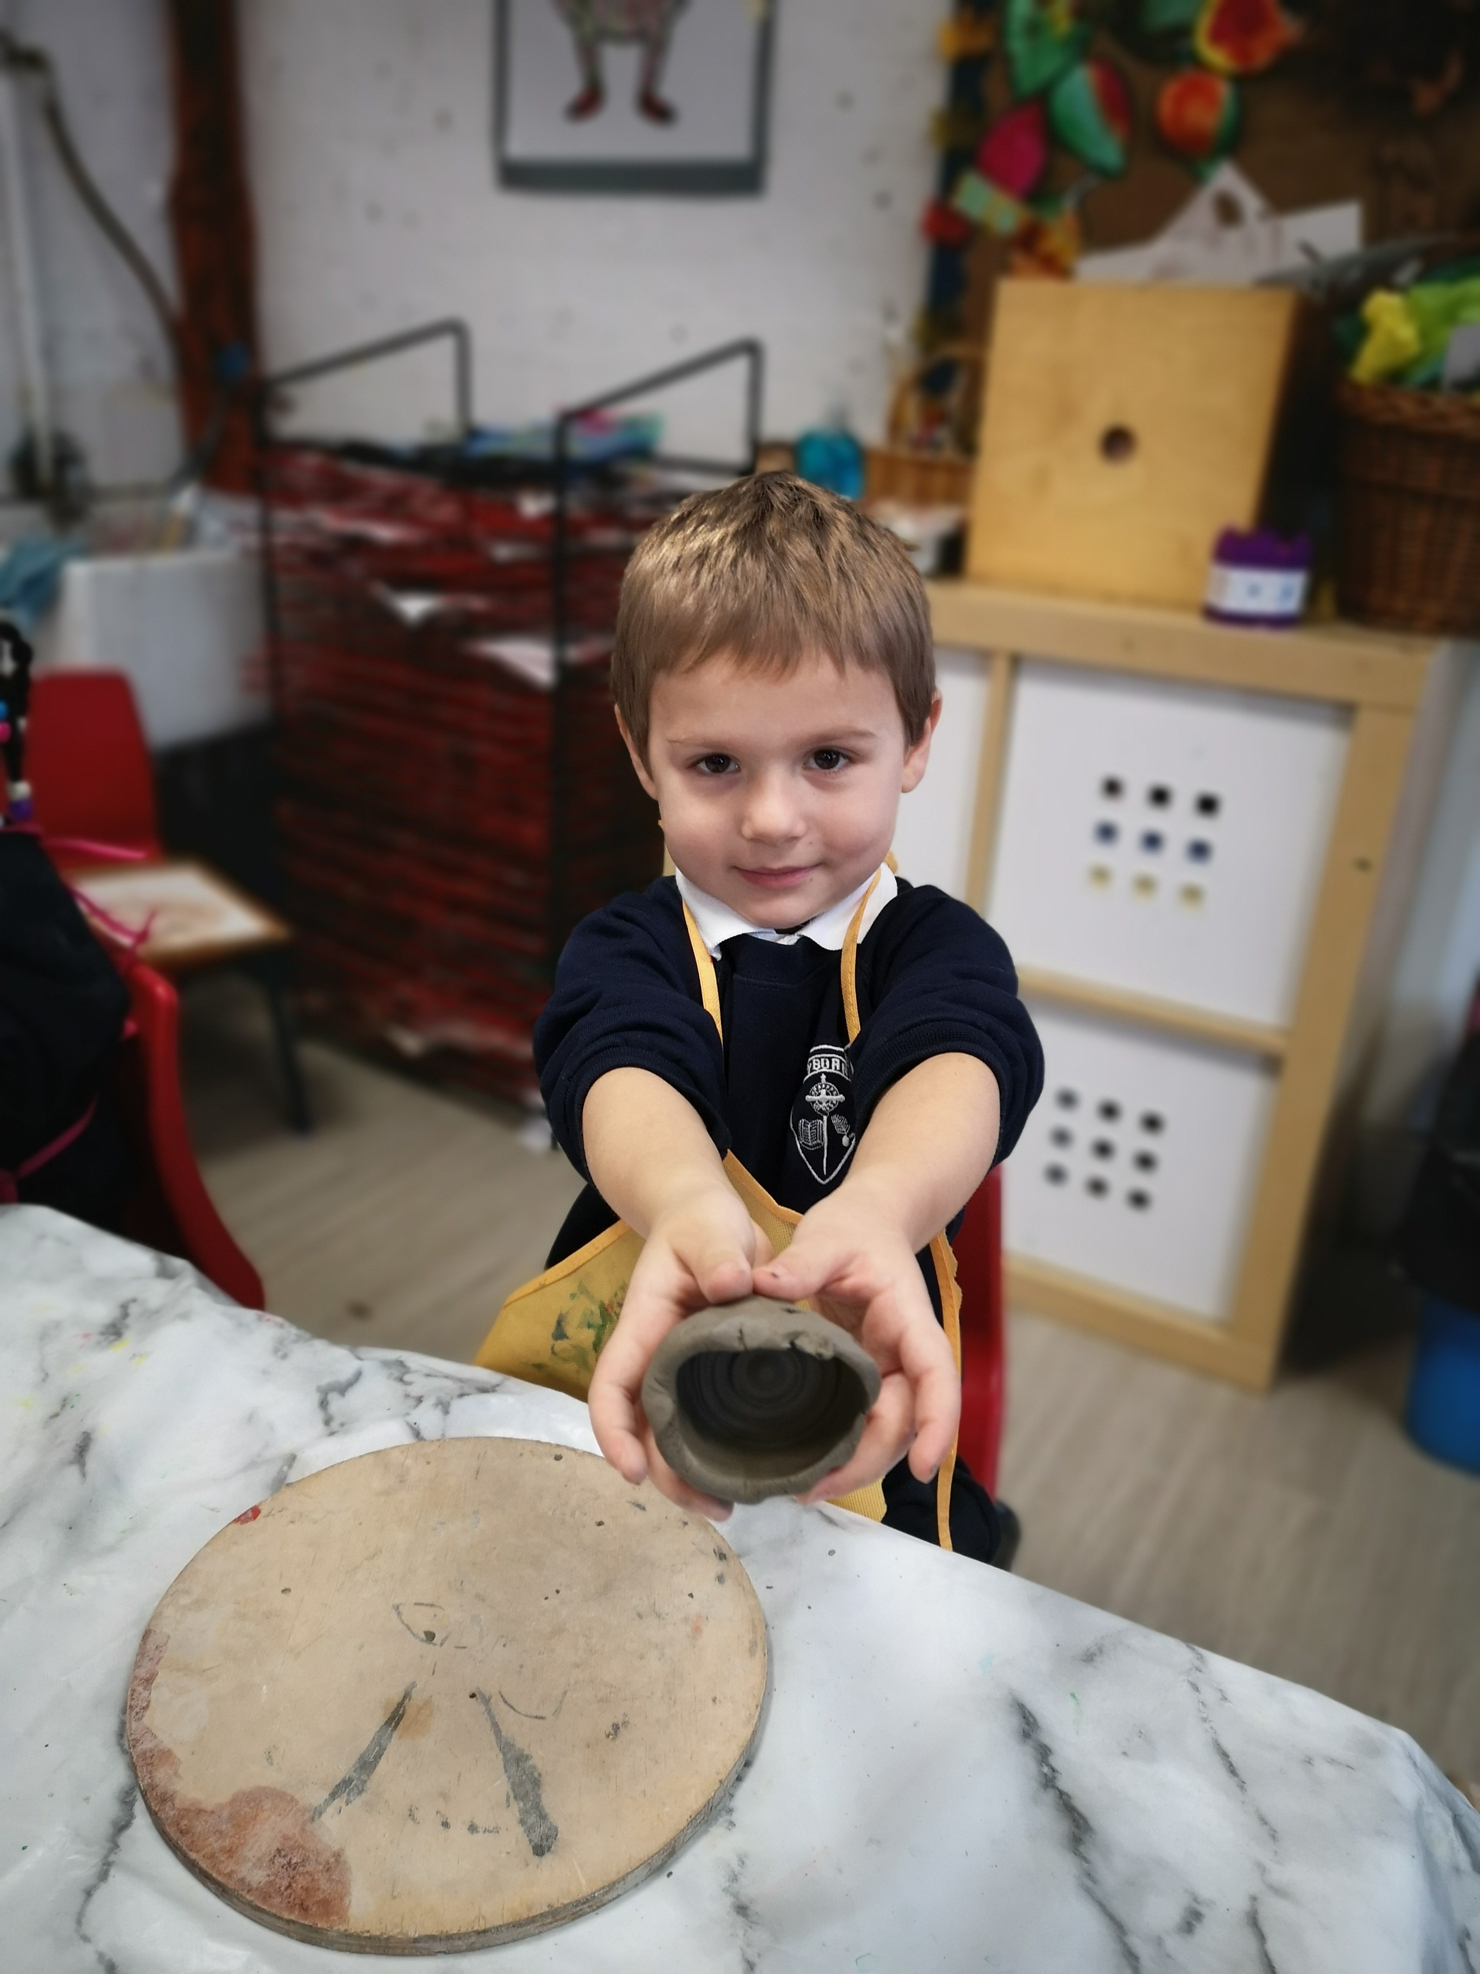
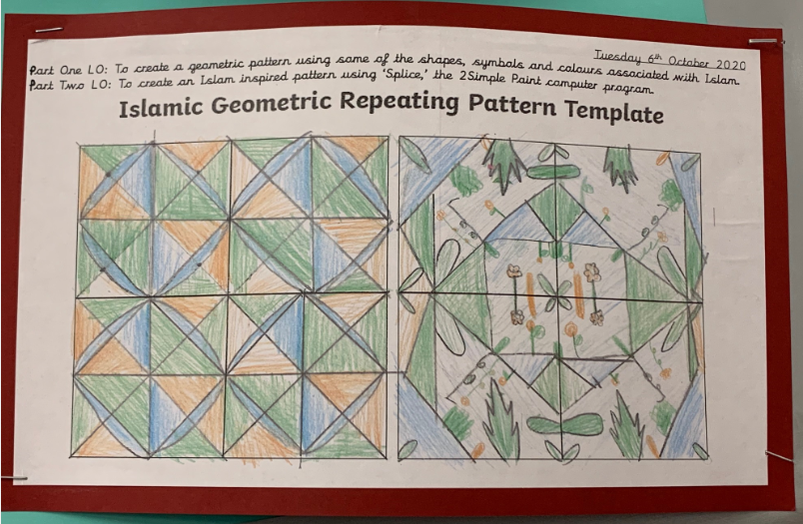
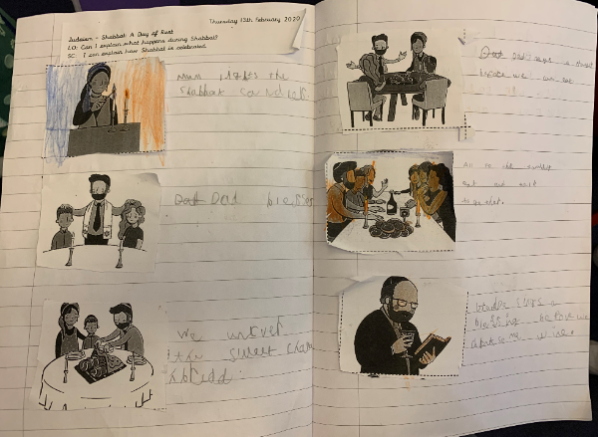
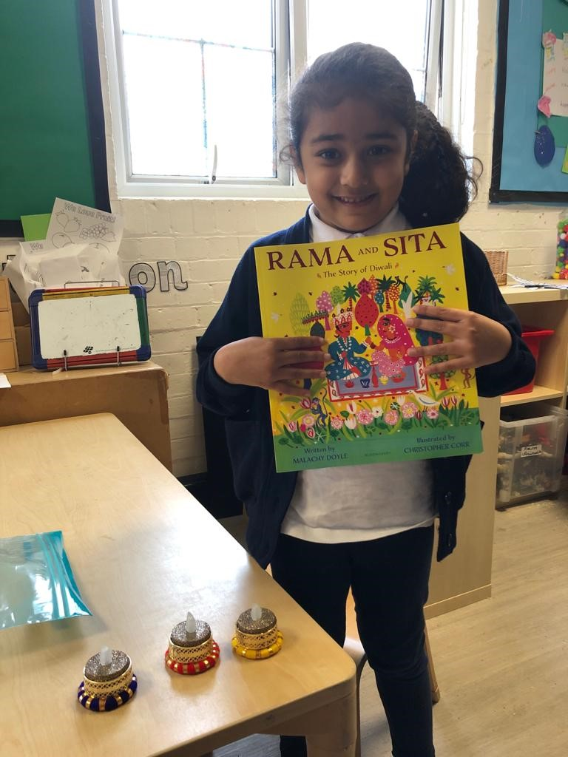
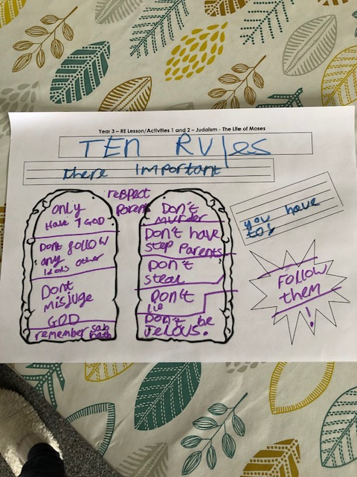
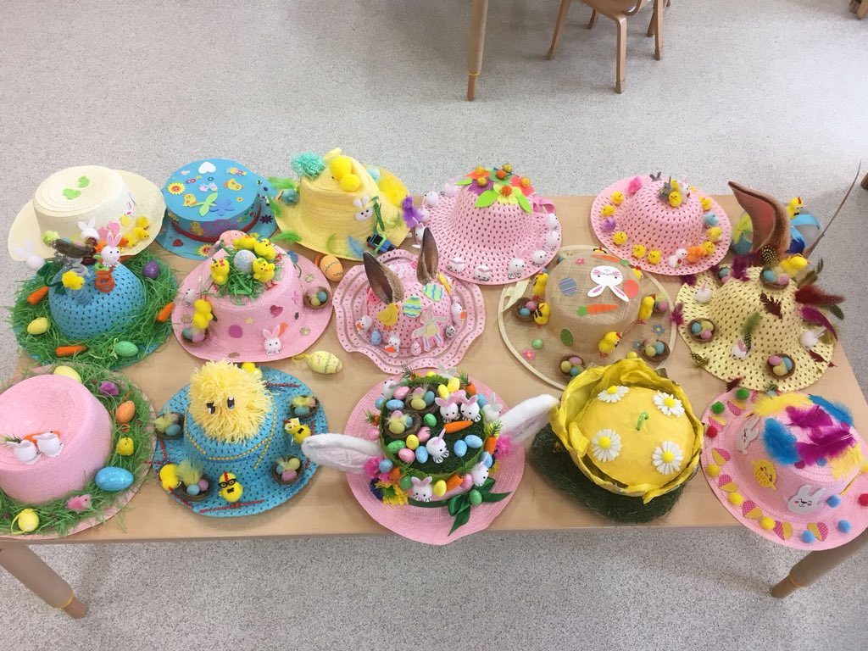
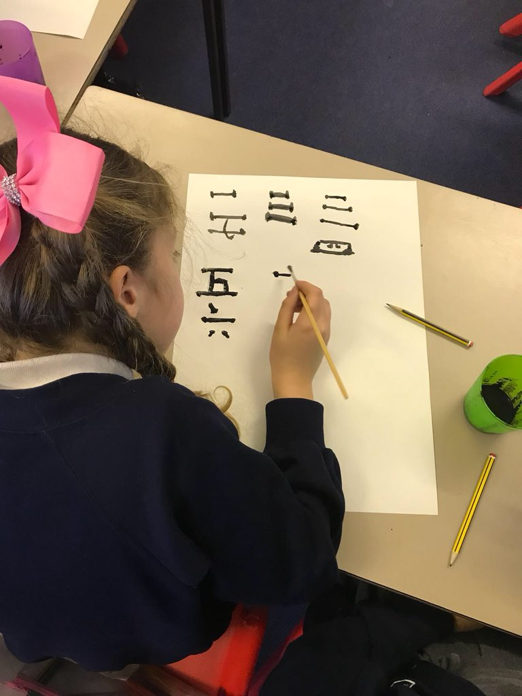
I feel ready for a wider society and have respect for everyone.
I like learning about how different beliefs are expressed and that I have learned better ways to describe them.
What we are trying to achieve for our learners through the Religious Education curriculum.
Religious Education is an integral part of everyday life for many children, especially in the culturally and religious diverse community of Greenwich. Here in our school, children will learn about different religions, belief systems, festivals and rituals and whenever possible they will be able to visit a place of worship. We aim to provide our pupils with a broad, balanced, spiritual, moral, cultural and knowledge-based Religious Education curriculum in which every child will be able to achieve an insight into the nature of Religion and what it means to be religious.
We endeavour to create an atmosphere in which every child feels secure in their own beliefs and has respect for the beliefs of others, whilst acknowledging the broadly Christian tradition of the country. We feel that all children have the right to discuss the elements of their own faith, the faith of others and the ideas of those who have no religious beliefs in a free atmosphere that promotes openness, fairness and mutual respect. Our curriculum enables our children to embrace the diverse global community in which they live and build their sense of identity and belonging. This will help them to flourish within their communities and as citizens in a diverse society.
We actively promote equality of opportunity, racial equality and good relations among all the different groups in the school. At Wyborne, we want our pupils to learn to empathise with others, be generous and have compassion. Our RE curriculum encourages pupils to ask questions, and consider the values of our school, our community and the wider world.

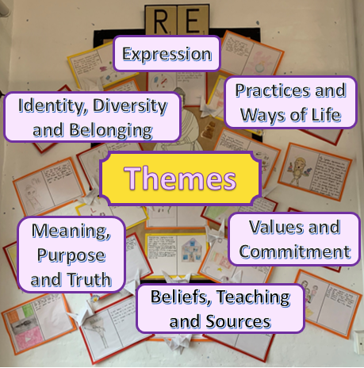
I like that we do not discriminate people for their religion or beliefs.

Rationale
RE at Wyborne will follow the curriculum and guidance outlined by the Royal Borough of Greenwich (RBG) in September 2019. This curriculum is based on the national requirements for teaching Religious Education at Primary level. Our curriculum is based on documentation provided from the Royal Borough of Greenwich authority and the National Curriculum but it has been tailored to the religions and beliefs of our families. Appendix 1 (at the end of this document) shows a chart of the number of children belonging to each religion at Wyborne Primary School (May 2020) and this is typical of previous years’ intake. This data was pulled from our school registration system (ScholarPack) and is the most accurate representation of the beliefs of our families. It can be seen that the majority of children are Christian, but many families have no religion or did not declare one during the registration process. It is our strong belief that children must learn about the beliefs and cultures of their peers and those of world religions in or order to develop into tolerant, respectful members of society. This links very much with British values.
The national and local curriculum requires schools to teach some mandatory units of work and gives an indication of how these should be taught. The diagram in Appendix 2 is the chart that schools in RBG should be following. It ‘breaks down’ the teaching into age-appropriate units. Some of these units, or faith components, have been adapted from the previous national curriculum, some have remained the same and there are a couple of new units which have replaced older ones.
EYFS Religious Education Overview: Key Skills & Knowledge – Religious Education Planning in context of long-term knowledge & coherence
Nursery & Reception | Themes: | Subject Rationale: How does this work support children’s wider Religious Education journey? What does it build upon and what does it prepare them for in the future (proximal role of the content)? | Key Vocabulary | NC Key Skills: |  |  | Significance;  Using Evidence;  Interpretations;  Communication
Knowledge (substantive religious content) Significant people and stories/ Significant events/ Visits | Themes: |  | Key Vocabulary | Continuity & Change;  Cause and consequence;  Similarity and Difference;
Festivals  Diwali  Christmas  Lunar New Year  Valentine’s Day  Easter  Ramadan/ Eid  It is important to focus on these festivals at the relevant time of the year. | Practices and Ways of Life  Expression  Identity, Diversity and Belonging | The festivals listed are a suggested based on the religious beliefs held by members of the school. This may change year on year so it is important for the EYFS teachers to be aware of the faiths that their class belong to and to cater to those children each year. However, it is also important for the children to be exposed to a wide variety of faiths and their celebrations. Festivals celebrated by members of the school community that feature in the programme planned for the school or in the classroom will provide many opportunities to help children to begin to develop connections between faiths, festivals, key figures, places, stories and symbols. As they talk about the story associated with each festival and the way in which the festival is celebrated, children should be beginning to connect festivals to their faith context. For example, it is important that children learn that Christmas is a Christian festival celebrated by Christians.  This will prepare the children for KS1 as they would have been provided with the opportunity to experience the ways in which their faith and others celebrate throughout the year. | This will depend on the festivals that each Early Years class has chosen to focus on. | Understanding the World: People, Culture and Communities
 |  |  |  | 3 and 4-year-olds | Reception | Early Learning Goal
 |  |  |  | - Continue developing positive attitudes about the differences between people.  - Talk about members of their immediate family and community. | -Talk about members of their immediate family and community.  - Understand that some places are special to members of their community.  - Recognise that people have different beliefs and celebrate special times in different ways.  - Recognise some similarities and differences between life in this country and life in other countries. | -Know some similarities and differences between different religious and cultural communities in this country, drawing on their experiences and what has been read in class
Self and others  Children should know and understand about their own culture and beliefs and those of other people; that there are differences between people and that different does not mean better or worse.  Amazing Grace | Identity, Diversity and Belonging  Expression | This unit will enable the children to raise their self-esteem and value themselves; develop sensitivity and respect towards others and develop a sense of belonging.  This links with KS1 R.E as children will begin to develop an understanding that religious belief is an important part of people's lives; familiarity with dress, food, celebrations related to different faiths; and an awareness that books can be written in different languages as a foundation for studying holy books. | Similarities  Differences | Personal, Social and Emotional Development: Managing Self
 |  |  |  | 3 and 4-year-olds | Reception | Early Learning Goal
 |  |  |  | -Develop their sense of responsibility and membership of a community.  -Show more confidence in new social situations.  Increasingly follow rules, understanding why they are important. | -See themselves as a valuable individual.  Identify and moderate their own feelings socially and emotionally.  -Think about the perspectives of others | -Explain the reasons for rules, know right from wrong and try to behave  accordingly
Symbols and Rituals  Children should know and understand the symbolism and rituals that are part of everyday life.  Visit a place of worship to find out about a faith/family ritual e.g. a wedding | Meanings, Purpose and Truth  Beliefs, Teachings and Sources | This unit will enable the children to understand and appreciate that there are a variety of ways in which people live their lives. Children will have the opportunity to talk about why certain rituals are part of everyday life and their values (e.g. washing hands before meals) and be able to share how they live their lives and to learn to accept that there are many ways in which life may be lived. This unit will also help children learn that there are symbols which help people to lead their lives e.g. green and red men on the crossing.  This links with KS1 RE as children will have some understanding of rituals in religions, e.g. the importance of 'being clean' before worship; that different religions have different rituals; they’ll recognising that some practices are expressed differently in different religions and that religious symbols relate to different religions. | This will depend on the festivals that each Early Years class has chosen to focus on. | Communication and Language: Speaking
 |  |  |  | 3 and 4-year-olds | Reception | Early Learning Goals
 |  |  |  | - Use a wider range of vocabulary.  - Be able to express a point of view and to debate when they disagree with an adult or a friend, using words as well as actions. Start a conversation with an adult or a friend and continue it for many turns. | - Learn new vocabulary.  - Articulate their ideas and thoughts in well-formed sentences.  - Connect one idea or action to another using a range of connectives.  - Describe events in some detail.  - Retell the story, once they have developed a deep familiarity with the text, some as exact repetition and some in their own words.  - Listen to and talk about selected non-fiction to develop a deep familiarity with new knowledge and vocabulary. | -Express their ideas and feelings about their experiences using full sentences, including use of past, present and future tenses and making use of conjunctions, with modelling and support from their teacher.
Living things  Children should know and understand: the significance of living things  Looking after chicks during Science week  Dogger  The Very Hungry Caterpillar | Values and Commitments | This unit will encourage children to learn about their world by helping them develop a sense of the pattern in nature. Children will be encouraged to further develop knowledge and understanding of living things and have the opportunity to look closely at similarities, differences, pattern and change. During this unit children will develop a caring and responsible attitude to living things, in addition to being provided with opportunities to experience awe and wonder.  This will prepare children for KS1 RE as they will have prior knowledge regarding KS1 work on faith beliefs about respect for nature and all life and beliefs regarding the creation of the world. |  | Understanding the World: The Natural World
 |  |  |  | 3 and 4-year-olds | Reception | Early Learning Goals
 |  |  |  | -Plant seeds and care for growing plants  -Begin to understand the need to respect and care  for the natural environment and all living things.  . | -Explore the natural world around them.  -Describe what they see, hear and feel whilst outside.  -Recognise some environments that are different from the one in which they live.  -Understand the effect of changing seasons on the natural world around them. | - Explore the natural world around them, making observations and drawing pictures of animals and plants;  - Know some similarities and differences between the natural world around them and contrasting environments, drawing on their experiences and what has been read in class;
Right and Wrong; fairness and justice  Children should know and understand: about right and wrong and fairness and justice  The Lost Sheep | Values and Commitments  Practices and Ways of Life | This unit encourages children to understand that there is a need for agreed values and codes of behaviour for groups of people. In addition to encouraging the development of appropriate behaviour patterns and self-discipline. During this unit children will be helped to explore and express their feelings and to interact positively with each other. This unit also provides children with the opportunity to foster the development of a sense of responsibility and to help children realise the effect of their words and actions on themselves and others.  This will prepare children for KS1 RE by providing them with an understanding that communities have rules and that when rules are broken you make yourself and other people unhappy. They will also develop early knowledge of some faith rules e.g. do not steal.

https://www.royalgreenwich.gov.uk/downloads/file/4216/religious_education_syllabus_2019-2024_-_eyfs_agreed_content

Year 1 Religious Education Overview: Key Skills & Knowledge – RE Planning in context of long-term knowledge & coherence
Year 1 | Themes: | Subject Rationale: How does this work support children’s wider Religious Education journey? What does it build upon and what does it prepare them for in the future (proximal role of the content)? | Key Vocabulary | NC Key Skills:
Knowledge (substantive religion content) Significant people and stories/ Significant events/ Visits/ Key Qs | Themes: |  | Key Vocabulary | Investigate;  Interpret;  Reflect;  Empathise; | Analyse;  Synthesise;  Express;  Apply;  Evaluate;
Who Am I? Belonging  What does it mean to belong?  What does it mean to belong to a family?  What are outward signs that a person belongs to a religious family?  What happens when a child joins a religious family?  How does belonging to a religious family influence family life?  What have we learnt about the importance of belonging to a religious family? | Celebration  Community  Belonging  Practices and Ways of Life | In this unit pupils draw on their understanding of what it means to belong and relate it to how children are given a sense of belonging in five religions: Christianity, Islam, Hinduism and Sikhism, Buddhism. Pupils investigate how children are welcomed into different religions. They think about how people show they belong and what is special for them about belonging.  Through this unit pupils will focus on a number of Key Questions and begin to deepen the knowledge they have already gained from their life experiences and begin to build on their depth and knowledge of understanding of peoples’ lives within each faith studied. | Belonging  Naming ceremony  Family  worship  Christianity  Islam  Hinduism  Buddhism  Church  Baptism  Qur’an  Temple | Beliefs and Teachings
 |  |  |  | Retell religious stories in chronological order and talk about it.
 |  |  |  | Use common words & phrases relating to religious stories.
 |  |  |  | Identify the importance, for some people, of belonging to a religion and recognise the difference this makes to their lives.
Christianity 1 – Jesus’ birth and Christmas  What do Christians remember at Christmas?  What do Christians believe about Jesus?  Why is the Bible important to Christians? | Christmas  Celebration  Showing Belief | Children will learn about the story of Jesus’ birth and Christmas.  By the end of the unit, children will know that Christians believe that Jesus is God’s Son and that Christmas is a celebration of Jesus’ birth. They will also know that The Bible is a special book that is different to other books and it contains stories about the birth and life of Jesus.  This topic is covered again in later years when children will have a deeper understanding of the story and what it means to Christians. | Christian  God is Father  Jesus is the Son of God  The Bible | Ways of Living
 |  |  |  | Recall and name different beliefs and practices, including festival, worship rituals and ways of life.
 |  |  |  | Describe some simple similarities and differences between different beliefs and practices.
 |  |  |  | Relate his/her own account of religion/experiences and understand that others may give a different version.
 |  |  |  | Ways of Expressing Meaning
 |  |  |  | Recognise religious art, symbols and words and talk about them.
Judaism 1 – Shabbat: A Day of Rest  Why is Shabbat important to Jews?  Why do Jews attend the synagogue?  Why is there a day of rest? | Practices and Ways of Life  Diversity  Belonging | In this unit, children will learn about Shabbat (the Sabbath Day). This starting point is important because children will learn how Jewish families prepare for Shabbat and the customs that are carried out before and on the day. It gives children an idea of what Jewish people believe; that God created the world and is resting and so should they. There is also a focus on the Synagogue and Havdalah (the end of Shabbat).  Children learn through stories from other children. They might be able to make connections between the Sabbath day and Sunday in the Christian faith, and that Christians believe God created the world. | Synagogue  Kosher (food)  Shabbat  Tzedakah (charity contributions)  Synagogue  Havdalah  Creation | Identity, Diversity and Belonging
 |  |  |  | Begin to ask questions about the faith communities in their school.
 |  |  |  | Meaning, Purpose and Truth
 |  |  |  | Think about the special things that happen to them and others.
 |  |  |  | Values and Commitments
 |  |  |  | Think about what is important to them and to other people.
Christianity 2 - Jesus the Teacher  What values do Christians believe Jesus taught?  How do Christians believe Jesus taught them these values?  Zacchaeus  The Lost Son  The Good Samaritan  Harvest | Helping people  Teacher  Lessons | Children will progress to learning more about Jesus as an adult. They will learn that he helped people by teaching them. They will discuss what being a teacher is and hear stories from the Bible about how Jesus was a teacher.  This unit begins to teach children how Christian people should behave towards each other and how they follow Jesus’ example by caring for other e.g. the elderly and less fortunate (Harvest/ giving to charity).  Children will learn about the Ten Commandments in more detail in Christianity Unit 5, therefore it is not necessary to teach them all in this unit. However, learning about Jesus as a teacher will help children to understand what and how Christians feel about him. | Values  Teacher  The Bible  Commandments (‘Love God’ and ‘Love your neighbour’
Islam (Part 1) 1 - Prophet Muhammad (pbuh)  What do Muslims believe?  Why is Prophet Muhammad (pbuh) important to Muslims?  What is the Qur’an? | Teaching  Beliefs and Sources  Worship | This unit is an introduction to the Muslim faith and children will learn through stories. They will learn about the life of the Prophet Muhammad (pbuh), the Qur’an and the Muslim place of worship (Mosque). | The Qur’an  Prophet  Madinah  Arabic  Mosque
Islam (Part 1) 2 – Five Pillars of Islam  What are the five pillars of Islam?  What does worship mean to Muslims?  How do Muslims show their respect for Allah in everyday life? | Ways of Life | In this unit children will learn about how Muslims live and worship. Children will learn about the Five Pillars of Islam and how Muslims practice these. Muslims believe that good values are important and that they should show these often.  This unit expands the knowledge of what Muslims believe and will help children to think about their own lives. They will be taught to think about values, what they mean and how they can implement in their own lives – reflective learning with links to PSHE curriculum. | Values  Allah

Year 2 Religious Education Overview: Key Skills & Knowledge – Religious Education Planning in context of long term knowledge & coherence
Year 2 | Themes | Subject Rationale: How does this work support children’s wider Religious Education journey. What does it build upon and what does it prepare them for in the future (proximal role of the content)? | Key Vocabulary | NC Key Skills:
Knowledge (substantive religion content) Significant people and stories/ Significant events/ Visits/ Key Qs | Themes |  | Key Vocabulary | Investigate;  Interpret;  Reflect;  Empathise; | Analyse;  Synthesise;  Express;  Apply;  Evaluate;
Hinduism (Part 1) 1 – Diwali  What understanding do Hindus have about God?  What do stories at Diwali explain about God? What is the role of a Hindu temple in a Hindu’s life?  Stories with a theme of good and evil connected to Rama and Sita (part of Diwali festival). | Ways of Life  Teachings  Identity and Belonging  Worship | Children will learn that Hindus believe in one God represented through different names. They will find out what Hindus believe in; God has visited Earth at different times and in different forms to help people.  They will make links to their own existing knowledge and build on it. They can make connections between Christian festivals and celebrations and have a basis of knowledge for the next unit. There are possible links here with Music and PE; learning a dance will inspire children and be enthusiastic learners. | Diwali  Hindi Mandir  Arti ceremony  Puja  Ramayana  Rama Ganesh, Hanuman, Lakshmi | Beliefs and Teachings
 |  |  |  | Retell a religious story and suggest meanings to some religious and moral stories.
 |  |  |  | Identify and suggest meanings for religious symbols and begin to use a range of religious words.
 |  |  |  | Ask and respond imaginatively to puzzling questions, communicating their ideas.
Celebrations  How are special occasions celebrated?  What is it like to share a celebration?  What is a Religious Festival? – the Festival of Christmas  What is a Religious Festival? – the Festival of Hannukkah  How do religious believers celebrate the meaning of a festival?  What have we learnt about the festivals? | Celebration | In this unit, through a focus on celebrations and festivals, pupils consider the place of celebration in people’s lives and are given the opportunity to learn about the beliefs of two religions, Christianity and Judaism. They will learn the meanings of the festivals for believers, the way in which the festivals are celebrated around the world, and about their own lives and communities from it.  This unit complements learning in other parts of school life (e.g. Christmas – Nativity, weekly celebration assemblies, birthday parties, etc.) and in other elements of the RE curriculum. It focuses on common human experiences with regard to celebrations and festivals. | festival  church  celebration  joyful  Christian  sharing  Christmas  Jewish  Nativity  Hannukkah  Jesus  latkes  Christingle  Synagogue  prayer  Doughnuts  worship | Ways of Living
 |  |  |  | Identify the importance, for some people, of belonging to a religion and recognise the difference this makes to their lives.
 |  |  |  | Reflect on and consider religious and spiritual feelings, experiences and concepts such as worship, wonder, praise, thanks, concern, joy and sadness.
Judaism 2 – Festivals in the Jewish Year  Why is it important to keep traditions/ customs alive?  How do the Festival events help to teach young Jews about their past?  What do these festivals show about the Jews’ relationship with God?  Moses  Stories: ‘Moses and the Exodus from Egypt’ and ‘Esther Saves her People’ (found in the Torah) | Festivals  Celebrations | Children will learn about the Jewish festivals Succot (Sukkoth), Passover (Pesach) and Purim. Jewish people have routines, traditions and customs that they have to keep.  The learning in this unit should give children an understanding of what it is like to be a Jewish child in a Jewish family, and will prepare them for further learning about Jewish life in Unit 4. | Festival of Tabernacles  Synagogue  Moses | Ask and respond to questions about why religious communities do different things.
 |  |  |  | Ways of Expressing Meaning
 |  |  |  | Recognise that religious symbols, words and actions express a community way of living.
 |  |  |  | Use religious vocabulary to describe some of the different ways in which people show their beliefs.
Christianity 3 – Easter and Symbols  What do symbols of Easter represent?  How do symbols and symbolic actions show the importance of Easter for Christians? | Showing Faith | Children will learn about the story of Easter and the symbols that represent the time of year. They will look at the food and colours that are linked to Easter in the Christian faith and in society. They will also learn about the days leading up to Easter weekend.  This will help the children when making comparisons and connections between other religions. It will also help support them when they visit a Christian church in the next unit of learning. | Easter  Symbols – cross, egg, palm cross (Palm Sunday), Easter gardens, colours of vestments and candles in Christian churches, washing Jesus’ feet (in the Easter story and statues in church) on Maundy Thursday  Importance of Easter | Identity, Diversity and Belonging
 |  |  |  | Notice and respond sensitively to some similarities between different religious and worldviews.
 |  |  |  | Reflect on how spiritual and moral values relate to their own behaviour.
 |  |  |  | Recognise that religious teachings and ideas make a difference to individuals, families and the local community.
Hinduism (Part 1) 2 – Worship  What is the importance of families in Hinduism?  Why are honesty and truthfulness important in Hinduism?  How do Hindus pray at home and in the Temple? | Beliefs  Teachings  Ways of Life  Identity and Belonging | This unit focuses on the Hindu home and place of worship, the Mandir. They will look at family relationships, particularly between brother and sister and the Festival of Raksha Bandhan. There is a focus on worship and how Hindus worship at home and in the Mandir. Children will learn about how Hindus portray God in different images and the roles in the Mandir.  By learning about Hindu worship they will be able to understand more about cultures around the world, which will help in the next Hindi unit as well as the principles and practices of other religions. |  | Meaning, Purpose and Truth
 |  |  |  | Explore questions about meaning and truth.
 |  |  |  | Values and Commitments
Christianity 4 – A Local Church  What happens in a Christian place of worship?  How does a place of worship help Christians to develop their beliefs about Jesus?  How do Christians try to follow Jesus’ example?  Visit – All Saints Church | Showing Beliefs  Community  Worship | Children will be able to visit a church in the local area. They will find out how Christians use churches to worship together, read the Bible, sing and pray one or more times weekly. Children will find out about the leaders of the church services and people in the community who help. They will also learn about special objects and symbols in buildings and how people join the church; important ceremonies like baptisms. | Symbols  Leaders – Priest, Reverend, Vicar, ministers, elders, etc. | Begin to express their ideas and opinions and to recognise there could be more than one answer.

Year 3 Religious Education Overview: Key Skills & Knowledge – Religious Education Planning in context of long term knowledge & coherence
Year 3 | Themes | Subject Rationale: How does this work support children’s wider Religious Education journey? What does it build upon and what does it prepare them for in the future (proximal role of the content)? | Key Vocabulary | NC Key Skills:
Knowledge (substantive historical content) Significant people and stories/ Significant events/ Visits/ Key Qs | Themes |  | Key Vocabulary | Investigate;  Interpret;  Reflect;  Empathise; | Analyse;  Synthesise;  Express;  Apply;  Evaluate;
How did the world begin?  Where did the world and everything in it come from?  What do Jews and Christians believe about the creation of the world?  How do Christians thank God for the world? How do they show their care for other people?  How did St. Francis show his thanks to God for his creation?  What do Muslims believe about the creation of the world?  How should we care for the world? | Identity, Diversity and Belonging  Meaning, Purpose and Truth  Beliefs, Teaching and Sources | This unit introduces pupils to beliefs in Judaism, Christianity and Islam, incorporating content from the appropriate sections of the syllabus and should be taught in years 3 or 4. Please note that some other faiths and beliefs do not believe in a creator God.  Throughout the unit pupils should be encouraged to notice change in the world around them – in the weather; in plant life around the school; in themselves and in seeds/bulbs that can be grown in class. If possible they should be encouraged to care for creatures, for example feeding fish or birds.  Links to PHSE curriculum and Wyborne Pupil Governors - how pupils can be active members of the school community. | Create/ Creation/Creator  Christianity  Christian unique mysterious  Judaism  earth  special beautiful  God Allah  Muslim Islam  sea sky  shell feather  alive/dead/living  animal stone  bird egg  Saint Francis
 |  |  |  | Describe what a believer might learn from a religious story/sacred text.
 |  |  |  | Reflect and respond thoughtfully to what a believer might learn from a religious story/sacred text.
Buddhism (Part 1) 1 - The Buddha  What is a Buddha?  How did the Buddha teach that people should live? | Teachings  Beliefs  Practices and Ways of Life | Children will be introduced to the Buddhist faith by learning about the Buddha and how Buddhists live by following his teachings. The main teaching in this unit is that actions have consequences.  This unit can be linked to our PHSE curriculum- friendship, community, being truthful. | Reflection  Meditation  Morals  Buddha  Honesty  Consequences | Ways of Living
 |  |  |  | Describe and begin to make links between some of the things that are the same and different for religious people.
Christianity 5 – The Bible  How do Christians use the Bible?  What does the Bible contain?  What is the relationship between the life of Jesus and the Old and New Testaments?  How does using the Bible help Christians to grow in their faith?  The Lost Sheep – a parable about the Kingdom of God | Teachings  Beliefs  Practices and Ways of Life | Children will learn that the Bible is a source of Christian belief and teaching, and some read it every day and find it helpful for their everyday lives. They will learn that the Old and New Testaments include many books with different genres, including history, law, songs, Gospels and letters. Children will also learn more about the Ten Commandments and how Christians use these to guide their lives.  They will have the opportunity to find themes, similarities and differences in the stories they are given. Their previous units of learning will support their knowledge. | The Bible  The Old and New Testaments  Gospels  Parables  The Ten Commandments | Ways of Expressing Meaning
 |  |  |  | Use religious vocabulary to describe some of the different ways of life and ways of expressing meaning.
 |  |  |  | Identity, Diversity and Belonging
 |  |  |  | Compare their own understanding of belonging with that of someone else’s by identify similarities and differences.
Sikhism 1 –  What do Sikhs believe about God?  What does Guru mean?  What does it mean to be equal?  Celebration of Guru Nanak’s birthday  Guru Har Gobind, the story of the Guru celebrated at Divali | Teachings  Beliefs  Practices and Ways of Life | Children will be introduced to the Sikh faith by learning about Guru Nanak, the first of ten human Gurus, and how Sikhs live by following his teachings. The main teaching in this unit is about Guru Nanak and his life and teachings, including that all people are equal. The children will also learn that Sikhs believe in one God, symbolised by the Ik Onkar symbol. | God  Guru  Guru Nanak  Guru Granth Sahib  The Mool Mantra  Hymns  Akhand Path  Ten Human Gurus  IK Onkar symbol  Equal | Meaning, Purpose and Truth
 |  |  |  | Ask important questions about life and compare their ideas with those of other people.
 |  |  |  | Discuss and represent their own views on challenging questions.
 |  |  |  | Values and Commitments
 |  |  |  | Link things that are important to them and other people with the way they think and behave.
Sikhism 2 –  How do the lives of Sikhs show they follow rules in their lives?  What does worship mean to Sikhs?  The story of Guru Gobind Singh and the Water Carrier, Bhai Ghanaya  Akhand Path | Beliefs  Teachings and Sources  Practices and Ways of Life | This unit builds on the previous one by looking more closely at how the Sikh community live by the teachings of the Gurus and the Guru Granth Sahib. Children will learn that Sikhs have three important rules to follow, work honestly; share food with the needy; remember God. Children will listen to stories and think critically about how they might help people in the Sikh faith. | God  Guru  Guru Granth Sahib  Akhand Path  Worship  Gurdwara  Equal | Begin to ask questions about the moral decisions they make and suggest what might happen as a result of different decisions, including those made with reference to religious beliefs/ values.
Judaism 3 – The Synagogue  How do Jews show that God is present in the synagogue?  How does the Torah help Jewish people to understand what being Jewish means?  Stories about Moses’ life and ‘David and Goliath’ | Worship  Teachings  Practices and Ways of Life  Family | Children will learn more about the Jewish place of worship, the Synagogue, in this unit. They will learn about the important features of inside the Synagogue, the Torah and the role of the Rabbi. Children will also learn about the Torah in more detail and will hear stories and teachings read from it. These tell Jewish people about their faith, and tell them how to live. They will also learn about The Ten Commandments (particularly the first four) and how Jews live by them. | Synagogue – Ark, Ner Tamid, Torah readings, Rabbi  Torah

Year 4 Religious Education Overview: Key Skills & Knowledge – Religious Education Planning in context of long term knowledge & coherence
Year 4 | Themes | Subject Rationale: How does this work support children’s wider Religious Education journey? What does it build upon and what does it prepare them for in the future (proximal role of the content)? | Key Vocabulary | NC Key Skills:
Knowledge (substantive religion content) Significant people and stories/ Significant events/ Visits/ Key Qs | Themes |  | Key Vocabulary | Investigate;  Interpret;  Reflect;  Empathise; | Analyse;  Synthesise;  Express;  Apply;  Evaluate;
Buddhism (Part 1) 2 - Living as a Buddhist  What is the importance of a temple or a Buddhist centre?  Why do Buddhists have images of the Buddha?  The story of The King’s Elephant | Teachings  Community | This unit builds on the previous one by looking more closely at how the Buddhist community live by the teachings of the Buddha. Children will learn that Buddhists support one another and meditate to help them understand the teachings. Children will listen to stories and think critically about how they might help people in the Buddhist faith.  This unit will allow children to have a deeper insight into life as a Buddhist. They will have opportunities to try meditation to not only learn about Buddhism but to aid their own learning and mindful thinking. Links with PSHE curriculum. | Temple/Buddhist Centre  Sacred  Respect  Values  Wisdom and Compassion | Beliefs and Teachings
 |  |  |  | Make links between the beliefs (teachings, sources, etc.) of the different religions studied and show how they are connected to believers’ lives.
Describe the key aspects of religions, especially the people, stories and traditions
that influence the beliefs and values of others;
 |  |  |  | Ways of Life
 |  |  |  | Use the correct religious vocabulary to describe and compare what practices and experiences may be involved in belonging to different religious groups.
Islam (Part 2) 3 – Ramadan and Eid ul Fitr  Why do Muslims fast during Ramadan?  How does fasting help Muslims to grow closer to Allah and to each other?  How do Muslims celebrate Eid? | Commitment  Ways of Life | This unit deepens the understanding of the Five Pillars of Islam by looking more closely at ‘Sawm’ and the importance of Ramadan. Muslims believe it is a time to; focus on Allah, be a good Muslim and consider those who have less. This unit is also about the celebration of Eid and its importance to Muslim and in the Muslim calendar. | Islam  Eid al Fitr – celebrating the completion of Ramadan  Ramadan  Zakat al Fitr  Fasting  Mosque  Ka’ba –first house of worship for God | Ways of Expressing Meaning
 |  |  |  | Verbalise and/or express their own thoughts about belief, ways of living and expressing meaning, using a range of media.
 |  |  |  | Use religious vocabulary in suggesting reasons for the similarities and differences in forms of religious, spiritual and moral expression found within and between religions.
 |  |  |  | Identity, Belonging and Diversity
 |  |  |  | Verbalise their own understanding of the concept/belief, e.g. belonging, and start to relate this to the people they are studying e.g. Jewish people.
Islam (Part 2) 4 – Hajj: The Journey of a Lifetime  What is a pilgrimage?  Why do Muslims go on Hajj?  Which stories are associated with the places on Hajj?  How does the Hajj make Muslims feel they are all part of one family? | Commitment  Celebration  Beliefs  Respect | Children will find out more about the Muslim pilgrimage, the Hajj, in this unit. There is a focus on The Ka’aba and the celebration Eid ul Adha. Children should learn the requirements of Hajj and how Muslims prepare for it.  This is the last unit of Islam. The children should consider what pilgrimage means to Muslims and people of other faiths. They may also think about journeys/pilgrimages that they might make in their lifetime. | Hajj  Makkah/Mecca  Eid ul Adha – celebration at the end of the Hajj  Prophets Ibrahim and Ismail (pbuh)  Mount Arafat | Give their own and others’ views on questions about who they are and where they belong and on the challenges of belonging to a religion.
 |  |  |  | Meaning, Purpose and Truth
 |  |  |  | Begin to apply their own and others' ideas to a given question and support their viewpoint with facts and evidence.
Christianity 6 – Local Christian places of worship  Why are there different places of worship for Christians?  What similarities are there in what Christians believe?  How does coming together help Christians to grow in their faith?  Possible visit to another Christian church – Christ Church Eltham (Catholic) or New Eltham Methodist Church | Worship  Local Area/  Community  Places of Worship | In this unit, children will learn about other local places of Christian worship, focussing on one. They will be given the opportunity to learn about and analyse the differences between this church and a church previously visited (in Year 2). They will learn about other Christian denominations and how they are similar/different. They will also consider why people pray, and use stillness and silence to reflect/pray.  This unit will build on the learning from Unit 4 when the children will have focussed and visited one local church. They will think analytically and propose their own questions. | Reflection  Prayer  Stillness and Silence  The Lord’s Prayer  The Bible | Values and Commitments
 |  |  |  | Confidently ask questions about the moral decisions they make and suggest what might happen as a result of different decisions, including those made with reference to religious beliefs/ values.
Sikhism 3 –  How is the Gurdwara a centre for  worship and a place that demonstrates  Sikh values?  Why is the Guru Granth Sahib ‘The  Everlasting Guru? | Places of Worship  Practices and Ways of Life  Commitment  Helping Others | This unit builds on the children’s previous learning by recapping the ten Human Gurus, from Guru Nanak to Guru Gobind Singh. In this unit the children will learn more about Guru Gobind Singh, why he is ‘The Everlasting Guru’ and the Khalsa that he founded. The main focus for this unit is about the Gurdwara, which is the centre of the Sikh community and a place for prayer and worship. The children will discover how the Gurdwara demonstrates Sikh values. They will learn about the ceremonies that take place here and the rules that must be observed before entering the Gurdwara. | Gurdwara  Guru Granth Sahib  Nishan Sahib  Khanda Symbol  Granthi  Kara Prasad  Langar Kitchen  The Golden Temple  Gurmurkhi  Khalsa
Sikhism 4 –  Why was Guru Gobind Singh important?  What is the significance of the Amrit Ceremony?  Ceremonies – Ceremony of belonging, the Amrit Ceremony and Festivals  Sikh Visit – Gurdwara Sahib Woolwich | Practices and Ways of Life  Belonging  Values and Commitments  Beliefs | This unit will deepen the children’s knowledge about Guru Gobind Singh. They will learn about the celebration of Vaisakhi, how he established the Khalsa and the significance of the Amrit festival. This unit focuses on the Sikh importance of belonging to the community; by providing a service to all human beings (pingalwara) and the use of Langar Kitchens, and becoming a Khalsa Sikh. This unit also covers the 5 Ks and Sikh names. In addition, the children will learn about Sikh beliefs about life, death and the hereafter.  This is the children’s last Sikhism unit. They should be able to reflect upon what they have learnt about Sikhism so far and apply this knowledge to the local Sikh community. This unit includes a trip to a local Gurdwara where the children will have the opportunity to observe what they have learnt throughout this topic in real world circumstances. Our local Gurdwara is the Gurdwara Sahib Woolwich. | Guru Gobind Singh  Vaisakhi  The 5 Ks  Sikh names  The Khalsa  Amrit Festival  Khalsa Sikh  The Golden Temple  Pingalwara  Langar Kitchen

Year 5 Religious Education Overview: Key Skills & Knowledge – Religious Education Planning in context of long term knowledge & coherence
Year 5 | Themes | Subject Rationale: How does this work support children’s wider Religious Education journey? What does it build upon and what does it prepare them for in the future (proximal role of the content)? | Key Vocabulary | NC Key Skills:
Knowledge (substantive religion content) Significant people and stories/ Significant events/ Visits/ Key Qs | Themes |  | Key Vocabulary | Investigate;  Interpret;  Reflect;  Empathise; | Analyse;  Synthesise;  Express;  Apply;  Evaluate;
Hinduism (Part 2) 3 – Hindu Life  Why is the natural world important to a Hindu?  How does belief about creation lead to vegetarianism and ahimsa? | Beliefs  Creation  The World  Diversity  Belonging | This unit teaches children about what Hindus believe about creation and the world. They will learn that Hindus have positive attitdes towards animals, especially cows/bulls and have strong views about violence (Ahimsa). Children will learn about the origins of the religion and how Hindus living across the world keep links to India.  The contents of this unit will allow the children to think about how Hindus live and how they may have influenced modern culture (vegetarianism, not hurting living things). These principles are shared by other religions so connections can be made, allowing for deeper thinking – Christianity beliefs of creation. Children should be given the opportunity to ask questions about the Hindu faith and their own lives. The next unit is heavily planned around the theme of creation and life and it’s journey. | Environment  Aum/Om symbol  Ahimsa | Beliefs and Teachings
 |  |  |  | Suggest reasons for the similar and different beliefs that people hold, and explain how religious sources are used to provide answers to important questions about life and morality.
 |  |  |  | Say what religions teach about some of the big questions of life, using different sources and arguments to begin to explain the reasons for diversity within and between them.
 |  |  |  | Ways of Living
 |  |  |  | Begin to explain, with reasons, the meaning and significance religion/faith to individuals and communities.
 |  |  |  | Show some understanding of and explain how concepts/beliefs, e.g. forgiveness, resonate in their own life.
Peace  What is peace? What does peace mean in the world and to you?  What does Peace mean for countries and the people living in them?  What does Peace mean to Christians?  How did Martin Luther King’s attitude to peace change lives?  How was Gandhi able to change attitudes peacefully?  How do Muslims associate peace with Allah?  Where do Buddhists get their ideas about peace from? How does the Tibetan Peace garden illustrate what Buddhists think  about peace?  Where do Humanists get their ideas about peace from?  Buddhism Visit  Black History Month focus:  Martin Luther King Desmond Tutu  The Dalai Lama Ghandi | Meaning, Purpose and Truth  Practices and  Ways of Life  Diversity | In this unit, teachers will need to emphasise that peace and living harmoniously with your neighbour is an important belief of all religions, including Sikhism and Judaism. Teachers should also be mindful of current world events that can generate discussions about peace. Lessons on important Black and Mixed Ethnicity individuals are suggested to link with Black History Month.  https://www.royalgreenwich.gov.uk/downloads/file/4222/religious_education_syllabus_2019-2024_-_peace  This unit contains the following content from Christianity, Hinduism, Islam, Buddhism and Humanism. It builds on the units previously studied but will allow children to think deeper, question concepts and reflect on their own identity. The unit also links to citizenship in the PSHE curriculum. | peace/ful  Hinduism/ Hindu  Islam  conflict  Ahimsa  Buddhism  Salaam  asylum seeker Christianity confrontation  Shalom  Muslim  Buddhist Dharmachakra Bhavachakra  enlightenment  Metta interconnectedness Bodhisattva | Understand that concepts/beliefs e.g. forgiveness, might be different for other people because of their religious belief.
 |  |  |  | Ways of Expressing Meaning
 |  |  |  | Show understanding of the similarities and differences in forms of religious, spiritual and moral expression found within and between religions.
 |  |  |  | Begin to apply their knowledge to their own understanding of religious and spiritual expression of belief and value.
 |  |  |  | Identity, Diversity and Belonging
 |  |  |  | Begin to consider and apply ideas about ways in which diverse communities can live together for the well-being of all and respond thoughtfully to ideas about community, values and respect.
Hinduism 4 – God and Beliefs  How do Rama and Krishna help Hindus to understand God?  What stories do you know that help Hindus to learn about right and wrong or evil or good?  What does it mean to be a Hindu?  Stories – ‘The Birth of Krishna’ and ‘Krishna and Sudhama’ | Beliefs  Teachings  Meaning, Purpose and Truth | Children will learn more about the forms of God in the Hindu faith, building on learning from Unit 1 and learn that Hindu have three main images of God (Trimurti). Children will be taught about how Hindus think about life’s journey and what makes up each person’s identity. | Krishna  Rama  Shiva  Ganesh  Ashrama  Samskars | Meaning, Purpose and Truth
 |  |  |  | Represent the views of others about meaning, purpose and truth.
 |  |  |  | Use reasoning and examples to express insights into their own and others’ views on questions about the meaning and purpose of life and the search for truth.
Christianity 7 – Who was Jesus? – Human and Divine  Who do Christians believe Jesus to be?  What evidence do Christians base their beliefs upon?  What meaning does the life and death of Jesus have for Christians?  Stories – ‘Stilling the Storm’, ‘The Four Friends’ or ‘Healing a Leper’ | Life and Death  Beliefs | Children will look more closely at Jesus in this unit and learn about how Christians see him. They will look at how his birth, life and death helps Christians have a relationship with God.  The learning from this unit focuses on Jesus and God building on the knowledge the children have gained from previous units. It will help the children understand how Christians live and what they believe, which will give them a base for the next two units of work. Focussing on a single significant person will support the children through other faith units of a similar nature. | The Trinity – Father, Son and Holy Spirit  Christmas – Jesus’ birth  Jesus Disciples  Jesus’ temptations  Jesus’ baptism  Miracles and acts of healing  Easter – Jesus’ death, resurrection and afterwards | Values and Commitments
 |  |  |  | Apply and express their own and others' ideas about ethical questions, including ideas about what is right and wrong and what is just and fair.
Christianity 8 – Christian Festivals  How do festivals help Christians to remember Jesus and His teachings?  What happens in places of worship to help Christians understand the meaning behind their festivals? | Worship  Community  Celebrations | This unit is about the church and its calendar. Children will learn about the special names for certain times of year, expanding their existing knowledge (Christmas and Easter). These times of year relate to parts of Jesus’ life and the children will learn how these are understood and celebrated by Christians. | Advent – preparing for Jesus’ birth  Lent – Jesus’ temptation  Christmas  Epiphany  Easter  Pentecost  Sharing the Lord’s Supper (Bible story and during church services)
Worship | Ways of Life  Values and Commitment | Children will be provided with an opportunity to discover what is meant by the act of worship and why people of faith engage in this activity.  This unit provides an opportunity to focus on our curriculum attainment target of enquiring and investigating the nature of religion and understanding beliefs, practices, ways of life and forms of expression within Christianity, Islam, Hinduism and Buddhism. | Worship Confession  Ceremony Puja  Pilgrimage/ Hajj  Baha’i Temple  Mandir / kovil  Masjid /mosque  Church /chapel  Quiblah chanting  Genuflecting  Adoration Devotion  Expression Authority  Hymn Deities  Sacrament Meditation  Commemoration  Ablutions Ritual  liturgy Prayer  altar Offering  Eucharist/Communion

Year 6 Religious Education Overview: Key Skills & Knowledge – Religious Education Planning in context of long-term knowledge & coherence
Year 6 | Themes | Subject Rationale: How does this work support children’s wider Religious Education journey? What does it build upon and what does it prepare them for in the future (proximal role of the content)? | Key Vocabulary | NC Key Skills:
Knowledge (substantive religion content) Significant people and stories/ Significant events/ Visits/ Key Qs | Themes |  | Key Vocabulary | Investigate;  Interpret;  Reflect;  Empathise; | Analyse;  Synthesise;  Express;  Apply;  Evaluate;
Buddhism (Part 2) 3 – Following the Buddha’s Teaching  How do Buddhists try to follow the teachings of the Buddha?  How do the teachings and example of the Buddha help Buddhists to grow towards enlightenment?  The story of The Monkey King | Community  Teachings  Symbols  Festivals | In this unit, children will have a chance to deepen their understanding of Buddha and stories that illustrate his values. Children will learn that all Buddhists try to learn and practice the Dharma. This is the teaching and practice that leads to awakening. They must be sympathetic and kind to others, including animals; give their time generously, food and abilities.  As children will have learned about many religions by this point, they will have opportunities to explore how symbols and stories can help to show faith, and how they help people live. They will also have the opportunity to explore symbols in their own lives, and consider symbols that represent them as young people. | The Noble Eightfold Path  Dharma (the practice of)  Values  Generosity  Festivals – Wesak/Vesak or Vaisakha Puja | Beliefs and Teachings
 |  |  |  | Describe, connect and explain different features of religion and worldviews in terms of celebration, worship, pilgrimage and the rituals, which mark important points in life.
 |  |  |  | Ways of Living
 |  |  |  | Understand, express and explain how concepts/beliefs resonate in their own life and in the life of a believer.
 |  |  |  | Evaluate how concepts/beliefs impact on the way they and a believer chooses to live their life.
 |  |  |  | Ways of Expressing Meaning
Christianity 9 - : Leading a Christian life | Faith  Belonging | Commitment, belonging and belief are the main learning principles of this unit. Children will learn how individuals lead Christian lives and the challenges they may face. This unit also requires children to look more closely at how Christians help others through charities. They will also have an opportunity to encounter a local Christian who will share how they live their life.  This unit is the last Christianity unit before the children move to KS3 and will provide them with the knowledge they will need for it. The children will have experiences to learn first-hand from individual Christians and learn how collectively they can help others. There is a link with the PHSE curriculum here (supporting the community) and there may be an opportunity for a charitable event organised by the children. | Jesus, God, Challenges, Commitment,  Belonging  Belief  Teachings  Significant life events  Charitable organisation  Faith | Consistently use correct religious and philosophical vocabulary in explaining what the significance of different forms of religious, spiritual and moral expression might be for believers.
 |  |  |  | Identity, Diversity and Belonging
 |  |  |  | Apply ideas about ways in which diverse communities can live together for the well-being of all and respond thoughtfully to ideas about community, values and respect.
 |  |  |  | Consider the challenges and impact of belonging to a religion today with reference to their own and other people’s views on human nature and society.
 |  |  |  | Give a personal view with reasons and examples on what value religious and other views might have for understanding ourselves and others.
Judaism 4 – Jewish Life  How does the Shema tell Jews to keep their religion alive?  How does life change for a Jew after their Bar/Bat Mitzvah?  Why are the home and synagogue equally important in Jewish life? | Traditions  Practices and Ways of Life | In this unit, children will use what they have learned in Unit 2 to help them. They will expand their knowledge by learning more about life as a Jew and life in the Jewish home. They will learn about the tradition/celebration of a young person’s Bat/Bar Mitzvah. | Mezuzah  Kashrut (rules found in the Torah)  The Shema  Bar/Bat Mitzvah | Meaning, Purpose and Truth
 |  |  |  | Use reasoning and examples to express confidently insights into their own and others’ views on questions about the meaning and purpose of life and the search for truth.
 |  |  |  | Reflect on personal views and explain with reasons and examples on what value religious and other views might have for understanding questions about the meaning and purpose of life.
The End of Life’s Journey –  How is life like a journey?  How do we feel when people leave us?  What do Christians believe happens after we die? How does the Christian community respond to bereavement?  What do other faiths and beliefs believe happens after we die? How do they respond to bereavement?  How do we remember people who have died? |  | During this unit pupils investigate beliefs about life and life after death. The unit encourages them to reflect on and express their hopes for their future. Pupils will have the opportunity to share feelings of loss caused by separation, and consider how faith and belief can provide some answers to life’s most challenging and ultimate questions, and also challenges attitudes, values and commitments in life. They will consider how important it is to celebrate the lives of those they have lost and how remembering can help the healing process. They will examine their attitudes, values and commitments in the light of this learning.  In the first session children should be able to realise there are significant milestones on the journey of a life; consider what they would like to happen for themselves and the world in the future; appreciate the importance of hope to human beings.  The unit concludes with children considering how we remember people who have died. They will reflect of their responses to human experience of death and understand how important it is to celebrate a life and how remembering them can help their friends to become less sad.  https://www.royalgreenwich.gov.uk/downloads/file/4220/religious_education_syllabus_2019-2024_-_end_of_lifes_journey  CAUTION: Some lessons could be upsetting to a pupil who has recently suffered bereavement or has a friend or family member with a terminal illness. Care needs to be taken to check whether any pupils are in this situation and to deal with this sensitively in communication with parents/ carers. | Christian Buddhism grief epitaph service Christianity Buddhist healing eulogy grieving loss community God grave death sadness reincarnation hope gravestone memorial remembering Sikhism memorial priest bereaved religious Sikh burial spirit Baha’i Islam Heaven coffin soul Hindu Muslim Karma commemorate Judaism Sikhism Hinduism bereavement Humanist bereaved cremation Humanism Jewish person | Values and Commitments
 |  |  |  | Use reasoning and a range of examples to express insights into the relationship between beliefs, teachings and world issues.
 |  |  |  | Reflect on their own ideas and views and explain what value religious, and other, views might have for understanding what is important to them and to other people.
Buddhism 4 (Part 2) 4 – The Buddhist Community worldwide  Which places have special meaning to Buddhists?  What might Buddhists gain from visiting these places?  How do Buddhists try to live a good life? | Community  Practices  Symbols | Children will expand their knowledge by looking at Buddhism across the world, focussing on places of pilgrimage and their significance. They will learn about the Sangha, the people who follow the Dharma and learn how they practice Buddhism.  They will be able to use research skills to find their own information. This will allow them to use their previous knowledge, and learn more about the Buddhist faith as well as the wider world. | Pilgrimage
Understanding Faith and Belief in Royal Borough of Greenwich -  What can we discover about the faiths and beliefs in our class and school?  What can we discover about the faiths and beliefs in the local community and Greenwich?  How have faith and belief communities in Greenwich changed over the past 50 years?  What are the reasons for changes in these communities in Greenwich? How do faith groups work in partnership with each other and the local community?  How has life in Greenwich been enriched by the diversity of the faiths and beliefs that make up the borough?  Islam Visit | Expression  Practices and Ways of Life  Values and Communities  Beliefs, Teachings and Sources  Meaning, Purpose and Truth  Identity, Diversity and Belonging | In this unit the children will have the opportunity to further explore the many faiths and beliefs in their local community. They will begin the unit by recalling the beliefs, teachings and sources of the relevant faiths and identifying any key beliefs of smaller local communities not previously studied e.g. Baha’i  The children will discover what it means to be a member of a faith locally, nationally and globally. They will investigate which communities the class belong to; which communities make up the school, are and borough and how this has changed over the past 50 years.  They will then begin to think about the impacts this has on the broader community, if there any ways where practices and ways of life are shared, and have these changed over the years.  The children will need to consider how faith communities support members of other communities when they have a need, in times of celebration or crisis.  In this unit they will also reflect on how they express their own faith and beliefs. They will investigate how communities show and share their beliefs and faiths in the wider communities and how this has changed. Children will investigate how people from the same faith do things differently because of their family links to other countries such as specific foods eaten at festivals.  The unit concludes with the children reflecting, expressing and evaluating their own values and commitments. They will consider what is important to them and their faith. They will consider whether you need to have a faith or belief to have values. They will also evaluate how the broader community links people of faith and belief with those who have no religious faith. https://www.royalgreenwich.gov.uk/downloads/file/4223/religious_education_syllabus_2019-2024_-_understanding_faith_in_royal_greenwich  This is the final RE topic. The children will apply everything they have learnt and discovered so far and apply this to their local community. They will analyse, synthesise, express and evaluate. They will reflect on their own faiths and beliefs and consider the impact of this on their local community. | Key words will depend on the children’s investigations about the local area

Appendix 1: Religious Education data from ScholarPack (May 2020)

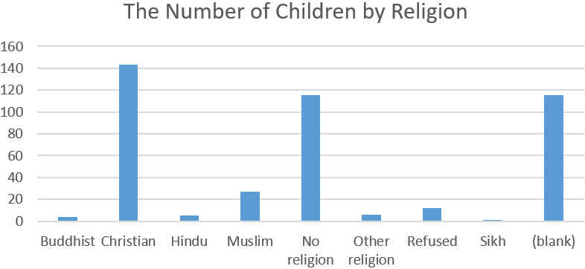
Appendix 2: The organisation of faith components from the National Curriculum and Local Authority.

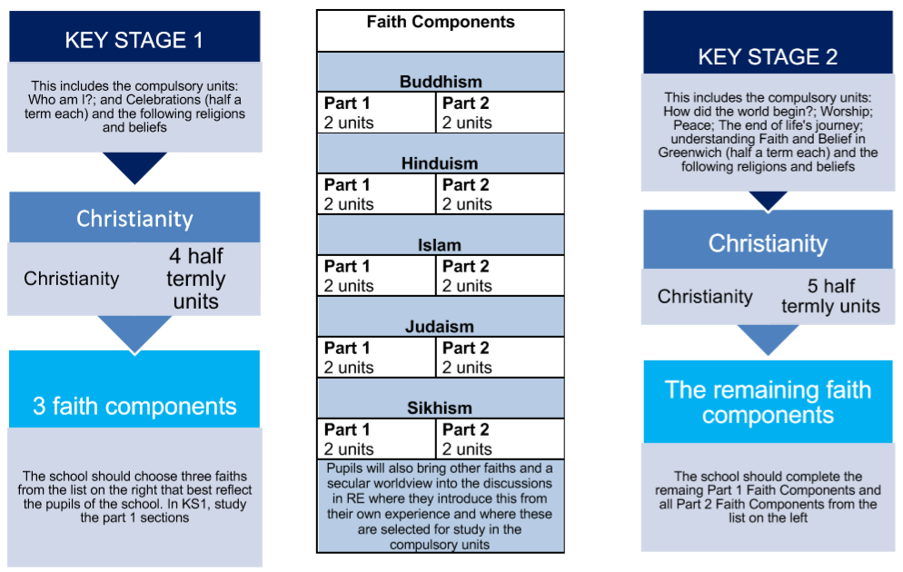

Appendix 3: The units (faith components) of our curriculum in each year group.
This is the suggested organisation of the units. However, at Wyborne we give our teachers the right to choose when to teach the units of work.

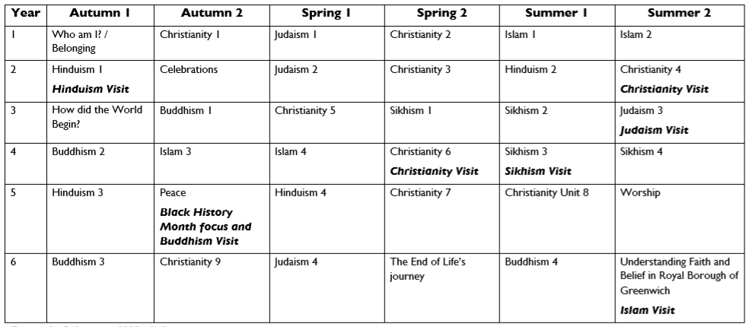
Appendix 4: Further EYFS Information (taken from RBG Syllabus document)

The Royal Greenwich Agreed Syllabus draws upon the principles that underpin the EYFS Framework:
• quality and consistency in all early years settings, so that every child makes good progress and no child gets left behind;
• a secure foundation through learning and development opportunities which are planned around the needs and interests of each individual child and are assessed and reviewed regularly;
• partnership working between practitioners and with parents and/or carers;
• equality of opportunity and anti-discriminatory practice, ensuring that every child is included and supported.

Overarching Principles
Four guiding principles should shape practice in early years settings. These are:
• every child is a unique child, who is constantly learning and can be resilient, capable, confident and self-assured; • children learn to be strong and independent through positive relationships; • children learn and develop well in enabling environments, in which their experiences respond to their individual needs and there is a strong partnership between practitioners and parents and/or carers; and • children develop and learn in different ways and at different rates. The framework covers the education and care of all children in early years provision, including children with special educational needs and disabilities.

Our guidance provides suggestions for ways in which practitioners can create an environment and plan activities which help children to further understand the world around them through Religious Education across all the seven areas of learning.

