
STOW ON THE WOLD

PRIMARY SCHOOL
Attendance Policy
In conjunction with The North Cotswolds Cluster of schools
Please also refer to our Safeguarding and child protection policy, SEND, Health and Safety, Behaviour, Anti-bullying Policy, Equal Opportunities and Admissions Policies which are all available on our website
Date of Ratification:  10/7/2023 | Updated:  7/7/2023 | Signed:  HEAD TEACHER  CHAIR OF GOVERNORS

Stow on the Wold Primary School & North Cotswold School Partnership Attendance Policy
At Stow on the Wold Primary School it is recognised that the responsibility for promoting good attendance and punctuality is shared by all staff, governors, parents and carers and the pupil. As a school we aim to maintain 100% attendance, the expectation is that every child comes to school on every day that it is open to them. Our aim is to maintain parents’ and pupils’ awareness of the importance of regular attendance. Working together to put the right support , at the right time, in conjunction with staff and parents we aim to remove any barriers to attendance.
This policy has been produced in conjunction with other North Cotswold Primary Schools, following advice from the Local Authority (LA).
Good attendance is important because:
- Statistics show a direct link between under-achievement and poor attendance.
- Regular attenders make better progress, both socially and academically.
- Regular attenders find school routines and school work easier to cope with.
- Regular attenders find learning more satisfying.
- Regular attenders have an easier transfer to secondary school.
- Builds resilience and self-motivation

Legislation and guidance
This policy meets the requirements of the working together to improve school attendance from the Department for Education (DfE), and refers to the DfE’s statutory guidance on school attendance parental responsibility measures. These documents are drawn from the following legislation setting out the legal powers and duties that govern school attendance:
    - Part 6 of The Education Act 1996
    - Part 3 of The Education Act 2002
    - Part 7 of The Education and Inspections Act 2006
    - The Education (Pupil Registration) (England) Regulations 2006 (and 2010, 2011, 2013, 2016 amendments)
    - The Education (Penalty Notices) (England) (Amendment) Regulations 2013
    - This policy also refers to the DfE’s guidance on the school census, which explains the persistent absence threshold.
Parental responsibility:
Parents and carers should:
- Advise school of any planned absence using the Request for Absence Form (Appendix 1).
- Ring school on the first morning of every absence to state the reason for the absence and the date the child is expected to return to school ore report the absence on Weduc, our school APP.
- Keep school updated by telephone or email if your child has an extended period of absence due to illness.
- Provide the school with more than one emergency contact number for their child.
- Make sure their children attend school regularly and on time, appropriately dressed and equipped and in a fit state to learn.
- Let the school know if they are having difficulty with attendance so that any available help or support can be offered and accepted.
- Arrange medical and dental appointments out of school hours, or during school breaks.
- Understand that there is no entitlement for parents to take pupils on holiday during term time and that holidays within term time are not an automatic right.
- Ensure that their children arrive in school on time. It is important to be on time, as the first few minutes of the school day are often used to give out instructions, organise schoolwork or for children to use this as work improvement time. If your child misses this short but vital session, their work for the whole day may be affected. Late arrivals disrupt the whole class and the late child is often embarrassed to arrive late. If your child arrives after registration it will be recorded as an unauthorised absence and could lead to a Fixed Penalty Notice being issued. (See appendix 2 Fixed Penalty Notice Leaflet)
School’s responsibility:
The school shall:
- Follow up unexplained absences with phone calls as soon as possible.
- Check for patterns of absence in order to reduce it.
- Keep and mark registers accurately.
- Remind parents of the importance of regular attendance and punctuality in newsletters, on the school website and APP
- Acknowledge and reward good attendance.
- Publish your child’s attendance rate on their annual school report.
- Let parents know if we have concerns regarding their child’s attendance and offer support and advice. (See Appendix 3 Attendance Intervention)
- Offer Attendance Improvement meetings (AIMS) with families to support improving attendance and draw up/ oversee Attendance contracts
- Ensure that if poor attendance continues following intervention/support a referral will be made to our Attendance Support Officer (ASO) who will consult with the LA’s Education Entitlement and Inclusion team who will consider taking legal action under the s444(1) of the 1996 Education Act. (See Appendix 4 Prosecution Leaflet)

Headteacher’s responsibility
The Headteacher shall:
- Ensure that everybody at school treats attendance as a priority.
- Promote the importance of good attendance to pupils and their parents/carers.
- Be available to discuss attendance concerns with pupils, parents, staff and governors.
- Remind parents at least annually of attendance procedures.
- Analyse attendance data and report it to Governors.
- Oversee attendance policy and procedures
- Monitor the impact of strategies used.
- Request the issue of fixed penalty notices.

Attendance Officer’s responsibility
The school attendance officer shall:
- Take calls from parents about absence on a day-to-day basis and record it on the school system
- Keep accurate and up to date records of calls and communication with parents
- Benchmark attendance data to identify areas of focus for improvement
- Provide regular attendance reports to school staff and report concerns about attendance to the headteacher. Work with school staff e.g. pastoral lead/family liaison officer/SENDCo to tackle persistent absence
- Advise the headteacher when to issue fixed-penalty notices

Individual teacher responsibility
The class teacher shall:
- Record attendance on a daily basis in the morning (by 9:00am) and afternoon (by 1:15/30 pm)
- Use the correct codes to show whether a pupil is present or absent by submitting the information to the school office

Governing Body Responsibility
The Governors shall:
- Recognise the importance of school attendance and promote it across the school’s ethos and policies
- Ensure school leaders fulfil expectations and statutory duties
- Regularly review attendance data, discussing and challenging trends, and helping school leaders focus efforts on the individual pupils or cohorts who need it most
- Ensure school staff receive adequate training on attendance
- Hold the headteacher to account for the implementation of this policy

School Processes

School times

The school gate opens at 8.40am every morning. Children should be in class ready for registration and morning tasks by 8.45am.
Registration
School must keep attendance registers for all pupils on the school roll. The class teacher will call the register twice a day and every pupil will be marked as present, absent or engaged in an approved educational activity away from the school site. It must be shown, by the use of approved codes, whether an absence is authorised or not.
- Registration will take place between 8.45 and 9.00 for the morning session and between 1.00 p.m. and 1.10 p.m. for the afternoon session.
- Pupils arriving during registration will be marked with an L (late), which denotes that the pupil is present. Registration will close 20 minutes after the register has been taken. Unless there is an acceptable reason for the lateness the pupil will be marked with a U, which denotes an unauthorised absence. If a pupil is registered with eight U’s in a ten-week period a Fixed Penalty Notice can be issued. A written warning of this will usually be issued, in the first instance, by the school. (See appendix 2 Fixed Penalty Notice Leaflet)
- If the child is late arriving to school, the parent/carer should report to the office.
The marking of registers will be in accordance with the set attendance codes. (See Appendix 5 Attendance Codes)

End of the school day:
Children should be collected promptly from the playground or class doors at 3.15pm unless they are attending an after-school activity (in which case they will finish at 4.15pm). In the unlikely event that a child is not collected at the end of the school day, we shall take him/her to our school office. If we have been unable contact parents/carers or any of the given emergency contacts by that time, the duty social worker from the Children and Families team will be contacted.

Absences
Absence, legally, has to be recorded as either authorised or unauthorised and reported on to the Department for Education and, in some circumstances, to the LA. Only school can decide whether an absence is authorised or not, and is not obliged to accept the reasons given by a parent or carer.

Authorised absence is when a pupil:
- is absent with the prior permission of the school
- has suffered a close family bereavement
- has been excluded
- Illness and non-routine medical/dental appointments
- Religious observance where the day is exclusively set apart for religious observance by the religious body to which the pupil and their parents belong. If necessary, the school will seek advice from the appropriate religious body to confirm whether the day is set apart
- Traveller pupils travelling for occupational purposes – this covers Roma, English and Welsh gypsies, Irish and Scottish travellers, showmen (fairground people) and circus people, bargees (occupational boat dwellers) and new travellers. Absence may be authorised only when a traveller family is known to be travelling for occupational purposes and has agreed this with the school, but it is not known whether the pupil is attending educational provision
- A crisis; eg housing, flooding, respite care etc
Unauthorised absence is when:
- a pupil is absent and no explanation, or an unacceptable explanation, is offered;
- a pupil arrives after the registration period has closed without an acceptable reason;
- a pupil is away from school on a family holiday.
An approved educational activity is not recorded as an absence and will be marked when a pupil is on a school/educational visit, is attending an approved off-site activity or is receiving special off-site tuition.
Appointments
If appointments have to be made during school hours, school should be pre-notified using the Request for Absence Form (Appendix 1) Pupils leaving school mid-session should, for safety reasons, notify the office on departure and re-arrival. If present at registration no amendment to the register is necessary. If absent at registration the register should be marked with an authorised absence mark. Again, for safety reasons, pupils should report to the office on arrival.
Frequent absences for Medical reasons
We will mark absence due to illness as authorised unless the school has a genuine concern about the authenticity of the illness.
If the authenticity of the illness is in doubt, the school may ask the pupil’s parent/carer to provide medical evidence, such as a doctor’s note, prescription, appointment card or other appropriate form of evidence. We will not ask for medical evidence unnecessarily.
If the school is not satisfied about the authenticity of the illness, the absence will be recorded as unauthorised and parents/carers will be notified of this in advance. We work in collaboration with our medical partners and invite relevant medical professionals to Team Around the Family meetings to support attendance for pupils.

Persistent and Severe absence
The persistent absence threshold is set at 10% by the government. This means that any pupil who is absent for 38 sessions (19 days) of school will be classified as persistently absent. Severe absence is when a pupil misses 50% or more of the school 190 sessions (95 days). The school will work with the parent and pupil to address any attendance concerns and may also call upon the expertise of the Parent Support Advisor, the Educational Welfare Officer or, where relevant, medical professionals, to help improve a pupil’s attendance.

Term-time holiday
Amendments to the Education (Pupil Registration) (England) Regulations 2006 regulations remove references to family holiday and extended leave as well as the statutory threshold of ten school days. The amendments make clear that the Headteacher may not grant any leave of absence during term time unless there are exceptional circumstances. There is no entitlement to time off in term time and the school can issue a Fixed Penalty Notice if absence is recorded as an unauthorised holiday. A written warning of this will usually be issued, in the first instance, by the school. (See Appendix 2 Fixed Penalty Notice)

School procedures
School registers are recorded on SIMS, the school’s Information Management System. Once the registers are closed the school secretary checks the registers for missing marks or unexplained absences.
Where the register shows an unexplained absence and there has been no message received at school by 9.30am a phone call will be made to the parent/carer to find out the reason for absence and the date of expected return. (Parents/carers will be asked to follow up with a written note on their child’s return to school.) All telephone messages will be recorded on SIMS.
If school have been unable to make contact by telephone a written communication will be sent on the 3rd day of absence, requesting the reason for absence. If there is no response a reminder will be sent on the 6th day of absence. If there is still no response the absence will be recorded as unauthorised and school will refer to the Attendance Support Officer. If school have been unable to make contact after the 10th school day of absence the Headteacher will report the pupil as a ‘Child Missing Education’ to the LA who will enforce their missing Child Missing Education protocol.

Where the register shows 6 separate late marks either during or after registration over a 6-week period the school will contact the parent/carer to discuss the reasons for the lateness.

Where the register shows 10 separate ‘late after registration’ marks (U) over the last 10 weeks, the LA may issue a Fixed Penalty Notice. (See appendix 2 Fixed Penalty Notice Leaflet.) A written warning of this will usually be issued, in the first instance, by the school.

Any concerns about attendance or punctuality will be referred to the Headteacher who will, if necessary, contact parents/carers to try to resolve any issues and, if appropriate, refer to the Parent Support Advisor or the Attendance Support Officer. If these issues cannot be resolved and there is continued unauthorised absence the matter may be referred ultimately to the Education Entitlement and Exclusion Team at Shire Hall.

The Law Reducing persistent and severe absence
Persistent absence is where a pupil misses 10% or more of school, and severe absence is where a pupil misses 50% or more of school.
The school will:
- Use attendance data to find patterns and trends of persistent and severe absence
- Hold regular meetings with the parents of pupils who the school (and/or local authority) considers to be vulnerable, or are persistently or severely absent, to discuss attendance and engagement at school
- Provide access to wider support services to remove the barriers to attendance
- Make links to other professionals, such as Early Help, medical professionals or community social workers to support pupils and their families
- Work collaboratively with the local inclusion teams, including outcomes co-ordinators to improve attendance for identified pupils
- Use parenting contracts to improve attendance
- Formalise support or use legal sanctions, in conjunction with Gloucestershire County Council, for example through using a parenting contract, engagement with social services, Education Supervision Order or consideration of attendance prosecution in the Magistrates Court
Legal sanctions
It is a parent’s responsibility to ensure that their child gets an education. In Education Law (Section 576 of the Education Act 1996) ‘parent’ means:
- All natural parents, whether they are married or not
- Any person who has parental responsibility for a child or pupil
- Any person who has care of a child or pupil, for example a person who lives with and looks after the child
Local councils and schools can use various legal powers if your child is missing school without a good reason. They can give you:
- a Parenting Order
- an Education Supervision Order
- a School Attendance Order
- a fine (sometimes known as a ‘penalty notice
You can be given one or more of these but the council does not have to do this before prosecuting you.
Parenting Order
This means you have to go to parenting classes. You’ll also have to do what the court says to improve your child’s school attendance.
Education Supervision Order
If the council thinks you need support getting your child to go to school but you’re not co-operating, they can apply to a court for an Education Supervision Order.
A supervisor will be appointed to help you get your child into education. The local council can do this instead of prosecuting you, or as well.
School Attendance Order
You’ll get a School Attendance Order if the local council thinks your child is not getting an education. You have 15 days to provide evidence that you’ve registered your child with the school listed in the order or that you’re giving them home education. If you do not, you could be prosecuted or given a fine.
Fine
Your local council can give each parent a fine of £60, which rises to £120 each if you do not pay within 21 days. If you do not pay the fine after 28 days you may be prosecuted for your child’s absence from school.
The school can request Gloucestershire County Council to issue a fine to parents for the unauthorised absence of their child from school, where the child is of compulsory school age. Fixed penalty notices are issued in accordance with the Local Authority Penalty Notice Code of Conduct Attendance - Schoolsnet (gloucestershire.gov.uk)
If not paid within 28 days the Local Authority can decide whether to prosecute or withdraw the notice – note there is no right of appeal in court by parents against a fixed penalty notice.
Prosecution
You could get a fine of up to £2,500, a community order or a jail sentence up to 3 months.
Leavers
If your child is leaving Bledington Primary School, other than to go on to Secondary School, parents/carers are asked to:
- give the school full information about their plans, including date of move; new address – or at least the town you will be moving to; new school and start date, when known; and reasons for moving (a form is available at the school office).
- confirm the school has your current mobile phone number.
- take our school’s compliments slip so the new school can easily arrange for records to be transferred.
- let us know when you move.
Children missing education
When pupils leave, if parents/carers have not given us the above information, and cannot be contacted, then the child is considered to be a Child Missing Education. This means that the Local Authority has a duty to carry out investigations that include liaising with Children’s Services (formerly Social Services), the Police and other agencies, to try to track and locate your child. When parents/carers provide the above information, unnecessary investigations can be avoided.

Strategies
To support our attendance policy we:
- will treat attendance as a priority;
- apply timely intervention/support and where necessary, if poor attendance continues, refer to the local authority’s Education, Entitlement and Inclusion team who will consider legal sanctions. (See appendix 3 Attendance Intervention)
- promote good attendance at every opportunity;
- always contact parents/carers on the first day of their child’s absence;
- reward and celebrate good and improved attendance;
- set attendance targets for the school
- keep parents/carers informed of their child’s attendance level;
- make good use of attendance data by specific analysis;
- notify Governors of attendance levels at each meeting of the full governing body;
- provide a safe, happy, stimulating environment for children, where they feel valued and welcomed, and that their presence in school is important.

Criteria for success
- Meeting or exceeding our attendance targets.
- Whole school attendance is in line with, or exceeds that of local comparator schools.
- We have positive feedback from outside agencies such as Ofsted, LA etc
- Everybody is clear about what to do if a child is absent from school.

Please find the following Appendices below
Appendix 1 Request for Absence form
Appendix 2 Fixed Penalty Notice leaflet
Appendix 3 Attendance Intervention
Appendix 4 Prosecution Leaflet
Appendix 5 Attendance Codes

Appendix 1
Request for Leave of Absence During Term Time
Parents and carers should be aware that the law does not grant parents an automatic right to take their children out of school during term time. The Department for Education allows a Head Teacher the discretion to consider authorising a leave of absence in term time only in ‘exceptional circumstances.’
You may consider that a holiday will be educational but your child will still miss out on the teaching and learning that their peers will receive whilst your child is away. Children returning from a leave of absence during term time are also unprepared for the lessons which build on the teaching they have missed and arrangements need to be made for individual children to catch up on missed work. Disruption to the continuity of teaching and learning is something we all have a responsibility to avoid.
If requesting a leave of absence you will need to complete the form on the reverse of this notice, setting out the reasons. If the holiday is not considered to be an exceptional circumstance it will not be agreed. If you nevertheless take your child out of school for the leave of absence this will be recorded as unauthorised leave.
In the case of an unauthorised leave of absence the head teacher may request that the Local Authority issue a Fixed Penalty Notice without further warning to the parent. Please note that such a penalty is issued to each parent for each child taken out of school.
A Penalty Notice is a fine of -
- £60, if paid within the first 21days of receiving the notice
- £120, if paid after 21 days but within 28 days.
If you don’t pay the penalty within 28 days, the local authority could pursue legal action.

All the leave of absence requests should be completed on the attached form by the parent with whom the child normally resides. This should be returned to the school at least seven days before the start of the holiday. All requests must be made prior to the leave being taken. Leave cannot be authorised retrospectively.

I hope you will support our efforts to maintain good levels of attendance and attainment.
Yours sincerely,
Rebecca Scutt
Head Teacher
Request for Leave of Absence During Term Time

Pupil Name: …………………………………………… Class/Tutor Group: ………………
Pupil’s Address: ……………………..…………………………………………………………
…………………………………………………………………………………..…………………
Date of First Absence: ………………….. Date of Return to School: ………………….
Number of days that your child will be absent from school: …………….……………
If a pupil fails to return within ten school days following the anticipated date of return and no reason is provided, there may be grounds (under some circumstances) to delete your child’s name from the Admissions Register and register them as a Child Missing Education.
Please detail the exceptional circumstance for which you are requesting leave of absence
…………………………………………………………………………………………………….
…………………………………………………………………………………...........................

In the case of an unauthorised leave of absence the head teacher may request that the Local Authority issue a Fixed Penalty Notice without further warning to the parent. Please note that such a penalty is issued to each parent for each child taken out of school.
A Penalty Notice is a fine of -
- £60, if paid within the first 21days of receiving the notice
- £120, if paid after 21 days but within 28 days.
- If you don’t pay the penalty within 28 days, the local authority could pursue legal action.
Name of Parent/Carer making the application:

Dr/ Mr/ Mrs/ Miss/ Ms

Forename: ……………………………………… Surname: ………………………………
Address: ………………………………………………………………………………………
…………………………………………………………………………………………………..
Signed: ………………………………………… Dated: ………………………………….
(Please ensure you are giving us at least seven days’ notice of the proposed absence, retrospective applications, cannot be authorised)

For the school to complete:
Request for Leave of Absence During Term Time
School Response
This response must be sent to each parent.
Parent’s Name: …………………………………………………………..

Child’s Name: ………………………………… Class: …………………
Your request for absence on the following dates:
__/__/__ to __/__/__ totalling …….days, has been considered and is
AUTHORISED

UNAUTHORISED
- Their attendance is currently:…………………………………………

- The request does / does not meet the criteria for
‘exceptional circumstances’
Please note: An unauthorised absence may be notified to the Local Authority and a Penalty Notice may be issued without further warning.
Signed: ……………………………………………..
Rebecca Scutt,
Head Teacher (for and on behalf of the Governors) Date: ___/___/___

Appendix 2 Fixed Penalty Notice leaflet


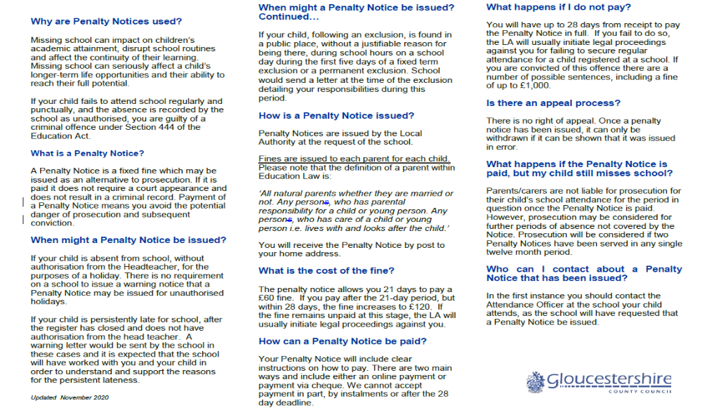

Appendix 3 Attendance Intervention
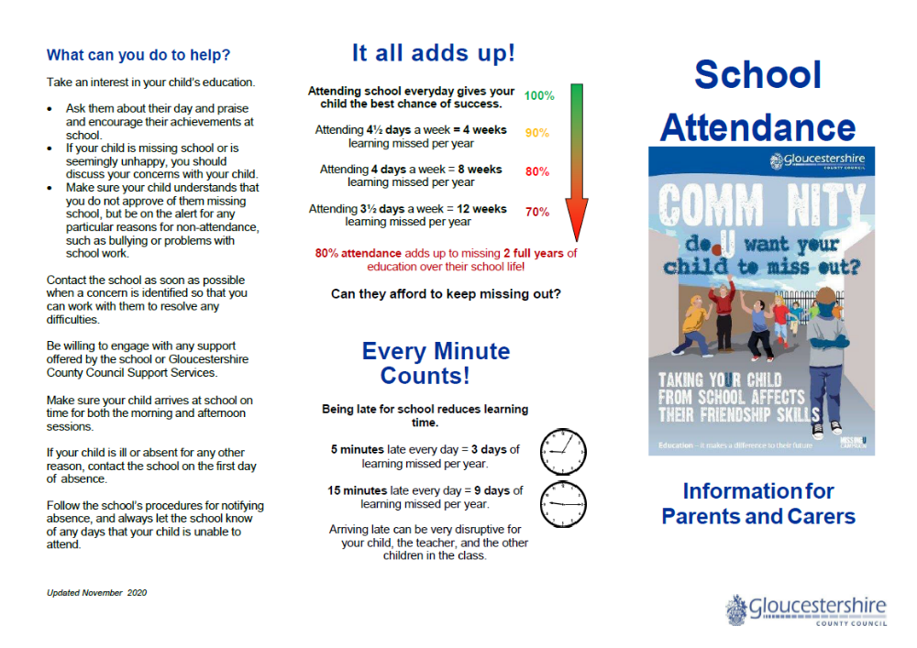
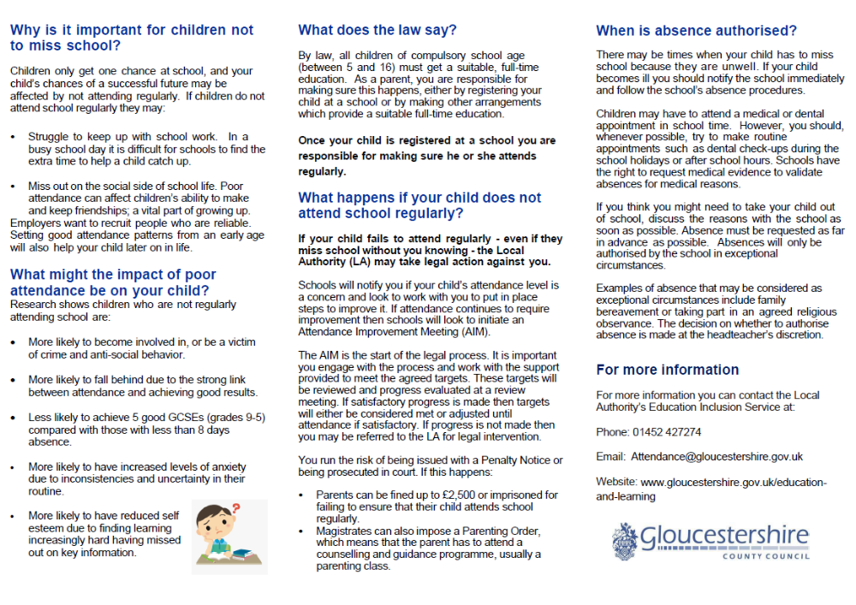
Appendix 4 Prosecution Leaflet

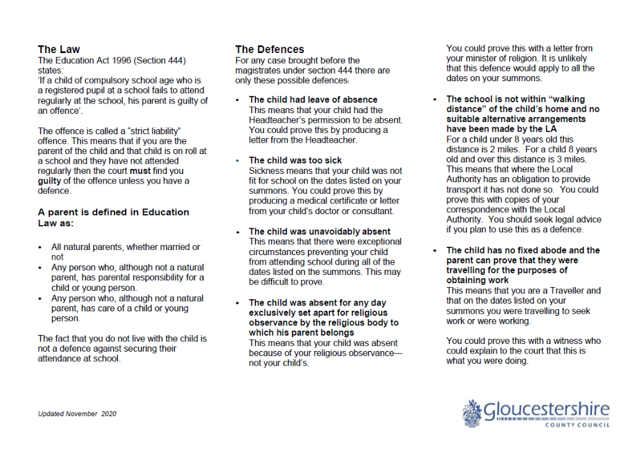

Appendix 5 Attendance Codes
Code | Description | Meaning
/ | Present (AM) | Present
\ | Present (PM) | Present
B | Educated off site (NOT dual registration) | Approved Education Activity (present)
C | Other Authorised Circumstances (not covered by another appropriate code/description) | Authorised absence
D | Dual registration (i.e. student attending another establishment) | Not counted in possible attendance
E | Excluded (no alternative provision made) | Authorised absence
G | Family holiday (NOT agreed or days in excess of agreement) | Unauthorised absence
H | Family holiday agreed | Authorised absence
I | Illness (NOT medical or dental etc appointments) | Authorised absence
J | Interview | Approved Education Activity (present)
L | Late (before the registers closed) | Present
M | Medical/dental appointments | Authorised absence
N | No reason yet provided for absence | Unauthorised absence
O | Unauthorised absence (not covered by any other code/description) | Unauthorised absence
P | Approved sporting activity | Approved Education Activity (present)
R | Religious observance | Authorised absence
S | Study Leave | Authorised absence
T | Traveller absence | Authorised absence
U | Late (after registers closed) | Unauthorised absence
V | Education visit or trip | Approved Education Activity (present)
W | Work Experience | Approved Education Activity (present)
X | Non-compulsory school age students not expected to attend | Not counted in possible attendance
Y | Unable to attend due to exceptional circumstances | Not counted in possible attendance
Z | Pupil not on admission register | Not counted in possible attendance

Written 09.09.15 Updated 31.03.2017 Updated 28.04.21 Updated 15.05.23

