11th September 2025

Dear Parent/Carer

**PARKING PLEDGE – sign up now for a chance to win a family prize!**

**WORLD CAR FREE DAY MONDAY 22ND SEPTEMBER**

**Parking and Road Safety updates**

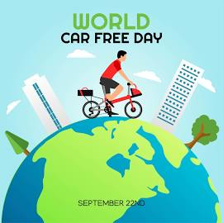

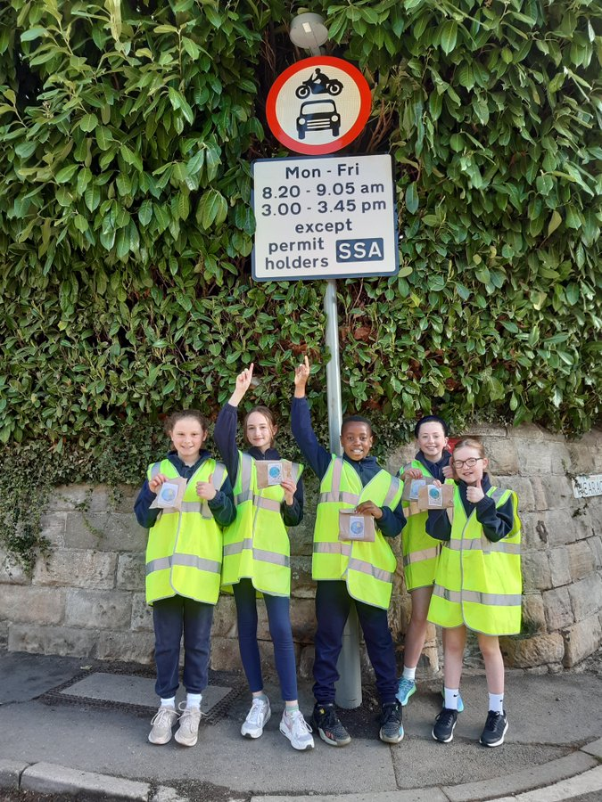Firstly, I would like to thank the many parents who support the School Street pilot daily by either travelling actively or parking away and walking along Vicarage Lane. It has been reassuring to see so many children walking, scooting or even cycling to school and the improvements seen on Vicarage Lane. Please note the School Street term time operational times (8:20 -9:05am and 3:00- 3:45pm).

For those families that need to drive into the village and park on neighbouring streets please remember the following:

* Park with consideration for local residents and other families who are choosing to travel actively to school.
* **Do not** obstruct resident drives. **Do not** park over dropped kerbs.
* Park at least 10 metres away from junctions
* Please turn your car engine off whilst waiting - it increases air pollution, wastes fuel, causes wear and tear on your car's engine.
* Abide by all the single and double yellow line parking restrictions.
* Do not drop off pupils near the crossing patrol supervisor. This reduces her visibility and makes getting pupils across the road safely very difficult.
* Drive slowly with extreme caution on the streets closest to school where pupils are walking, scooting or cycling.
* Model the behaviour you want to see in your child if and when they become a driver in years to come. They see and hear your driving and parking habits.

**Park and Stride/Ride options available locally**

Parents can park in the following places locally and walk the remaining distance to school.

* The Chevin Golf Club car park (DE56 4EE) – available free of charge every morning and afternoon during drop off and pick up times.
* The Viceroy Restaurant car park (DE56 4ER) – available free of charge until 4pm each day for village parking.

***Could you meet a friend at the golf club or Viceroy car park and take it in turns to walk each others children the remaining 5 minutes to school?***

* There is a large carpark 10 minutes away from school at Eyes Meadow (DE56 4JD), this leads to a car free route along Stiles Walk to Chapel Street and then King Street.

Please see attached ‘How to get to William Gilbert School map’ for the locations of these safe parking spaces.

**Latest news:**

* Rob Bounds (senior transport officer from Derbyshire County Council) will visit school on 18th September and deliver ‘Scooter Smart’ safety workshops to all pupils. There will be a quick demonstration and top tips for parents with pupils listening too at 9am on the infant playground for parents of EYFS and KS1 pupils and then again at 3:15pm on the junior playground for parents of KS2 pupils.
* The **William Gilbert School Parking Pledge** has been shared with pupils. To keep us as paper free and environmentally friendly as possible we are sharing an electronic copy of the parking pledge with you, with a QR code/link to follow and sign the pledge agreement form. We hope you will read and agree to the pledge to promote safer, healthier journeys to school.

Internally this creates a log of your family name which we with add to a prize draw. Prize to be announced shortly (we are aiming for it to be a family ticket to a local attraction). Raffle drawn on 30th September 2025.

* September is **Mode Shift Month.** We will be supporting this through prompting healthier ways to travel to school. See previous communication for full details of initiatives to get involved with. On **Monday 22nd September** it is World Car-Free Day which takes place every year on 22 September. In 2025, it falls on a Monday, coinciding with European Mobility Week, a broader campaign aimed at sustainable urban mobility. **Why it matters** **-** Reducing car traffic, even for a day, leads to lower air pollution and better respiratory health. We urge all families to **leave the car at home:** Walk, cycle, take the bus or train, or try a carpool. Even one day makes a difference.

I look forward to **our Car Free Day on Monday 22nd September** with as many of you as possible leaving the car at home and walking, scooting, cycling, taking the bus or train, or trying a carpool. **Even one day makes a difference!**

Yours Sincerely

Mrs E H Britten

Headteacher