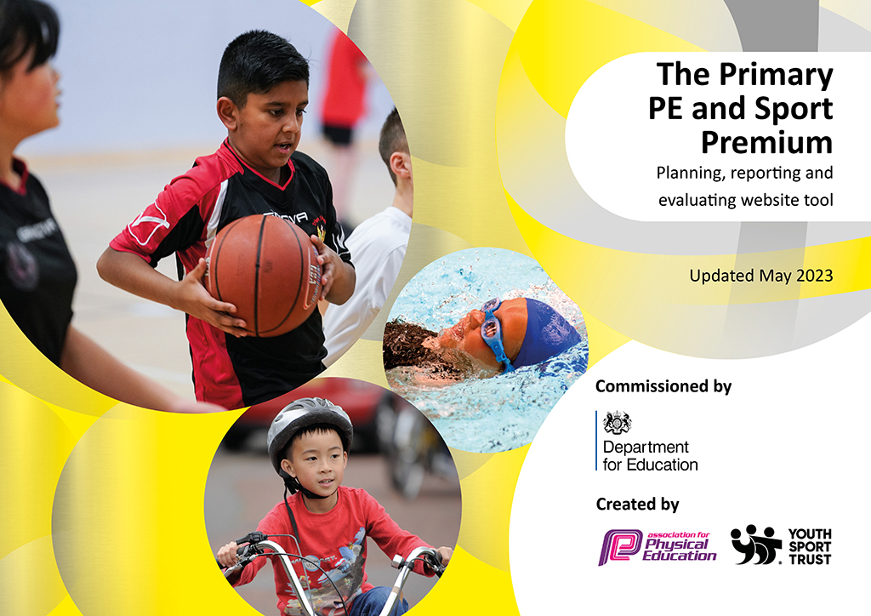
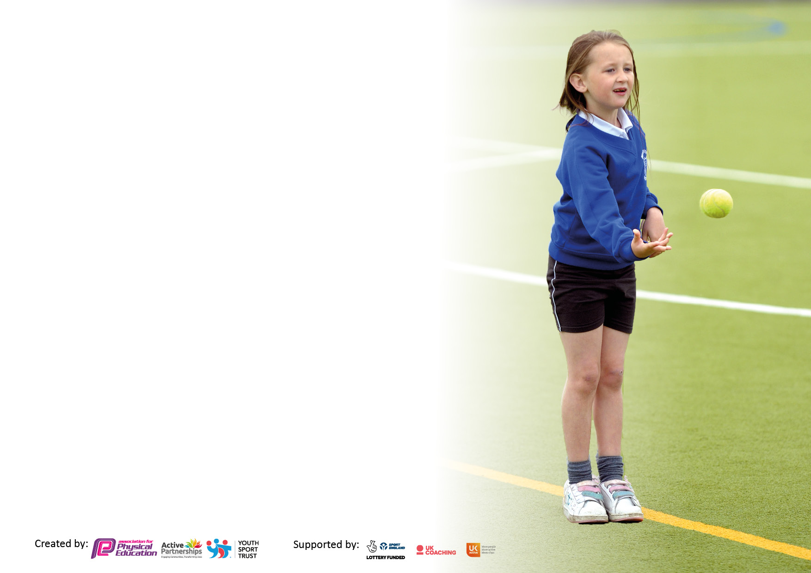

It is important that your grant is used effectively and based on school need. The Education Inspection Framework makes clear there will be a focus on ‘whether leaders and those responsible for governors all understand their respective roles and perform these in a way that enhances the effectiveness of the school’.

Under the Quality of Education Ofsted inspectors consider:
Intent - Curriculum design, coverage and appropriateness
Implementation - Curriculum delivery, Teaching (pedagogy) and Assessment
Impact - Attainment and progress

To assist schools with common transferable language this template has been developed to utilise the same three headings which should make your plans easily transferable between working documents.

Schools must use the funding to make additional and sustainable improvements to the quality of Physical Education, School Sport and Physical Activity (PESSPA) they offer. This means that you should use the Primary PE and sport premium to:

- Develop or add to the PESSPA activities that your school already offer
- Build capacity and capability within the school to ensure that improvements made now will benefit pupils joining the school in future years
- The Primary PE and sport premium should not be used to fund capital spend projects; the school’s budget should fund these.

Please visit gov.uk for the revised DfE guidance including the5keyindicatorsacrosswhichschoolsshoulddemonstrate an improvement. This document will helpyoutoreviewyourprovisionandtoreportyourspend.DfEencouragesschools to use this template as an effective way of meeting the reporting requirements of the Primary PE and Sport Premium.

We recommend you start by reflecting on the impact of current provision and reviewing the previous spend.

Schools are required to publish details of how they spend this funding, including any under-spend from 2021/2022, as well as on the impact it has on pupils’ PE and sport participation and attainment. The funding should be spent by 31st July but the DfE has stated that there will be no clawback of any unspent money so this can be carried forward into 2023/24.

We recommend regularly updating the table and publishing it on your website throughout the year. This evidences your ongoing self-evaluation of how you are using the funding to secure maximum, sustainable impact. Final copy must be posted on your website by the end of the academic year and no later than the 31st July 2023. To see an example of how to complete the table please click HERE.

Details with regard to funding
Please complete the table below.

Total amount carried over from 2021/22 | £1533
Total amount allocated for 2021/22 | £
How much (if any) do you intend to carry over from this total fund into 2022/23? | £1,533.00
Total amount allocated for 2022/23 | £12,813.17
Total amount of funding for 2022/23. Ideally should be spent and reported on by 31st July 2023. | £ 14,346.17
Swimming Data
Please report on your Swimming Data below.

Meeting national curriculum requirements for swimming and water safety.
N.B. Complete this section to your best ability. For example you might have practised safe self-rescue techniques on dry land which you can then transfer to the pool when school swimming restarts.
Due to exceptional circumstances priority should be given to ensuring that pupils can perform safe self rescue even if they do not fully meet the first two requirements of the NC programme of study
What percentage of your current Year 6 cohort swim competently, confidently and proficiently over a distance of at least 25 metres?  N.B. Even though your pupils may swim in another year please report on their attainment on leaving primary school at the end of the summer term 2023.  Please see note above | July 2023 85% (17/20 children) able to swim competently  July 2022 three children unable to swim confidently  July 2021 80% of children unable to swim confidently
What percentage of your current Year 6 cohort use a range of strokes effectively [for example, front crawl, backstroke and breaststroke]?  Please see note above | 70 % in 2023 (14/20 children)  65% in 2022  70% in 2021
What percentage of your current Year 6 cohort perform safe self-rescue in different water-based situations? | 75% (15/20 children)
Schools can choose to use the Primary PE and sport premium to provide additional provision for swimming but this must be for activity over and above the national curriculum requirements. Have you used it in this way? | Not this year but plan to for 23/24 should there be Y6 still unable to swim

Action Plan and Budget Tracking
Capture your intended annual spend against the 5 key indicators. Clarify the success criteria and evidence of impact that you intend to measure to evaluate for pupils today and for the future.

Academic Year: 2023/24 | Total fund allocated: 14350 | Date Updated: JULY 2023
Key indicator 1: The engagement of all pupils in regular physical activity – Chief Medical Officers guidelines recommend that primary school pupils undertake at least 30 minutes of physical activity a day in school |  |  |  | Percentage of total allocation:
 |  |  |  | 20%
Intent | Implementation |  | Impact
Your school focus should be clear what you want the pupils to know and be able to do and about  what they need to learn and to  consolidate through practice: | Make sure your actions to achieve are linked to your intentions: | Funding allocated:  £2890 AT LEAST | Evidence of impact: what do pupils now know and what can they now do? What has changed?: | Sustainability and suggested next steps:
To ensure all classes have at least 2 hours of PE lessons per week minimum, including lessons with school staff and with appointed sports coaches and teachers working together  To ensure the children have additional sports and physical exercise hours as part of clubs and after school and inter /intra school sporting activities above and beyond the two hours class time within the school day  Breakfast club activities to include half the time spent outside on adventure playground and small mixed age games on the play ground  To focus on more on the daily 30 minutes of daily activity at play and lunchtimes by the provision of outdoor equipment and supervision at play and lunchtimes (miss heath and Mrs Nicholson) .  The daily mile to be revisited this term, could be done at lunchtime a couple of days a week with all pupils and in classtime  To increase pupil participation in extra curricular activities before and during school such as Forest school activities and exercise, gardening, walks in the community | Sports coaches and specialist PE teachers to teach alongside class teachers to ensure high quality teaching provision and engagement of all pupils.  Gloucestershire Rugby Club  Cirencester cricket coaches  Stow Active coaches  Supastrikers coaches , may be paid by parents and subsidised for targeted children  Weekly in three out of four classes, at least one hour each plus coaching for inter and intra sporting activities  Aim to add other lunchtime activities and after school clubs, with help from dinner ladies/TAs, record of what is taking place  Focus on forest school activities in 2023-4 and employ a teacher to do this in three classes each week for 23-24 offset by some sports premium  children to attend breakfast club to help well being and also increase physical exercise  Identify and mark the course for the daily mile in school which could be done at lunchtime a couple of days a week.  Identify and observe opportunities for consistent and regular exercise and activity throughout the school day- really active not sitting in lines waiting turns- get all pupils and staff to engage in whole school activity or pre and after school activities  Use of school council to promote activities in the classes such as daily mile, forest school and orienteering | Cost of M6 sports coach for 38 weeks at 4 hrs. a week  £4000  Cost of additional sporting activities from Rugby Club DEPENCING ON GRANTS | The school has achieved PLATINUM for its sports provision in 2022-23  Increased engagement of children in sports in school and after school to date  Aim to exceed daily target in 2022-23 and 2023-4  Increased engagement of the children in sports to date and we have achieved and likely to sustain/exceed the recommended target in 20-21 and 21-22 and 22-23  Children to report being more active and attending more sporting activities in the school day and after school at clubs | After school sports clubs to be reinstated after a period when there were fewer due to after school club in hub.  Clubs to continue to be very well attended, with 92% of key stage 2 children involved in after school sport.  These activities include football, tag rugby, netball, cricket and rounders and cross country as well as dance and panathlon activities, orienteering and forest school  Standards in NC PE are improving as a result  We continue to strive to achieve 100% AT A CLUB.  Daily mile and activity at breakfast will increase percentages , and improve attitudes to learning and concentration  Over the coming months we hope to run new clubs to help those who prefer quieter PE activities, and struggle with transport after school.
Key indicator 2: The profile of PESSPA being raised across the school as a tool for whole school improvement |  |  |  | Percentage of total allocation:
 |  |  |  | 20%
Intent | Implementation |  | Impact
Your school focus should be clear what you want the pupils to know and be able to do and about  what they need to learn and to  consolidate through practice: | Make sure your actions to achieve are linked to your intentions: | Funding allocated:  £2890 AT LEAST | Evidence of impact: what do pupils now know and what can they now do? What has changed?: | Sustainability and suggested next steps:
To increase the profile of sport in the school through website, assemblies, new school Weduc APP, dance showcase, sports day, intra house activities, colour run  Offer PE curriculum certificates and rewards in celebration assembly-Awarded from class teachers lessons, from Sports coaches and MDSAs and after school clubs.  To increase and build upon sports reports on APP and on website and also on the PE boards in the hall as well as regular mentions on assemblies and celebration assembly  Celebrate achievements outside school as well as in school  Membership of Youth sport trust for  £200 to help audit the sports provision, to be considered  Can get a discount for cluster arrangements and training becomes cheaper  Increasing profile by providing special sports clothing and team clothes for PE | Annual in house dance festival , with dances from all three junior classes  Match write ups on APP and website and in school hall and on newsltters/APP  Show casing two dances at the cluster festivals. It allows the children to perform on a stage in front of a friendly audience of parents and friends and raise profile of PE.  Cross curricular activities eg active music , orienteering, small bursts of activity in the school day, eg short dance when it is right for the teacher to do it whilst raising the profile of physical activity being valued APP celebrating PE and sporting achievements outside school hours  Whole school training to buddy more confident staff with less confident staff around PE and utilising CPD courses to full effect.  Noticeboard in hall with pictures and write ups of events and matches, raising the profile in school and on the APP  Fundraising by children to provide new sports kit and clothing, matched by PTFA funds sucha s football kit funded by Y6 pupils fund raising | POSSIBLY UP TO £4000 | The school has achieved PLATINUM for its sports provision in 2022-23 and this to be celebrated  Intra activities aim to build on profile of existing activities - sports hall athletics, cricket, rounders, pentathlon, quick sticks hockey and tag rugby tournament.  Aim to raise profile of infants PE with their involvement in intra activities too, getting them into the active habit right from the start of their school life  Build on the profile of sports at special days involving the community such as Sports day continues to be very popular, with all participating in the morning round robin activities based on our curriculum athletics but now add new events such as orienteering day at e and colour run getting families and house teams involved .  A focus on athletics and dance has had a very beneficial effect on our performance at the cluster athletics where a record number of children went on to district finals , and at dance events where the whole class had the opportunity to attend two festivals and dance on the stage twice to an unknown audience. | Sports coach and PE lead to continue driving the profile of PE and sport in school and building on staff expertise and confidence so that this can be sustained with fewer hours from coach  The specialist will on hand to assist new staff, teach key stage 1and 2 children the all-important fundamental movement skills but on reduced hours, allowing the Sports premium money to be directed to other areas such as updating equipment in future.  Use of professional coaches in other areas of the PE curriculum such as Gloucester rugby  Pupils are proud of their achievements and this will impact on self-confidence and self-esteem, this will in turn impact on learning  Children are invested in the fund raising and therefore in valuing the equipment and clothing provided for matches and events and the feeling of being part of a high profile event.

Key indicator 3: Increased confidence, knowledge and skills of all staff in teaching PE and sport |  |  |  | Percentage of total allocation:
 |  |  |  | 20%
Intent | Implementation |  | Impact
Your school focus should be clear | Make sure your actions to | Funding | Evidence of impact: what do | Sustainability and suggested
what you want the pupils to know | achieve are linked to your | allocated: | pupils now know and what | next steps:
and be able to do and about | intentions: |  | can they now do? What has
what they need to learn and to |  | £2890 AT LEAST OVERLAPPING WITH OTHER AREAS | changed?:
consolidate through practice:
The employment of a specialist PE teacher and coaches throughout the year to upskill class teachers during curriculum time has continued.  To ensure new school staff and those changing year groups are well supported in their new class or their new role  Renewed and continuing emphasis on upskilling new members of staff again with an emphasis on gymnastics and dance.  Increasing staff confidence on the schemes of work which are being used as the basis for PE planning and are proving beneficial as all children are following the same PE curriculum pathway.  Increasing staff confidence and knowledge to ensure consistency in content and enabling transfer of skills from one class to the next.  To make the most of cluster CPD opportunities such cluster training for staff in tennis, rugby, netball and cricket and also cluster subject leaders staff meetings and opportunities | To employ a PE specialist to continue to up skill our teaching staff, particularly in the areas of gymnastics, dance, hockey and athletics.  Continue to assist staff to develop their PE skills and become confident to teach a range of activities, rather than their own favourite sport  To continue to use and extend the usage of Schemes of work which have proved very useful to date. They allow us as a school to follow the same basic curriculum, ensuring continuity of skills across the board | £ 5000 | To ensure that by the end of the year the majority of PE is taught confidently by the class teacher.  Aim to use the specialist now works with particular staff on activities they would like to further develop and possibly a new ECT following a mid-year change of staff.  To ensure the school fully uses local courses to further their skills in particular areas, these include hockey, netball, cricket and tennis.  To ensure there is consistency in the transfer of skills from one class to the next.  The school will continue to fulfil the curriculum requirements of the Sainsbury’s School Games Gold award for the fifth year running and has this year achieved platinum award and can use this for its profile raising activities such as on letters and headed paper | In future the school aims to continue to up skill staff and students through the PE specialist, and also through our current class teachers.  Staff will become confident enough to be able to assist any ECTs/students joining the school.  Staff will take responsibility for the majority of our school games events and intra house competitions.  Continued excellence in PE subject leadership  Skills knowledge and understanding of pupils will significantly increase over the year especially new staff
Key indicator 4: Broader experience of a range of sports and activities offered to all pupils |  |  |  | Percentage of total allocation:
 |  |  |  | 20%
Intent | Implementation |  | Impact
Your school focus should be clear | Make sure your actions to | Funding | Evidence of impact: what do | Sustainability and suggested
what you want the pupils to know | achieve are linked to your | allocated: | pupils now know and what | next steps:
and be able to do and about | intentions: |  | can they now do? What has
what they need to learn and to |  |  | changed?:
consolidate through practice:
To ensure an improved overall picture with a better range of all national curriculum activities.  To explore swimming lessons agin for those unlikely to reach 25m by end of KS2  Now include gym, rugby dance, athletics,  major team games including  quick sticks and cricket.  Spend could be on cricket coach, rugby and more tennis provision.  To reinstate daily mile and wake and  shake at assembly time  To increase the amount of PE  and sport equipment available  in school and the ease with which  it is accessed. | The employment of a specialist  PE teacher to upskill class teachers during curriculum time has continued.  This year the emphasis has been on upskilling new members of staff  again with an emphasis on gymnastics and dance.  Use of local swimming pool and  robin bus to transport children  To employ specialist sports staff and coaches from:  Gloucestershire Rugby Club  Cirencester cricket coaches  Stow Active coaches  Supastrikers coaches , may be paid by parents and subsidised for targeted children  To consider other after school clubs  possibly tie in with after school  child care provision at the hub  To buy sports equipment and  to use the container effectively,  possibly purchase of new  thermoplastic playground  markings part funded by the PTFA  To undertake all PE  opportunities which are  offered through the sport partnerships and cluster activities  Arrange pupil survey of what  they would like to see as  part of wider pupil voice  Interrogation of online pupil  survey to address needs  identified by children  Additional cost of additional  1 hr a week for a club/ clubs  £25 a week over 10 weeks | £2890 | The school staff have worked tirelessly both PE subject leaders and specialist teacher , encouraging in house, after school participation and enabling school games activities to be entered.  School staff secured the services of cricket coaching and Gloucester Rugby Coaches  This gives weekly specialist coaching for all junior classes and enabled the school to run in house competitions and events.  To explore and make use of swimming facilities at Bourton for our swimming provision  Children more able to access equipment readily and report feeling well equipped.  New clubs will be up and running and higher proportions will be attending, with kit and on time | We continue to strive to achieve 100%, and the introduction of after school club may help increase participation along with many clubs using volunteer time and support from staff and parents  Purchase of new sports equipment to extend the range of activities and ensure that each class has the equipment it needs - this is helping to keep cupboards tidier, equipment for accessible and keep curriculum equipment separate from extracurricular equipment.  To use funding and sources of equipment and kit from sustainable courses such as that acquired through support of PTFA e.g. medals purchased by parents as a donation, professional looking sports kit and coats for away matches  Transport to and from matches and events outside school We continue to strive to achieve 100% participation and a broad range of clubs, and sports on offer

Key indicator 5: Increased participation in competitive sport |  |  |  | Percentage of total allocation:
 |  |  |  | 20%
Intent | Implementation |  | Impact
Your school focus should be clear | Make sure your actions to | Funding | Evidence of impact: what do | Sustainability and suggested
what you want the pupils to know | achieve are linked to your | allocated: | pupils now know and what | next steps:
and be able to do and about | intentions: |  | can they now do? What has
what they need to learn and to |  |  | changed?:
consolidate through practice:
Good already but aim to improve by spend on transport and occasionally might need TA help and the cost attached to this to take children to activities depending on class staffing.  To use some of the funding on more equipment  Urgent need for thermo plastic MUGGA pitch other trim trail type markings as well as consumables such as footballs, netballs, tennis and rugby balls  Possible use of orienteering activities for less engaged, or Forest Schools  Attending some development competitions and take B or C teams to compete  To develop level 1 intra school competitions within school  To develop level zero type games at play and lunchtimes where they compete against themselves to get a better score eg bouncing a ball, skipping on the spot–look for the biggest personal best improvements | Our competitive sport goes from strength to strength mainly through the Sainsbury’s School Games events.  We have entered twenty activities which include festivals for year 3/4 in rounders and orienteering these are occasions when the whole of year 3 and 4 participate!  We have been particularly successful in both netball and quick sticks hockey this year, something we feel is due to improved curriculum teaching and better after school provision.  Aim to sustain and build on this and also to purchase equipment as required for competitive games and sports  Coaches and transport to competitive events | £2890 | 92% of class 5 (Year 5 and 6) have taken part in two or more competitive activities, 100% have taken part in one. We have over 90% of our children participating in sport after school and crucially outside of school.  Our club links are proving successful too, with children joining Bourton gymnastics Club and Sherborne Hockey club.  This is alongside those already playing rugby at Stow Ruby Clunb and football at Bourton Rovers.  We are now regular participants in the area panethlon games. These are aimed at those who do not regularly take part in school teams for whatever reason, our children have a brilliant time and this increases the levels of competitive sport. | We are looking forward to the cluster athletics where each child in key stage 2 will participate, this means 100% of children have a chance to represent the school in a competitive situation  This coupled with a Y3/4 tournament and a Y5/6 football and hockey tournament will offer more children the chance to participate in competitive sport.  Y5/6, the aim is for at least 90% will take part in two or more competitive activities.

Signed off by
Head Teacher: | REBECCA SCUTT
Date: | JULY 2023
Subject Leader: | HANNAH LEWIS SUPPORTED BY HAYLEY TOWNSEND
Date: | JULY 2023
Governor: | VERITY FLAHERTY
Date: | JULY 2023

